|  |  |  |  |  |  |  |  |  |  |  |  |  |  |  |  |  |  |  |  |  |  |  |  |  |  |  |  |  |  |  |  |
| --- | --- | --- | --- | --- | --- | --- | --- | --- | --- | --- | --- | --- | --- | --- | --- | --- | --- | --- | --- | --- | --- | --- | --- | --- | --- | --- | --- | --- | --- | --- | --- |
| **臺北市政府捷運工程局**  **機電系統工程處**  **System-wide E&M Project Office,**  **Department of Rapid Transit Systems, TCG** | | | | | | | | | | | | | | | | | | | | | | | | | | | | | | | |
|  | | | | | | | | | | | | | | | | | | | | | | | | | | | | | | | |
| **臺北捷運環狀線(第一階段)**  **機電系統工程、軌道工程、自動收費系統工程**  **TAIPEI CIRCULAR LINE (PHASE 1)**  **E&M SYSTEM, Track Works, AFC SYSTEM**  **CF610/CF611/CF617** | | | | | | | | | | | | | | | | | | | | | | | | | | | | | | | |
|  | | | | |  | | | | | | |  | | | |  | | | | | |  | | | | | |  | | |  |
|  | | | | |  | | | | | | |  | | | |  | | | | | |
|  | | | | |  | | | | | | |  | | | |  | | | | | |  | | | | | |  | | |  |
|  | | | | |  | | | | | | |  | | | |  | | | | | |
|  | | | | |  | | | | | | |  | | | |  | | | | | | 初次發行First issue | | | | | | JUL 06, 2017 | | | A |
| L. Liao | | | | | D. Villa | | | | | | | S. Chen | | | | R. Kempanna | | | | | |
| **編 製**  **Prepared**  **(MT)** | | | | | **校 核Checked**  **(SPE)** | | | | | | | **複 核Approved**  **(QM)** | | | | **核 准Authorized**  **(PD)** | | | | | | **說 明**  **Description** | | | | | | **日 期**  **Date** | | | **版 次**  **Revision** |
| **發行者：**  **Issuer** | | | | | | | **義大利日立軌道車輛及安薩爾多交通號誌系統 共同承攬Hitachi Rail Italy S.p.A.–Ansaldo STS S.p.A. Consortium** | | | | | | | | | | | | | | | | | | | **發行者編號：**  **Issuer Code** | | | |  | |
| **文件名稱：**  **Doc. Title** | | | | | | | | | | **通訊系統 - 其他文件**  **通訊多功能操作台 - 訓練教材**  **COMMUNICATIONS - OTHERS DOCUMENT**  **Communication MULTI FUNCTION TERMINAL -**  **Training MANUAL** | | | | | | | | | | | | | | | | | | | | | |
| **廠商：**  **Contractor** | | | | | | | | | | **義大利日立軌道車輛及安薩爾多交通號誌系統　共同承攬**  **Hitachi Rail Italy S.p.A. – Ansaldo STS S.p.A. Consortium** | | | | | | | | | | | | | | | | | | | | | |
| **屬性Attributes:** | | | | | | | | | | | | | | | | | | | | | | | | | **送審文件編號Submittal Code:** | | | | | | |
|  | **ST** |  | | **AREA** | | | | | | | | |  | **PBS** | | |  | **ABS** |  | **TY** | | |  | | **TC1-67107-A** | | | | | | |
| **X** | **0** | | | | **0** | | | **0** | | **4** | | | **F** | **X** | | |
| **編號Code:** | | | | | | | | | | | | | | | | | | | | | | | | |
|  | **PROJECT** | | | | | | | |  | | **NUMBER** | | | | | | | | | |  | | **IRE** |  |  | | | | | | |
| **T** | **C** | | | | **1** | | | **6** | | **7** | | **1** | | | **0** | **7** | | **00** |
|  | | | | | | | | | | | | | | | | | | | | | | | | |
| **檔名：**  **File** | | | **TC1-67107-00-A Communications Multi Function Terminal - Training Manual.docx.** | | | | | | | | | | | | | | | | | | | | | | | | **頁碼：**  **Page** | | **1 of 132** | | |

|  |
| --- |
| **內部修正紀錄表**  **INTERNAL AMENDMENT LIST** |

|  |  |  |  |  |  |  |
| --- | --- | --- | --- | --- | --- | --- |
|  |  |  |  |  |  |  |
| L. Liao | D. Villa | S. Chen | R. Kempanna | 初次發行First issue | JUL 06, 2017 | 00 |
| **編 製**  **Prepared**  **(MT)** | **校 核**  **Checked**  **(SPE)** | **複 核**  **Approved**  **(QM)** | **核 准**  **Authorized**  **(PD)** | **說　明**  **Description** | **日 期**  **Date** | **版 次**  **Revision** |

|  |
| --- |
| **文件審查意見回覆表**  **RESPONSE REVIEW TRANSMITTAL** |

|  |  |  |  |  |
| --- | --- | --- | --- | --- |
|  |  |  |  |  |
|  |  | **N/A** |  |  |
| **版次**  Revision | **審查單位**  Issuer | **審查文號**  Issuer’s SRT Reference | **審查日期**  Date Issued | **審查狀況**  Status of Approval |

| **項次**  No. | **圖說/章節/項次**  Extracting/ Chapter/ Item | **審查意見**  Review Comments | **答覆**  Reply Answer |
| --- | --- | --- | --- |
|  |  | **N/A** |  |

**目 錄**

**TABLE OF CONTENTS**

1 範圍SCOPE 6

1.1 目的Purpose 6

1.2 適用性Applicability 6

1.3 參考文件Reference Documents 6

1.4 名詞、略語、縮寫Terms, Acronyms and Abbreviations 6

1.5 自前版次變更說明Description of Changes From Previous Revision 7

2 系統概述System Summary 8

2.1 系統範圍System Scope 8

2.2 系統架構System Architecture 9

3 CMFT軟體操作概述CMFT Operation summary 10

3.1 監控工作站啟動Surveillance Workstation software Start 12

3.1.1 開啟主控台電腦後，系統將自動啟動並進入登錄頁面 (如圖 3‑1) 12

3.1.2 帳號與密碼驗證 ID and Passward Verification 13

3.1.3 密碼設定規則Password setting rule 14

3.1.4 驗證成功 Verification is successful 14

3.2 功能列Function Bar 16

3.2.1 主控台狀態與記錄操作說明Console status and Logs monitoring 18

3.2.2 系統告警System Alarm Logs monitorin 20

3.2.3 使用者設定Console users Setup 22

3.2.4 系統設定Basic System setup 25

3.2.5 告警設定Alarm Setup 35

3.2.6 廣播設定 PA Program Assign 37

3.2.7 點矩陣設定 DMD Program Assign 43

3.2.8 列車收音 Voice Monitoring of Passenger Movement 48

3.2.9 無線電 TETRA Communication 51

3.2.10 閉路電視 CCTV Monitoring 58

3.2.11 點矩陣顯示 DMD Control 69

3.2.12 語音通訊 Voice Communication 80

3.3 DMD節能時間設定DMD Power Save Time Setup 89

3.4 無線電話事件處理 TETRA Call Event Process 90

3.4.1 TETRA 事件接聽 TETRA Call Receive 91

3.4.2 PI/SI 事件接聽 PI/SI Call Receive 91

3.5 直線電話事件處理DLT Events Process 92

4 CMFT系統維護概述CMFT SYSTEM MAINTAINANCE summary 93

4.1 資料庫/檔案備份處理 Database and Files Backup Process. 93

4.1.1 資料庫備份排程建立Database backup schedule establishment 93

4.1.2 資料庫備份資料刪除設定Database backup data deletion settings 96

4.1.3 檢視排程執行狀態View the schedule execution status 98

4.1.4 資料庫郵件通知設定 Database Mail Notification Settings 102

4.2 CMFT 軟體維護與更新處理 CMFT Software Maintainance and Upgrade. 111

4.2.1 人機介面軟體設定與更新流程 human machine interface on Console Setting and Uptading Flow 111

4.2.2 伺服器服務軟體設定與更新流程The Services on Server Setting and Uptading Flow 117

# 

# 範圍SCOPE

本文件範圍包含說明行控中心 通訊多功能操作台之操作及關聯系統維護之訓練教材。

Scope of this document contains a description of OCC CMFT operations and related system maintainance training materials.

## 目的Purpose

本操作手冊用於說明CMFT系統監控工作站的軟體操作及關聯系統維護之訓練教材。

The operation manual will be used to introduce the CMFT system operation and related system maintainance training material.

## 適用性Applicability

本文件適用於環狀線(第一階段)。

This document is applicable to the Taipei Circular Line Project phase 1.

## 參考文件Reference Documents

1. 捷運機電系統一般規範01704 1.7.6（2）B

Rapid Transit E&M System GS 01704 1.7.6（2）B

1. CF610機電系統標特別技術規範 16004 §2.4.9

CF610 E&M System PTS 16004 §2.4.9

1. 通訊 - 分項品質計畫 (TC1-60010)

Communications - Supportive Quality Plan (TC1-60010)

## 名詞、略語、縮寫Terms, Acronyms and Abbreviations

API 介面應用程式Application Interface

AT 自動電話 Automatic Telephone

ATS 自動列車控制 Automatic Train System

ROCC 備援行控中心Redundant Operation Control Center

BSS 主變電站Bulk Supply Substation

BS 基地台Base Station

CCTV 閉路電視 Closed Circuit Television

CDU 大廳點矩陣顯示器Concourse Dot Matrix Display Unit

CER 通訊設備房Communication Equipment Room

CMFT 通訊多功能操作台 Communications Multi-Function Terminal

CRS 控制室伺服器 Control Room Server

CTI 電腦電話整合 Computer Telephony Integration

DCU 點矩陣顯示器控制單元DMD Control Unit

DLT 直線電話 Direct Line Telephone

DMD 點矩陣顯示 Dot Matrix Display

EMC 電磁相容性測試 Electromagnetic Compatibility

EMI 電磁干擾 Electromagnetic Disturbance

EPABX 電子數位用戶交換機 Electronic Private Automatic Branch eXchange

GE 超高速乙太網路 Gigabit Ethernet Network

GUI 圖形使用者介面Graphic User Interface

HA 高可用度High Availability

HMI 人機界面 Human-Machine Interface

IP 網路協定 Internet Protocol

LAN 區域網路 Local Area Network

MCU 主要控制單元Main Control Unit

NVR 網路影像錄放影機Network Video Recorder

OCC 行控中心 Operation Control Center

PA 廣播系統 Public Address

PAO 旅客詢問處 Passenger Advisory Office

PGIS 旅客導引資訊 Passenger Guide Information System

PDIS旅客資訊顯示系統Passenger Information Display System

PDU 月台點矩陣顯示器Platform Dot Matrix Display Unit

PI 旅客對講機 Passenger Intercom.

SCADA 監控資料蒐集系統 Supervisory Control And Data Acquisition

SCN 控制交換中心 Switching Control Node

SDH 同步數位階層 Synchronous Digital Hierarchy

SI 服務對講機 Service Intercom.

SNMP 簡單網路管理協定 Simple Network Management Protocol

TAPI 電話存取協定介面 Telephone Access Protocol Interface

TETRA 陸地中繼無線電系統 Terrestrial Trunk Radio System

VCS 影像控制伺服器Video Control Server

## 自前版次變更說明Description of Changes From Previous Revision

|  |  |
| --- | --- |
| ■首次發行無內容Not applicable for the first issue. | |
| □已納入下列修訂The following modifications have been introduced: | |
| **說明**  **Description** | **修訂段落 / 頁面**  **Modified paragraph / page** |
|  | N/A |

# 系統概述System Summary

## 系統範圍System Scope

CMFT系統監控工作站軟體操作教育訓練含以下內容：

Education Training of CMFT Software includes the following contents:

* 基本資料建立，設定及操作

Basic data build, setup and operate.

* 警報管理

Alarm mamage.

* 無線電相關功能操作

TETRA relative functions operate.

* 閉路電視相關功能操作

CCTV relative functions operate.

* 點矩陣顯示器相關功能操作

DMD relative functions operate.

* 語音廣播相關功能操作

PA relative functions operate

* 直線電話相關功能操作

DLT relative functions operate.

CMFT系統維護作業含下列項目：

CMFT system maintainance includes following items:

* 資料庫檔案備份處理

Database and files backup process.

* CMFT 軟體更新處理

CMFT software upgrade.

## 系統架構System Architecture



圖 2‑1: 行控中心CMFT硬體與網路架構圖

Figure 2‑1: OCC CMFT Hardware & Network Architecture

# CMFT軟體操作概述CMFT Operation summary

監控工作站提供給操作員的操作功能如下：

Surveillance workstation provides operating function for operator as following:

* CMFT基本資料操作含以下項目：

Operation of CMFT basic data includes the follow functions :

* + 建立工作站及使用人員

To build console stations and users information.

* + 建立工作群組

To build work groups.

* + 操作環境設定

Operation habit setup.

* 警報管理操作主要是警報查詢與處理

Alarm mamagement operation includes alarm query and alarm process.

* 無線電相關操作操作含以下項目:

TETRA relative operation include the follow functions:

* + 主控台呼叫

Console call

* + 列車收音

Voice Monitoring of Passenger Movement

* + 列車廣播

Car(s) broadcast

* + 無線電呼叫事件處理

TETRA/PI/SI call enevts process

* 閉路電視相關操作含以下項目：

CCTV relative operation include the follow functions:

* + 電視牆及即時監控影像設定

TV wall and real-time image setup.

* + 歷史影像調閱

Historical Image Review.

* 點矩陣顯示器相關操作含以下項目：

DMD relative operation include the follow functions:

* + 車站/列車訊息排程設定

Station(s)/Car(s) pre-record messages schedule setup.

* + 車站/列車即時訊息處理

Station(s)/Car(s) real-time messages display process.

* + 節能時間設定

Power save time setup.

* 語音廣播相關操作含以下項目：

PA relative operation include the follow functions:

* + 車站/列車廣播排程設定

Station(s)/Car(s) pre-record messages schedule setup.

* + 車站/列車即時廣播處理

Station(s)/Car(s) real-time messages display process.

* 直線電話撥入接聽

DLT dial in events and receive process.

## 監控工作站啟動Surveillance Workstation software Start

### 開啟主控台電腦後，系統將自動啟動並進入登錄頁面 (如圖 3‑1)

After boot on console work station, CMFT system will auto-enable user login page as Figure 3‑1.

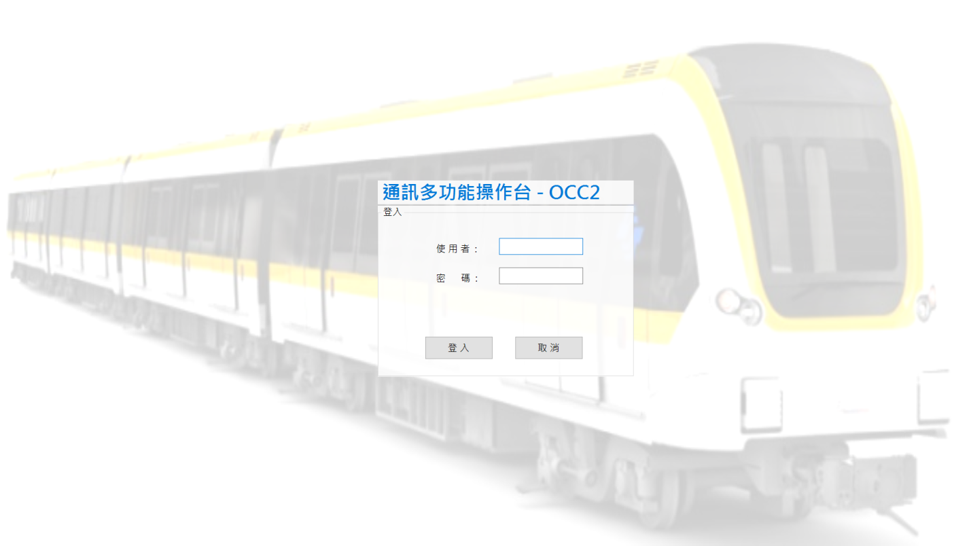

圖 3‑1: CMFT啟動登錄使用者

Figure 3‑1: Auto-start OCC CMFT login page

### 帳號與密碼驗證 ID and Passward Verification

第一次登入或者密碼已經使用超過三個月必須進行密碼修改，入帳號密碼後將出現如下畫面。

If that is the first login or password has been used for more than three months , the password must be modified again.after enter the account password, the following screen will appear for altering the password.

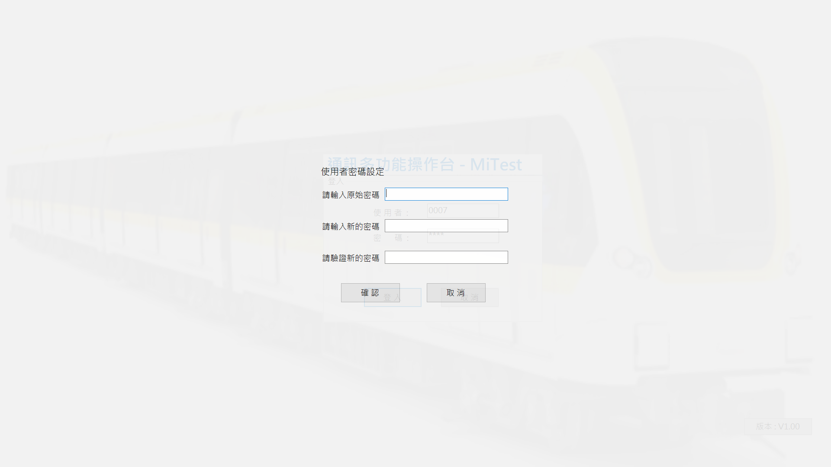

圖 3‑2: CMFT密碼更新

Figure 3‑2: CMFT Password Updateing

### 密碼設定規則Password setting rule

1. 系統中需要規定每三個月必須強制換一次密碼,於三個月期間使用者可自由更換密碼，更換密碼後將重新計算三個月強制更換密碼區間,修改後的密碼不可與前次密碼相同。
2. 密碼內需包含英文大小寫、數字、空格、以及特殊字元，密碼長度需於限制8碼(含)以上16碼以下。
3. The system needs to be specified every three months must be forced to change a password, during the three months the user can freely change the password, the password will be re-calculated after three months to replace the password interval, the modified password can not be with the former The same password is the same.
4. password needs to include English capitalization, numbers, spaces, and special characters, the password length to be limited to 8 yards (inclusive) above 16 yards.

### 驗證成功 Verification is successful

登入並經認證通過後,CMFT會自行啟動並以預設樣板進行即時監控功能, 畫面配置如圖 3‑3。

CMFT system will be start and run real-time surveillance function use default model when login and get certification success, the screen as shown as Figure 3‑3.

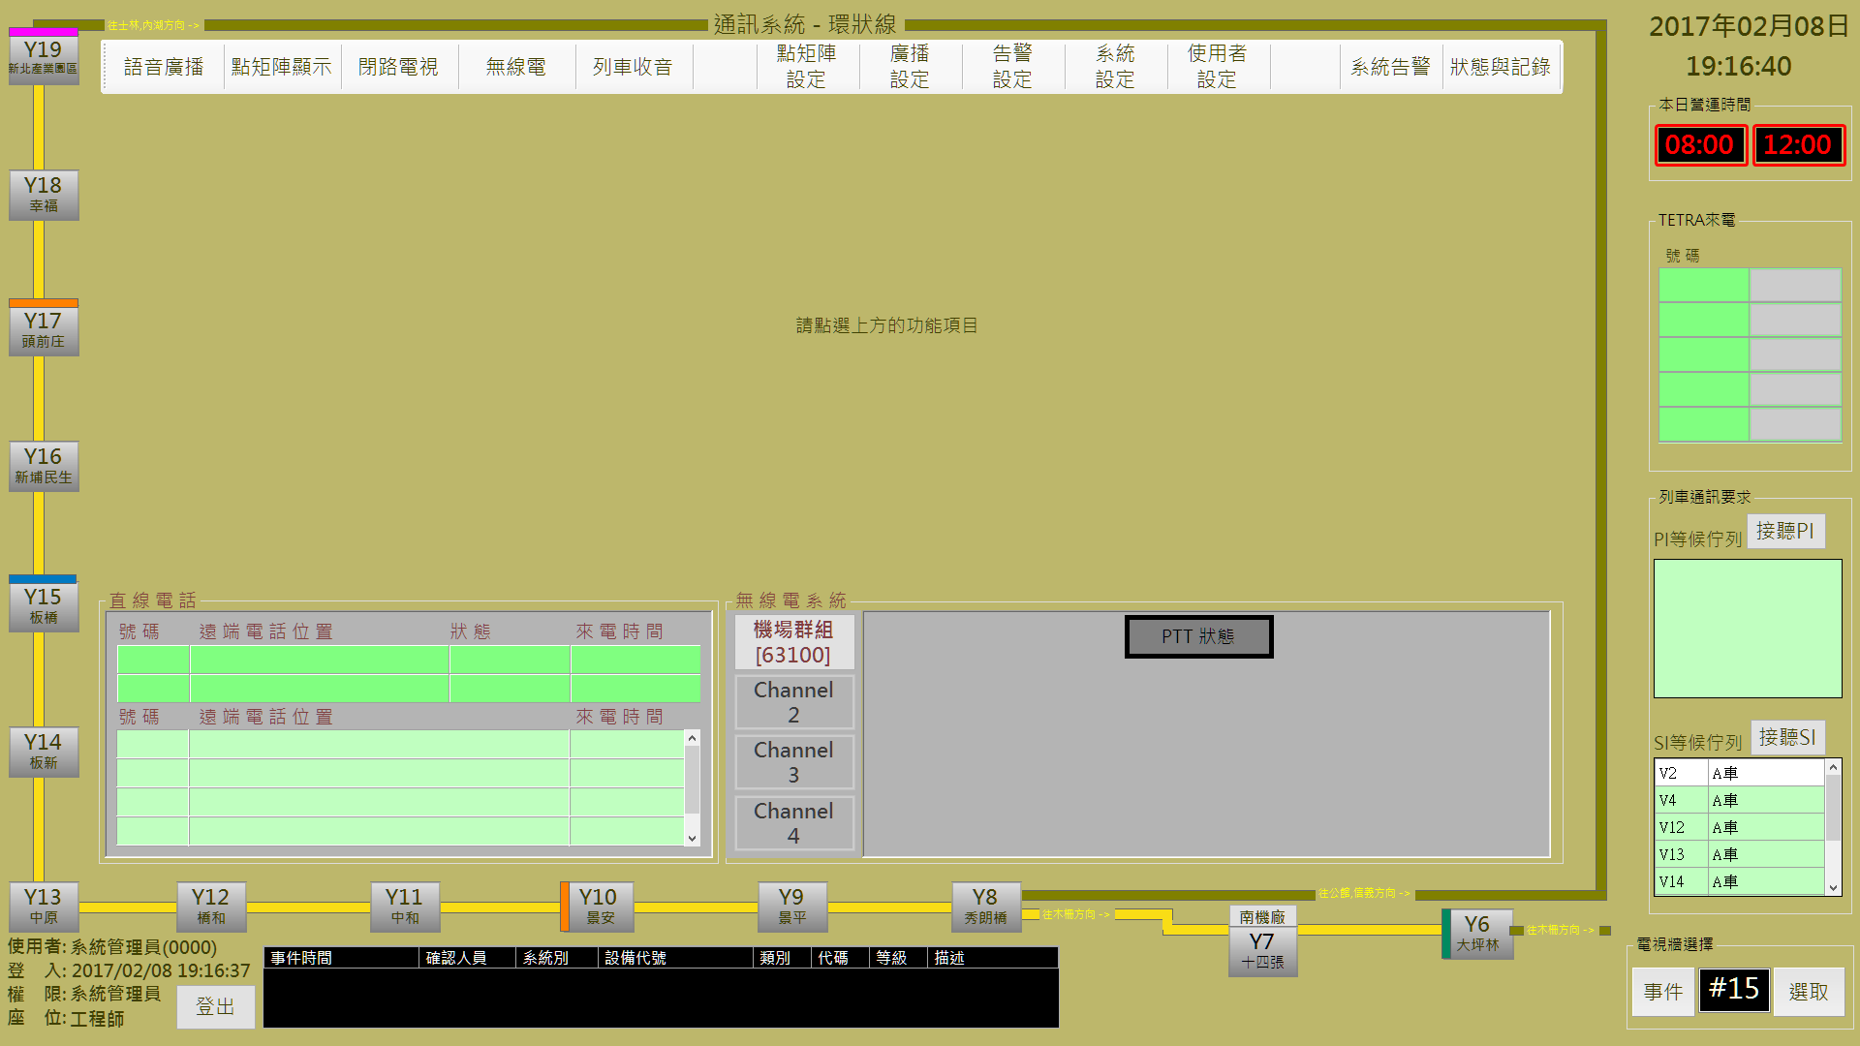

圖 3‑3: CMFT操作介面分割

Figure 3‑3: CMFT operation interface blocks

CMFT操作介面分為幾個部份如表 3‑1(詳細內容會於後續各章節內介紹)：

CMFT had been separated into several operation prats, list as Table 3‑1 (The detail operation descriptions will be introduced in the continuous pages):

|  |  |
| --- | --- |
| 編號  No. | 作業區塊名稱  Operation Area Name |
| 1 | 功能列區  Function Bar Area |
| 2 | 主要操作區  Main Operation Area |
| 3 | DMD顯示時間 (節能目的)  DMD Working Time (for power save purpose) |
| 4 | 待接無線電區  TETRA Income list area |
| 5 | 直線電話事件記錄區  DLT Events Logs Area |
| 6 | 無線電/語音頻道狀態區  Radio/Audio Channel Status Area. |
| 7 | 無線電/語音頻道明細區  Radio/Audio Channel Detail Area. |
| 8 | 車站及列車營運路線指引  Stations and Train Line Driection. |
| 9 | 即時警報區  Real-time Alarm Block |
| 10 | CCTV調播區  CCTV File Playback Option List |
| 11 | 登出按鍵  Logout button |

表 3‑1: CMFT頁面作業區塊一覽表

Table 3‑1: CMFT operation block description

## 功能列Function Bar

功能列提供各種功能設定及操作的快速切換,各項功能如表 3‑2所述。

Function Bar provides switch in each function setting and operation quickly. The function and setting has been described as **Error! Reference source not found.**



|  |  |  |
| --- | --- | --- |
| 編號  No. | 作業名稱  Function Name | 功能簡介  Function Description |
| 1 | 狀態與記錄  Console status and logs monitoring. | 提供主控台操作記錄及目前狀態資訊  Provide the console status and process logs information. |
| 2 | 系統告警  System alarm logs monitoring | 提供警報記錄查詢並進行處理回應  Provide the system alarm logs and process. |
| 3 | 使用者設定  Console users setup | 提供系統使用人員及工作站管制設定  Provide the system user and work station management setup. |
| 4 | 系統設定  Basic system setup | 提供相關系統參數設定及/或內容排程建立  Provide the related sub-system parameters setup and/or build the basic contents and default schedule. |
| 5 | 告警設定  Alarm define setup | 提供警報層級及顯示模式設定  Provide the alarm level and display mode setup. |
| 6 | 廣播設定  PA program assign | 提供建立廣播內容功能  Provide function to build the broadcast contents |
| 7 | 點矩陣設定  DMD program assign | 提供DMD顯示內容建立及排程設定功能  Provide the functions of building DMD display contents and schedule setup. |
| 8 | 列車收音  Voice monitoring of passenger movement | 提供列車收音錄音功能  Provide record function for the voice monitoring of passenger movement. |
| 9 | 無線電  TETRA communication | 開啟/關閉無線通訊頻道，建立無線電即時通訊功能  Open/Close the TETRA channel for real-time communications. |
| 10 | 閉路電視  CCTV monitor control | 開啟/關閉CCTV記錄檔案，進行即時影像監控  Open/Close CCTV file for real-time image monitoring. |
| 11 | 點矩陣顯示  DMD display control | 建立/變更DMD 即時顯示內容  Build/Change the DMD scheduled contents for real-time display. |
| 12 | 語音廣播  PA broadcast control | 建立/變更廣播即時播放內容  Build/Change the PA scheduled contents for real-time broadcast. |

表 3‑2: 系統功能列說明

Table 3‑2: Function Bar description

### 主控台狀態與記錄操作說明Console status and Logs monitoring

本作業含主控台**狀態顯示**及**操作記錄**查詢兩個次功能.

This operation including **Console Status Information** and **Operation Logs Information** two sub-functions.

#### 主控台狀態資訊查詢Console Status Information Query

進入本作業畫面預設為**主控台狀態資訊**資料頁 (如圖 3‑4)；內容會顯示各主控台所屬的控制設備及管制人員資訊

Enter this function, the default display is **Console Status Information** page (as Figure 3‑4). Assignment shows the control member and communication equipments imformation for every console station..

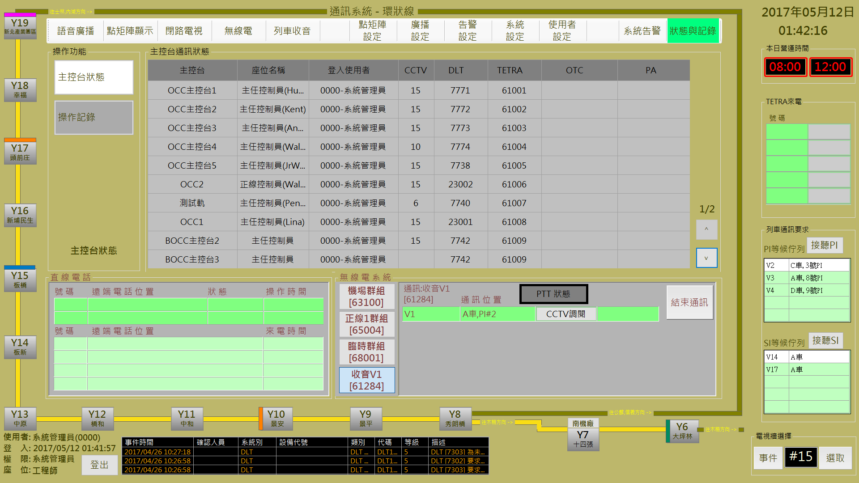

圖 3‑4: 主控台狀態資訊顯示

Figure 3‑4: Console status information display

#### 系統操作記錄查詢System Operation Logs Information Query

操作人員可以隨時切換為顯示**操作記錄資訊**資料頁面 (如圖 3‑5)

Operator can switch to show the **Operation Logs Information** page (as Figure 3‑5) any time.

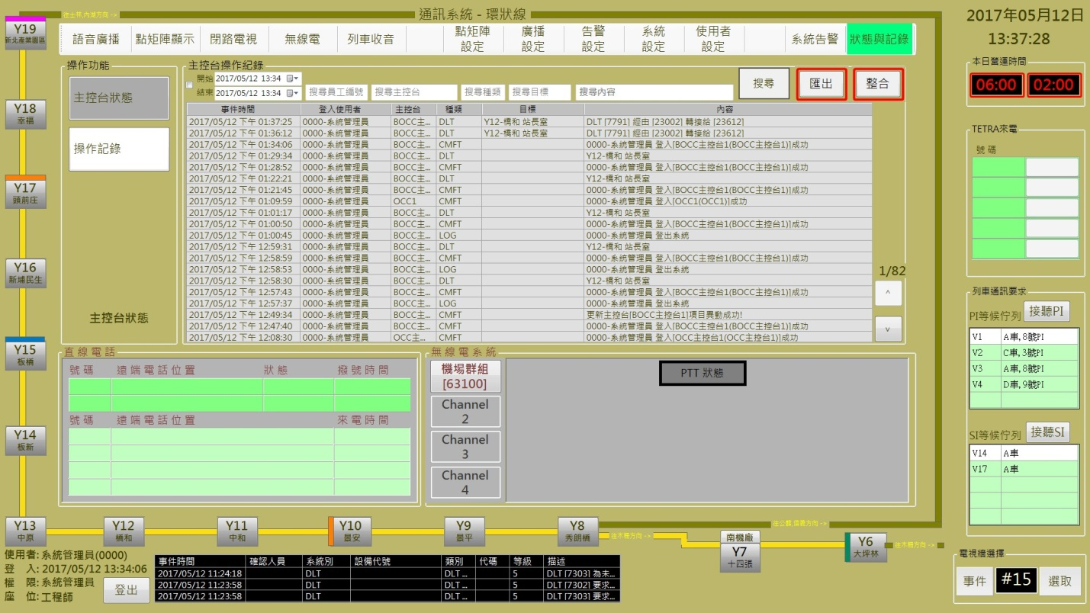

圖 3‑5: 主控台操作記錄顯示

Figure 3‑5: Console operation logs display

操作人員可以透過 “**匯出**” 或者是 “**整合**” 功能進行頁面資料匯出並轉存為 csv格式的檔案，以利後續資料處理。

Operator can export the logs and transfer to csv type file for the continuous process through click the “**匯出**” (Export) or “**整合**” (Integrate) button.

操作人員也可以透過 “**搜尋**” (Search) 功能進行特定記錄查詢。系統提供依**時間區間**、**操作人員**、**機台編號**、**作業類別**、**目標說明**及**作業內容**為查詢條件進行資料查詢.

Operator can using the “**搜尋**” function to find the specified logs. System provides to use **log time period**, **stuff No**., **console station No**., **log type**, **target description** and **log contents** as the search conditions.

### 系統告警System Alarm Logs monitorin

本作業主要是提供主控台人員查看系統警報處理狀況並進行必要的處理及回應 (如圖 3‑6):

This function is used to monitor system alarm logs and do the necessary process. (as Figure 3‑6).

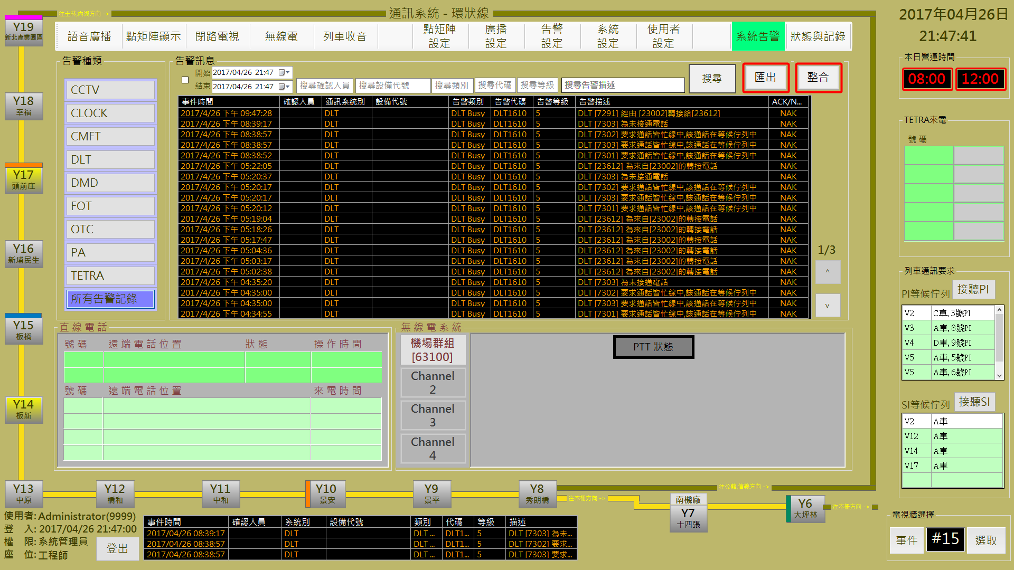

圖 3‑6: 警報記錄查詢處理作業

Figure 3‑6: Alarm Logs monitor and process mode

進入本作業，系統預設是調取當日所有的告警記錄，操作人員可以透過左方列出的告警種類列表直接指定查詢特定類別警報記錄。

Enter this assignment, system will show all alarm logs in current date as default range. Operator can directly specify the alarm type list in left side to show the specified alarm type logs.

主控台人員可以由顯示資料的最後一欄 (ACK/NAK欄) 知道該警報是否已交辦處理 (ACK表示已處理，NAK表示未處理)。如果是尚未處理 (NAK) 的警報，於交辦處理後，可變更該警報的處理狀態為已處理 (ACK)

Operator can know the specified alarm process status from the last field (field “ACK/NAK”, “ACK”means alarm had been processed, “NAK”means not yet). After the specified alarm had processed, operator can change the “NAK”status to “ACK”status.

於本作業內, 操作人員可以透過 “**匯出**” 或者是 “**整合**” 功能進行頁面資料匯出並轉存為 csv格式的檔案，以利後續資料處理。

In this draw, operator can export the alarm logs and transfer to csv type file for the continuous process through click the “**匯出**” (Export) or “**整合**” (Integrate) button.

操作人員也可以透過 “**搜尋**” 功能進行特定記錄查詢。系統提供依**時間區間**、**操作人員**、**設備編號**、**警報類別**、**警報代碼**、**警報等級**及**警報內容**為查詢條件進行資料查詢.

Operator can using the “**搜尋**” (Search) function to find the specified logs. System provides to use **log time period**, **stuff No**., **equipment No**., **alarm type**, **alarm code, alarm level** and **alarm contents** as the search conditions.

### 使用者設定Console users Setup

本作業主要是提供主控台人員帳號管理作業，本作業分為**使用者群組**管理（預設作業）、**使用者帳號**管理及**使用者密碼**管理三個項目。

This assignment is used to manage user account. It include three items: **User Group** management, **User Account** management and **User Password** management.

#### 使用者群組管理User Group management

進入本功能預設作業項目是**使用者群組**管理作業 (如圖 3‑7) 。主要功能是建立/刪除人員群組並依人員群組設定/變更本系統的可操作作業項目。 操作人員可透過**群組名稱**下方的 “**+群組名稱**” 按鈕來建立新群組名稱，“**確認**” 按鈕是用來儲存設定值；“**取消**” 按鈕則是復原設定值；“**刪除**” 按鈕則是用來刪除指定群組。

Enter this function, default assignment is **User Group Management** (as Figure 3‑7)**.** This assignment is used to create/delete user group and assign the operation functions. Operator can use the “**+群組名稱**” (Add Group Name) button at the “**群組名稱**” (Group Name) field bottom to build a new group and assign the allowed funtions. “**確認**” (Confirm) button can store the setup result. “**取消**” (Cancel) button can recover the original setup value. “**刪除**” (Delete) button is used to delete a specified group name.

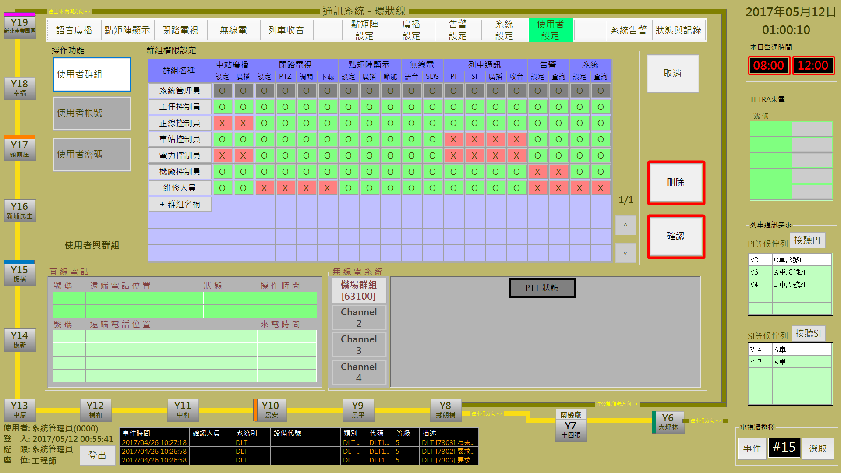

圖 3‑7: 使用者群組管理作業

Figure 3‑7: User group management assignment

#### 使用者帳號管理User account management

**使用者帳號**管理作業 (如圖 3‑8) 主要是用來建立/刪除人員帳號並設定/變更人員群組歸屬。 操作人員可透過**群組成員**區塊內的**系統編號**欄位下方的 “**+群組成員**” 按鈕來建立使用者帳號，“**確認**” 按鈕是用來儲存設定值；“**取消**” 按鈕則是復原設定值；“**刪除**” 按鈕則是用來刪除指定帳號。

**User Account Management** assignment (as Figure 3‑8)is used to create/delete user account and assign the use group. Operator can use the “**+群組成員**” (Add Group member) button at the “**系統編號**” (System No.) field in “**群組成員**” (Group Member) block to build a new user and assign user group. “**確認**” (Confirm) button can store the setup result. “**取消**” (Cancel) button can recover the original setup value. “**刪除**” (Delete) button is used to delete a specified user account.

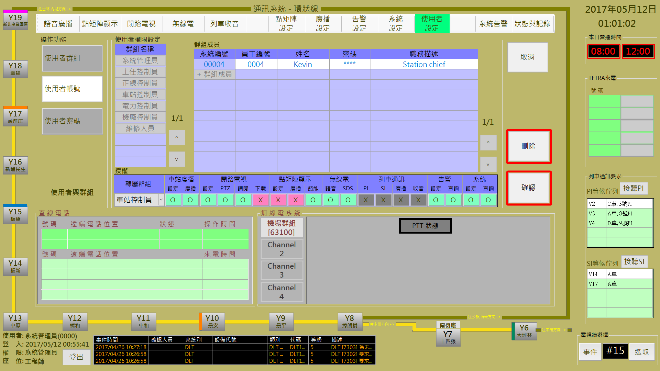

圖 3‑8: 使用者帳號管理作業

Figure 3‑8: User account management assignment

#### 使用者密碼管理User password management

**使用者密碼**管理作業 (如圖 3‑9) 主要是用來建立/變更人員帳號密碼。 操作人員需輸入一次舊密碼以驗證身份，新密碼需經由兩次的輸入驗證並確認儲存才算完成操作。“**確認**” 按鈕是用來儲存新密碼；“**取消**” 按鈕則會清空所有的輸入欄位。

**User Password Management** assignment (as Figure 3‑9)is used to setup/change user password. Operator need to input the old password once for certification, two times new password verify and click “**確認**” (Confirm) button to store then can finish this function. “**確認**” (Confirm) button will store the new password. “**取消**” (Cancel) button will clear all the input fields

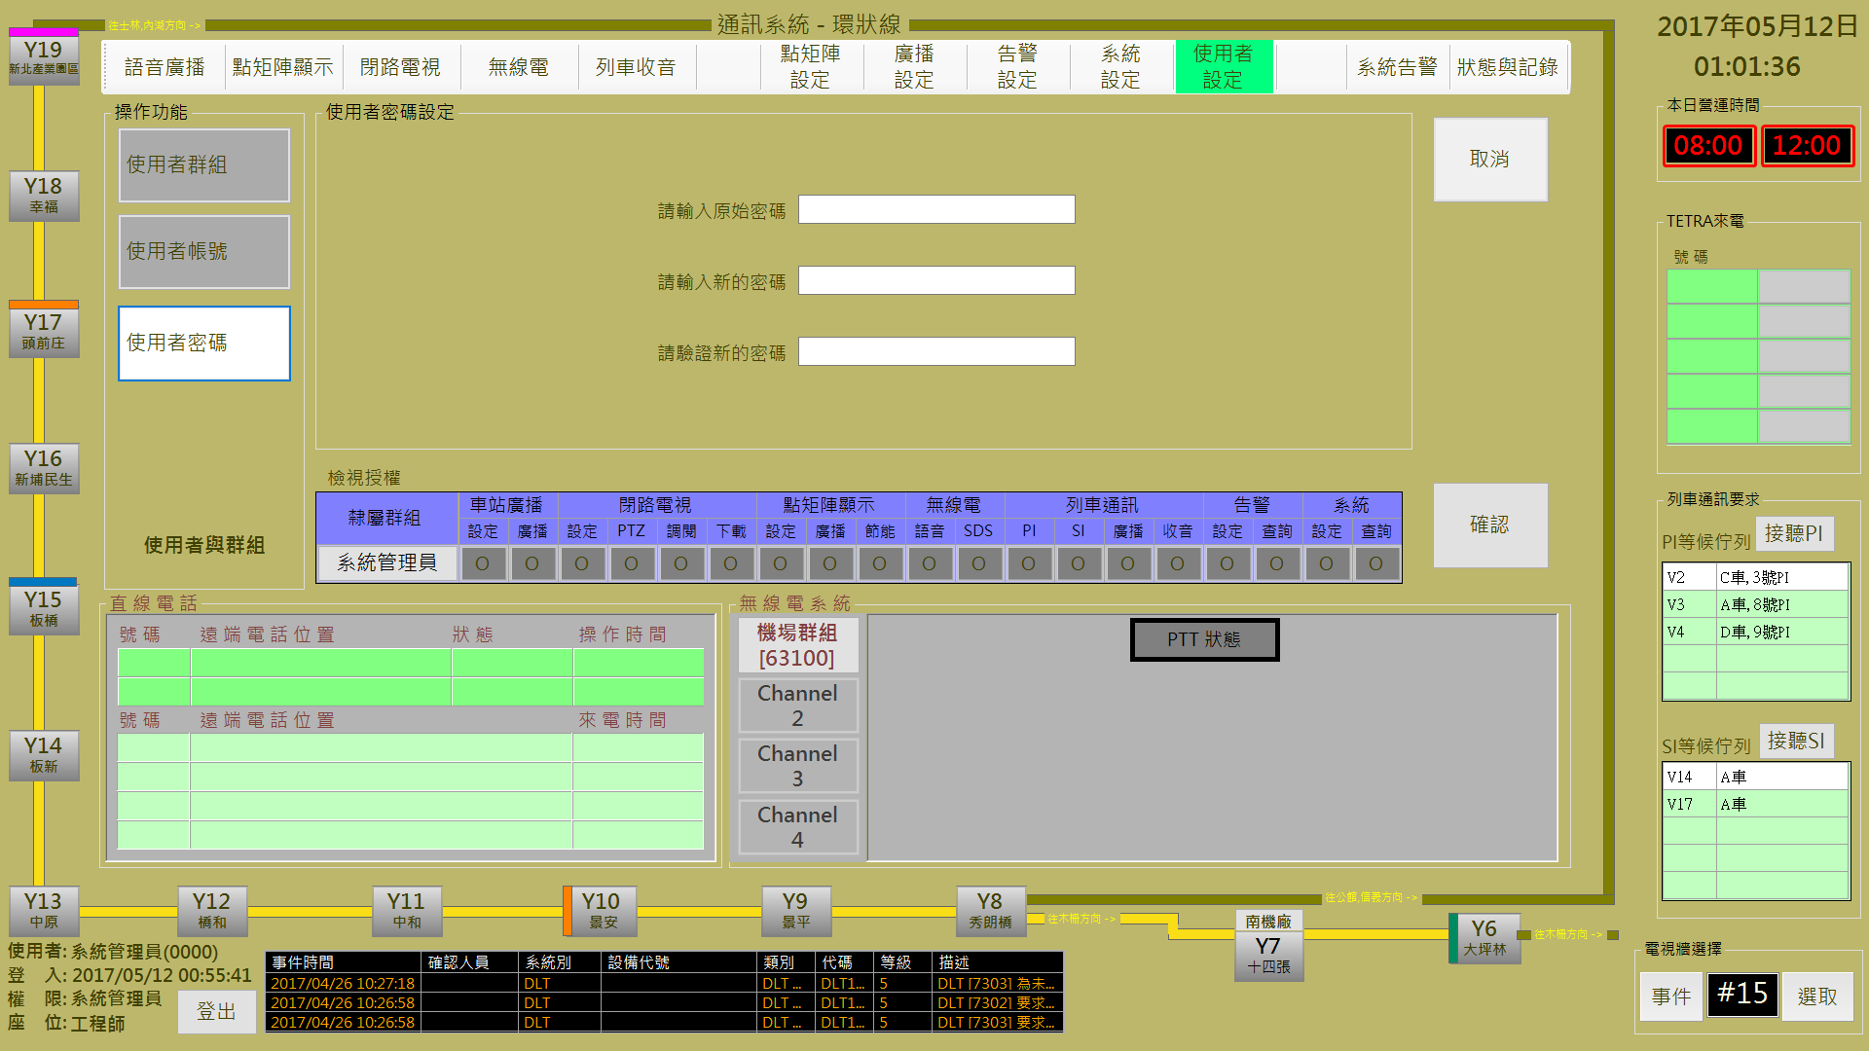

圖 3‑9: 使用者密碼設定作業

Figure 3‑9: User password setup assignment

### 系統設定Basic System setup

本作業主要是建立/調整相關系統的基本設定資料，含**主控台設定**、**列車語音通訊**設定、**群組與電話簿**設定及**不雅字設定**四個項目，預設作業是**主控台設定**作業。

This function is used to build/update the related sub-system basic reference data. It include **Console Station Setup**, **Voice Communication in Cars Setup**,  **Group and DLT Book Setup** and **Denied Bad Words Setup** four items.Default assignment is **Console Station Setup** process.

#### 主控台設定Console Station setup

主控台設定作業內含兩個項目: **主控台配置**管理作業及**主控台功能**管理作業，預設作業是主控台配置管理。

Console Station Setup assignment include two sub-function: **Console Station Equipment Allocate** management and **Console Station Function Setup** function.

##### 主控台配置管理作業Console Station Equipment Allocate function

進入主控台設定作業，預設作業項目是主控台配置管理作業。

Enter Console Station Setup assignment, the default operation item is the Console Station Equipment Allocate process.

主控台配置管理作業主要是建立主控台、使用者及其所能控制的設備 (主控台工作站固定IP及使用者，電視牆的閉路電視編號，直線電話號碼及無線電代號) 資訊設定作業(如圖 3‑10)。

Console Station Equipment Allocate Magagement is used to build console station and its specified user, setup the equipment information under the console station controlled (such as the station fixed IP/user account, CCTV No.of TV wall,DLT No. and TETRA No. as Figure 3‑10).

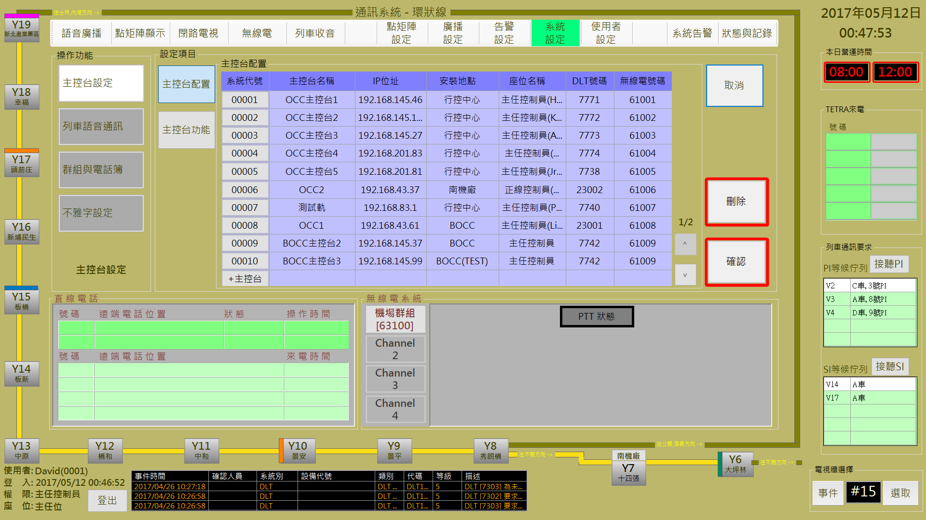

圖 3‑10: 主控台配置作業

Figure 3‑10: Console Station Equipment Allocate function

操作人員可透過**主控台配置**區塊內的**系統代號**欄位下方的 “**+主控台**” 按鈕來建立主控台及其相關資訊，或直接選取主控台進行相關資訊修改。“**確認**” 按鈕是用來儲存設定值；“**取消**” 按鈕則是復原設定值；“**刪除**” 按鈕則是用來刪除指定帳號。

**User Account Management** assignment (as Figure 3‑8)is used to create/delete user account and assign the use group. Operator can use the “**+主控台**” (Add Console) button at the “**系統代號**” (System No.) field in “**主控台配置**” (Console Allocate) block to build a new console and setup the related information. Operator can also select the listed console to update the related information. “**確認**” (Confirm) button can store the setup result. “**取消**” (Cancel) button can recover the original setup value. “**刪除**” (Delete) button is used to delete a specified user account.

圖 3‑10畫面必須具有管理者權限的帳號才能進行修正。主控台的權限認證透過將透過網路位址來驗證，所有的電腦必須註冊其網路位址，才能登入CMFT軟體，圖 3‑10中的IP位址顯示得即為已被認證的IP，管理者可以在此畫面修改驗證的IP。

You must have an account with administrator privileges to correct the screen in Figure 3‑10. The authority of the console will be verified through the network address, all the computer must register its network address, in order to log in CMFT software, Figure 3‑10 in the IP address that is certified IP, management can modify the verified IP on this screen.

##### 主控台功能設定作業Console Function Setup function

主控台功能設定作業主要是設定主控台可操作的作業項目 (如圖 3‑11)。

Console Function Setup Function is used to set the function items for console station as Figure 3‑11).

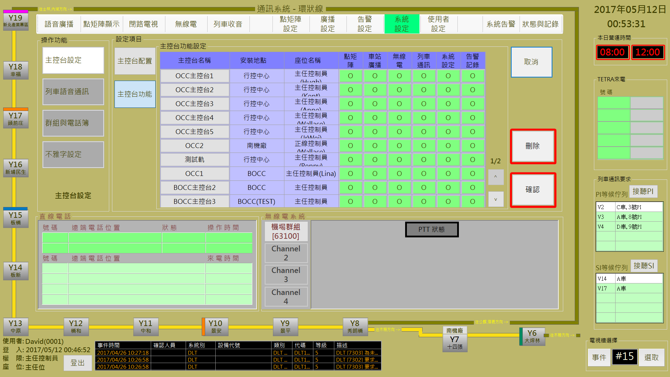

圖 3‑11: 主控台功能設定作業

Figure 3‑11: Console Station Function Setup function

操作人員可直接選取主控台右側功能項目點擊變更相關設定。“**確認**” 按鈕是用來儲存設定值；“**取消**” 按鈕則是復原設定值；“**刪除**” 按鈕則是用來刪除指定帳號。

Operator can directly select the function item in the right side of console to click to change the setup value. “**確認**” (Confirm) button can store the setup result. “**取消**” (Cancel) button can recover the original setup value. “**刪除**” (Delete) button is used to delete a specified user account.

#### 列車語音通訊設定Voice Communication In Cars Setup

列車語音通訊設定作業主要是設定主控台可控制的車上語音通訊的列車行駛區間(如圖 3‑12)。

Voice Communication In Cars Setup assignment is used to set the station segments control right with OTC function of console station (as Figure 3‑12).

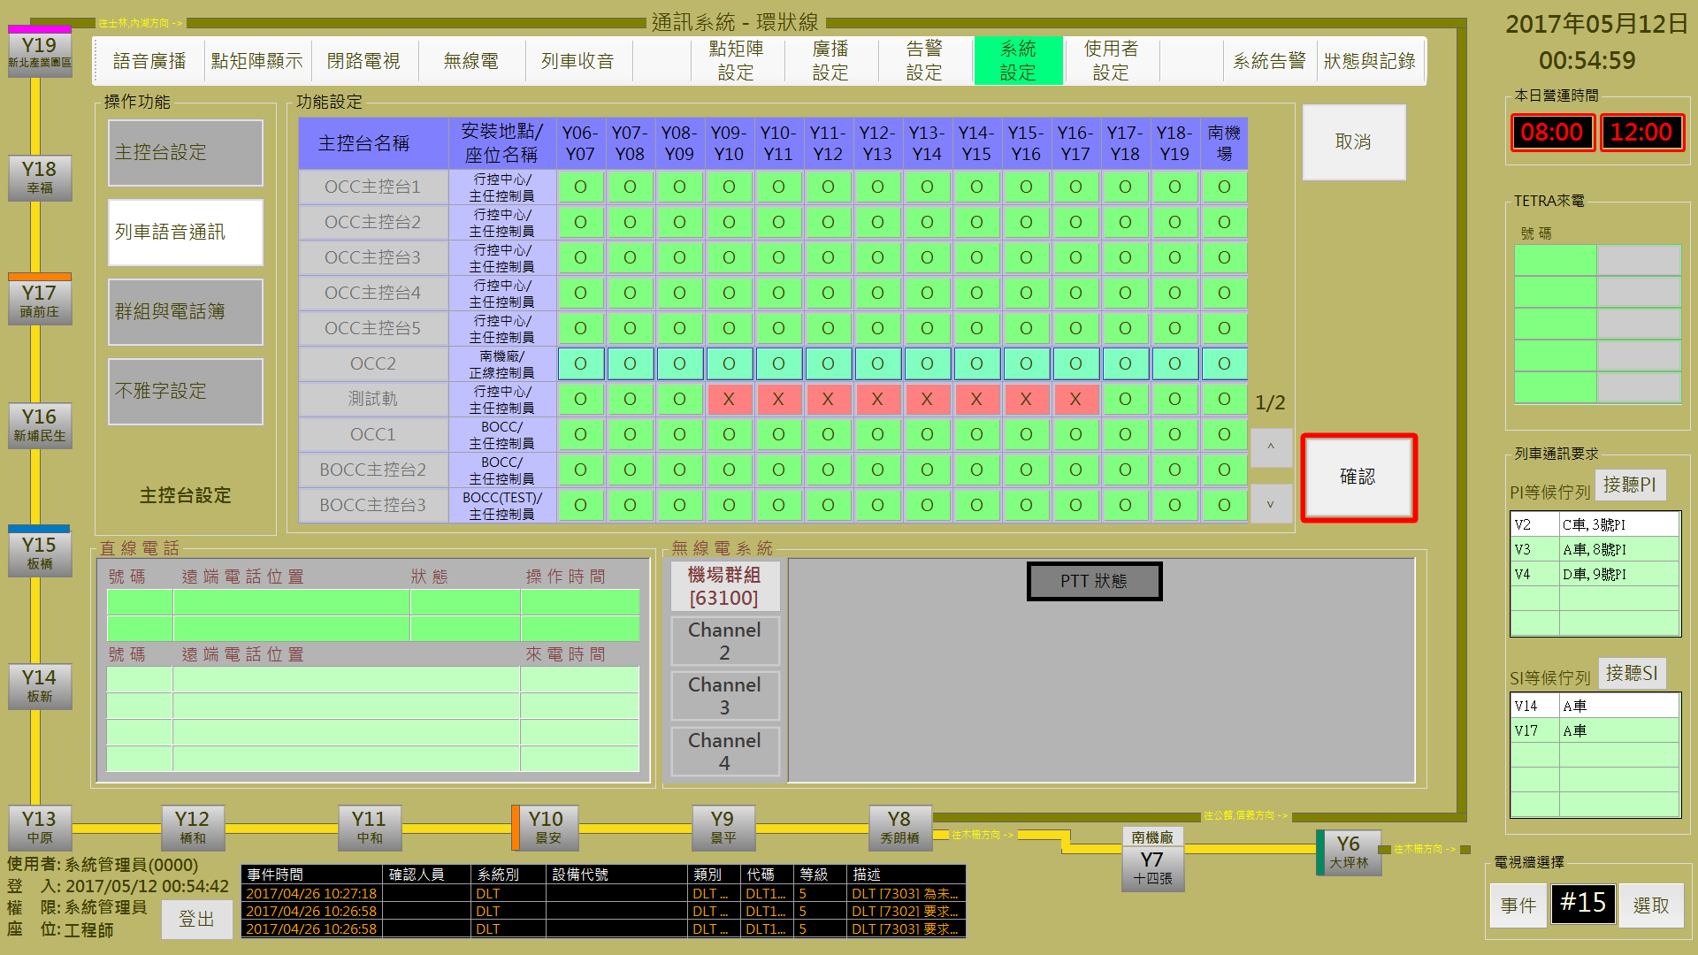

圖 3‑12: 列車語音通訊設定作業

Figure 3‑12: Console Station Function Setup function

操作人員可直接選取主控台右側的車站區間點擊變更設定。“**確認**” 按鈕是用來儲存設定值；“**取消**” 按鈕則是復原設定值；“**刪除**” 按鈕則是用來刪除指定帳號。

Operator can directly select the station segment in the right side of console to click to change the setup value. “**確認**” (Confirm) button can store the setup result. “**取消**” (Cancel) button can recover the original setup value.

#### 群組與電話簿設定 Group and DLT Book Setup

群組與電話簿設定作業含**車站群組**設定、**列車群組**設定、**無線電群組**設定、**直線電話簿**及**攝影機群組**設定五個作業項目。

Group and DLT Book Setup assignment includes **Station Group** setup, **Car Group** setup, **TETRA Group** setup, **DLT Book** setup and **Camera Group** setup 5 items.

##### 車站群組設定 Station Group setup

車站群組設定主要是建立/管理車站群組的處理作業 (如圖 3‑13)。

Station Group Setup assignment is used to build/manage station groups (as Figure 3‑13).

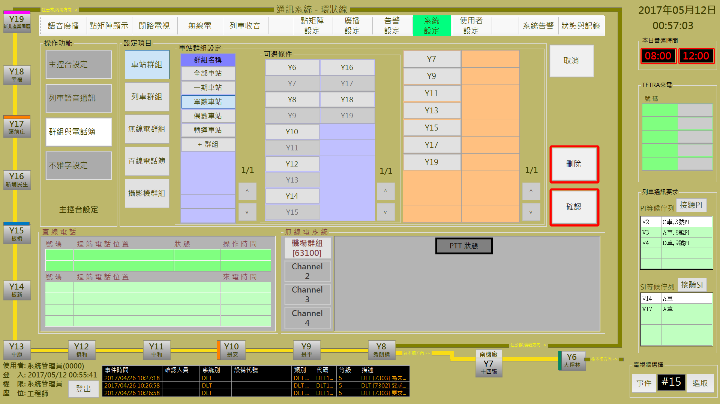

圖 3‑13: 車站群組設定作業

Figure 3‑13: Station Group Setup function

操作人員可透過**車站群組設定**區塊內的**群組名稱**欄位下方的 “**+群組**” 按鈕來建立新的車站群組並選取可用條件 (車站) 以建立新群組內容。或直接選取既有車站群組進行群組內容的修改。“**確認**” 按鈕是用來儲存設定值；“**取消**” 按鈕則是復原設定值；“**刪除**” 按鈕則是用來刪除指定群組。

Operator can use the “**+群組**” (Add Group) button at the “**群組名稱**” (Group Name) field in “**車站群組設定**” (Station Group Setup) block to build a new station group and select the group member (Station). Operator can also select the listed station group to change member. “**確認**” (Confirm) button can store the setup result. “**取消**” (Cancel) button can recover the original setup value. “**刪除**” (Delete) button is used to delete a specified station group.

##### 列車群組設定 Car Group setup

列車群組設定主要是建立/管理列車群組的處理作業 (如圖 3‑14)。

Car Group setup assignment is used to build/manage car groups (as Figure 3‑14).

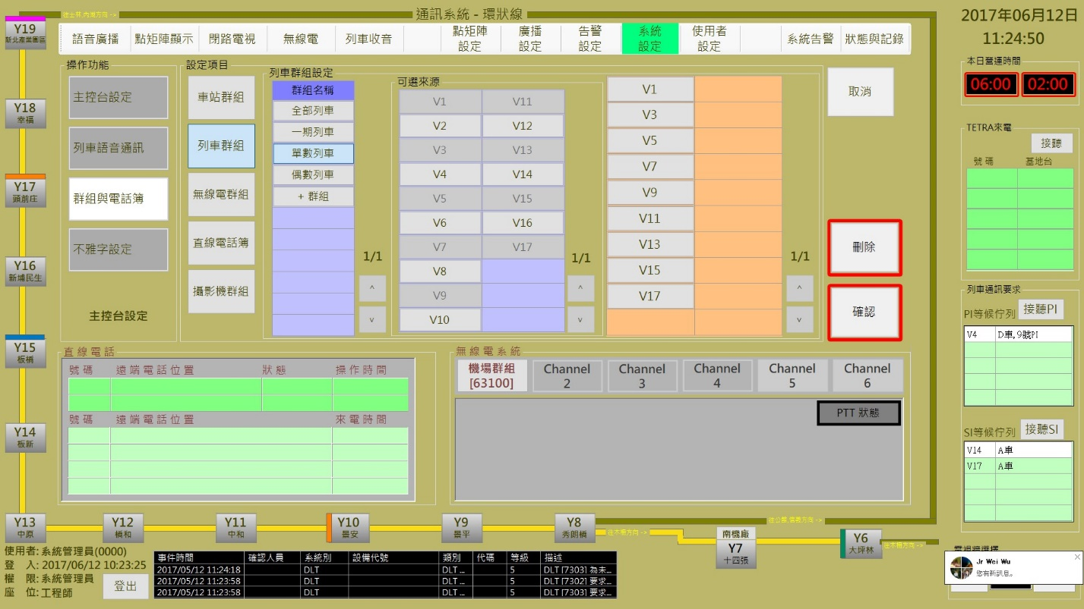

圖 3‑14: 列車群組設定作業

Figure 3‑14: Car Group Setup function

操作人員可透過**列車群組設定**區塊內的**群組名稱**欄位下方的 “**+群組**” 按鈕來建立新的列車群組並選取可用條件 (車號) 以建立新群組內容。或直接選取既有列車群組進行群組內容的修改。“**確認**” 按鈕是用來儲存設定值；“**取消**” 按鈕則是復原設定值；“**刪除**” 按鈕則是用來刪除指定群組。

Operator can use the “**+群組**” (Add Group) button at the “**群組名稱**” (Group Name) field in “**列車群組設定**” (Car Group Setup) block to build a new station group and select the group member (Car). Operator can also select the listed car group to change member. “**確認**” (Confirm) button can store the setup result. “**取消**” (Cancel) button can recover the original setup value. “**刪除**” (Delete) button is used to delete a specified car group.

##### 無線電群組設定 TETRA Group setup

無線電群組設定主要是建立/管理無線電群組的處理作業 (如圖 3‑15)。

TETRA Group setup assignment is used to build/manage TETRA groups (as Figure 3‑15).

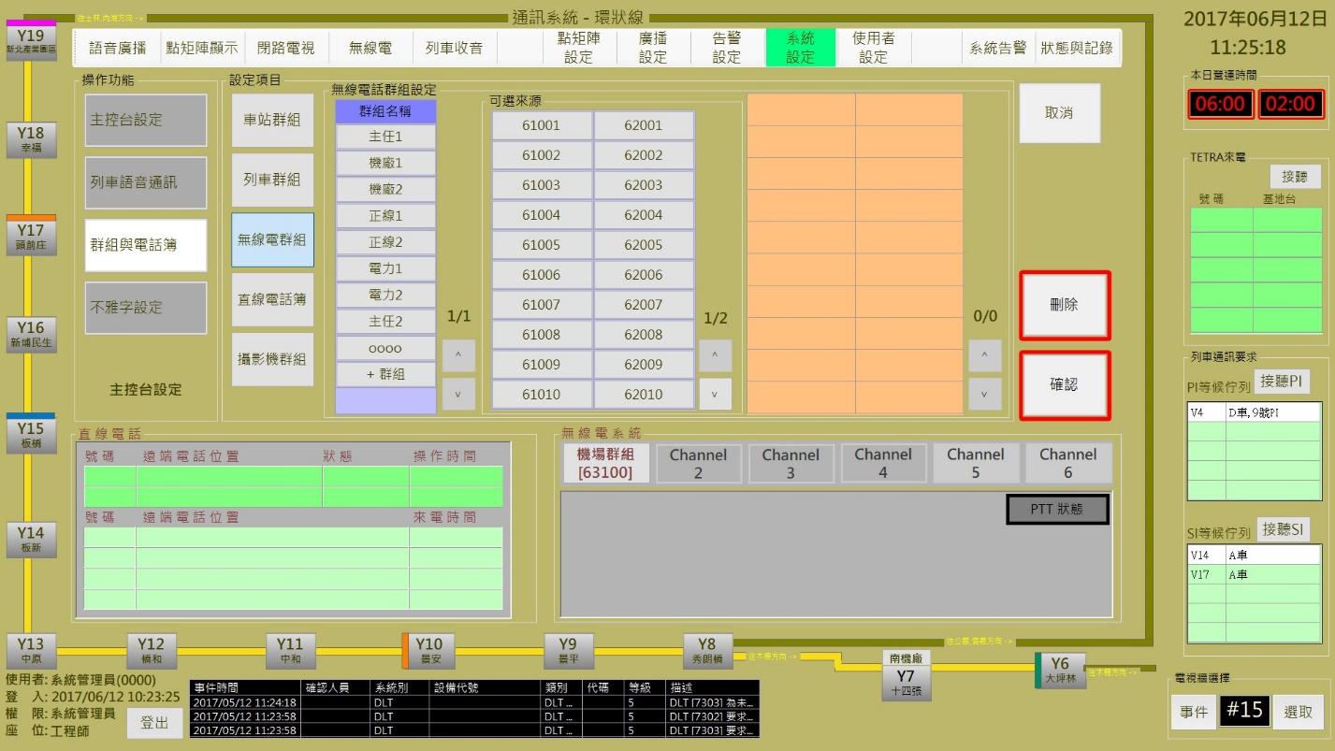

圖 3‑15: 無線電群組設定作業

Figure 3‑15: TETRA Group Setup function

操作人員可透過**無線電話群組設定**區塊內的**群組名稱**欄位下方的 “**+群組**” 按鈕來建立新的無線電群組並選取可用條件 (無線電話號碼) 以建立新群組內容。或直接選取既有無線電群組進行群組內容的修改。“**確認**” 按鈕是用來儲存設定值；“**取消**” 按鈕則是復原設定值；“**刪除**” 按鈕則是用來刪除指定群組。

Operator can use the “**+群組**” (Add Group) button at the “**群組名稱**” (Group Name) field in “**無線電話群組設定**” (TETRA Group Setup) block to build a new TETRA group and select the group member (Radio No.). Operator can also select the listed TETRA group to change member. “**確認**” (Confirm) button can store the setup result. “**取消**” (Cancel) button can recover the original setup value. “**刪除**” (Delete) button is used to delete a specified radio group.

##### 直線電話簿設定 DLT Book setup

直線電話簿設定主要是建立/管理 車站/機廠直線電話的處理作業 (如圖 3‑16)。

DLT Book setup assignment is used to build/manage the DLT list for station and depot (as Figure 3‑16).

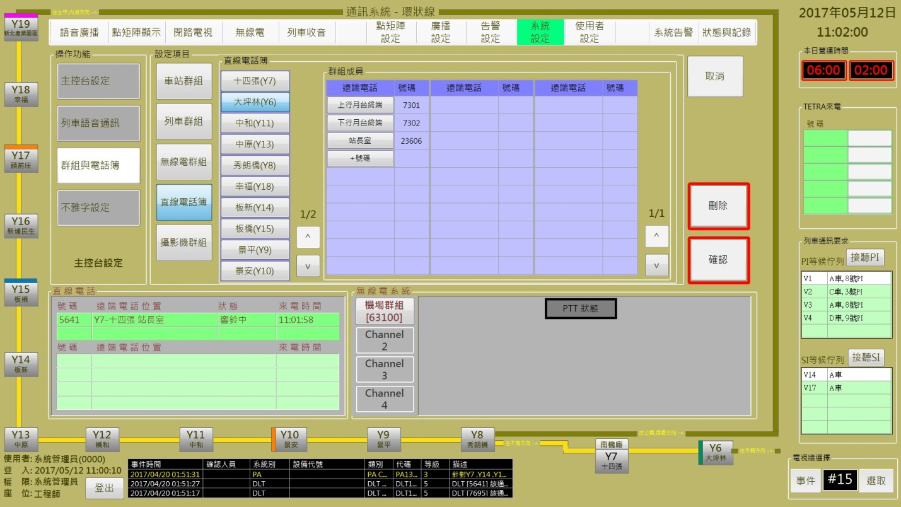

圖 3‑16: 直線電話簿設定作業

Figure 3‑16: DLT Book Setup function

操作人員選取車站或機場後，系統會列出已建立的直線電話分配記錄。操作人員可透過**群組成員**區塊內的**遠端電話**欄位下方的 “**+號碼**” 按鈕來建立新的直線電話位置。或直接選取既有位置修改號碼。“**確認**” 按鈕是用來儲存設定值；“**取消**” 按鈕則是復原設定值；“**刪除**” 按鈕則是用來刪除指定位置記錄。

Operator select the station/depot and system will show the existing list. Opeartor can use the “**+號碼**” (Add DLT No.) button at the “**遠端電話**” (Remote location) field in “**群組成員**” (Group member) block to build a new DLT No. Operator can also select the listed location to change DLT No.. “**確認**” (Confirm) button can store the setup result. “**取消**” (Cancel) button can recover the original setup value. “**刪除**” (Delete) button is used to delete a specified DLT location.

##### 攝影機群組設定 Camera Group setup

攝影機群組設定主要是建立/管理 電視牆的攝影機輪播群組樣本的設定作業 (如圖 3‑17)。

Camera Group setup assignment is used to build/manage the specified CCTV samples played bt turns on the TV wall (as Figure 3‑17).

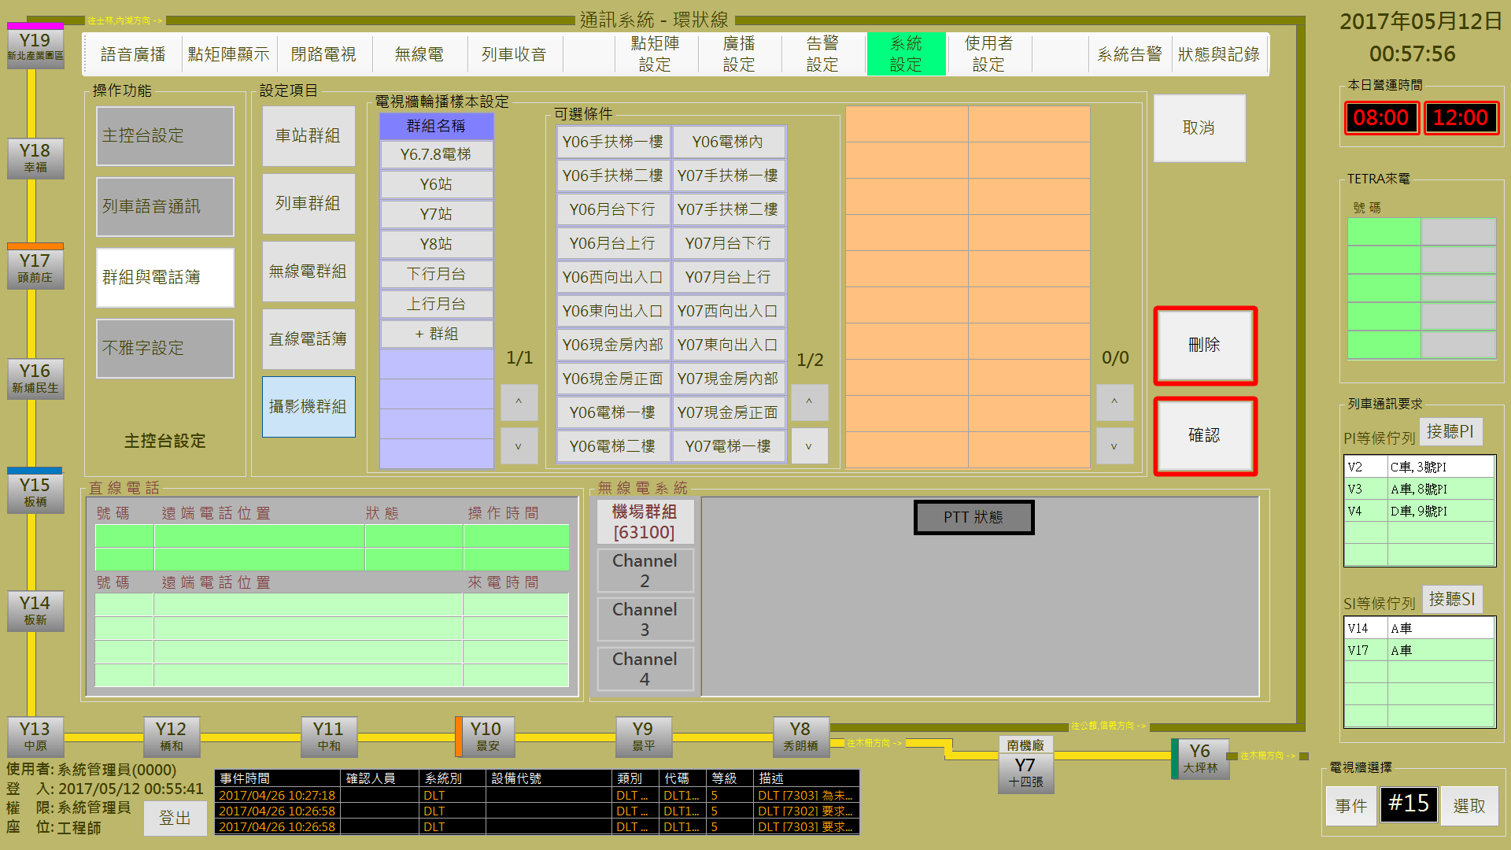

圖 3‑17: 攝影機群組設定作業

Figure 3‑17: Camera Goup Setup function

操作人員可透過**電視牆輪播樣本設定**區塊內的**群組名稱**欄位下方的 “**+群組**” 按鈕來建立新的攝影機輪播群組及其成員。或直接選取既有群組修改群組成員。“**確認**” 按鈕是用來儲存設定值；“**取消**” 按鈕則是復原設定值；“**刪除**” 按鈕則是用來刪除指定群組。

Opeartor can use the “**+群組**” (Add Group.) button at the “**群組名稱**” (Group Name) field in “**電視牆輪播樣本設定**” (Camera Group Played by Turns on TV Wall) block to build a new group and select the group member. Operator can also select the listed group to change its group member. “**確認**” (Confirm) button can store the setup result. “**取消**” (Cancel) button can recover the original setup value. “**刪除**” (Delete) button is used to delete a specified group.

#### 不雅字設定 Denied Bad Words Setup

不雅字設定主要是建立/管理DMD顯示內容的不雅字句排除項目的設定作業 (如 圖 3‑18)。

Denied Bad Words setup assignment is used to build/manage the denied words which can not show on the DMD. (as Figure 3‑18).

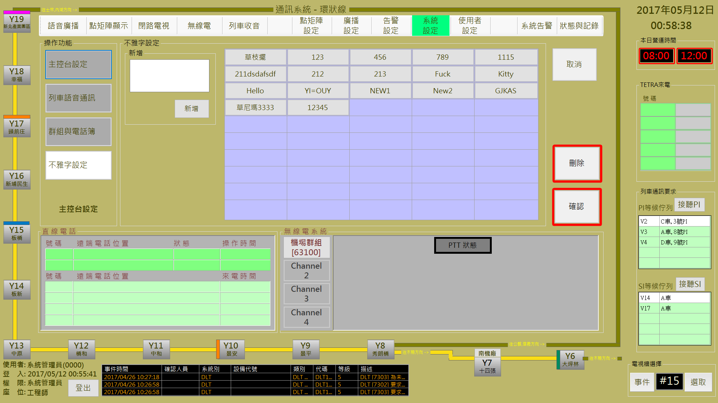

圖 3‑18: 不雅字設定作業

Figure 3‑18: Denied Bad Words Setup function

操作人員可透過**新增**區塊建立新的排除字句；如果要修改或刪除特定項目，直接點選該項目即可。“**確認**” 按鈕是用來儲存包含已修改項目及新加入的設定值；“**取消**” 按鈕則是復原初始設定值；“**刪除**” 按鈕則是用來刪除指定項目。

Opeartor can build a new words from the “**新增**” (Add New) block. If wnt to update or delete specified item(s), just click the item(s) and edit. “**確認**” (Confirm) button can store the final setup result include the new item(s) and the updated item(s). “**取消**” (Cancel) button can recover the initial setup items. “**刪除**” (Delete) button is used to delete all the specified item(s).

### 告警設定Alarm Setup

本作業含**告警等級定義**設定及**告警類型定義**設定兩個功能

This function include **alarm level define** and **alarm type define** two sub-functions

#### 告警等級定義Alarm Level Define

告警等級定義作業主要是提供操作人員依其習慣調整不同等級的警報顯示方式 (如圖 3‑19)。

Alarm level define assignment is used to adjust the display mode of different level alarm as operator used to monitor (as Figure 3‑19).

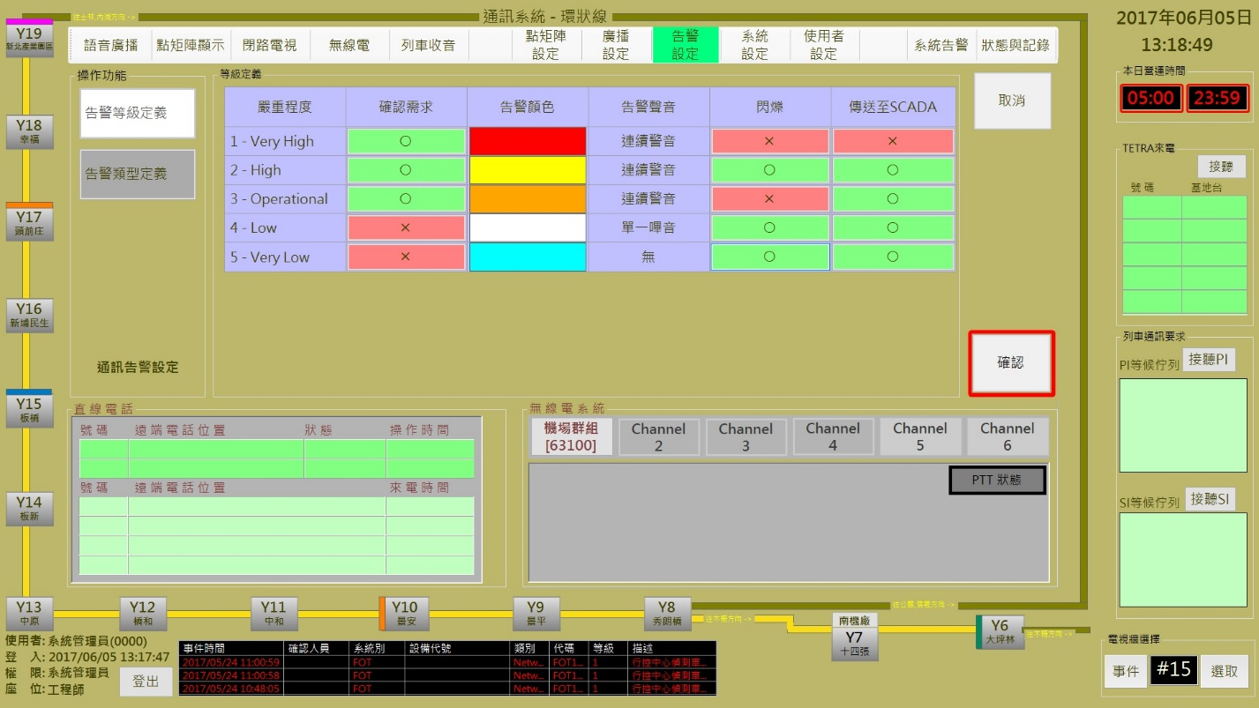

圖 3‑19: 告警等級定義設定作業

Figure 3‑19: Alarm Level Define setup assignment

CMFT 只有定義5個層級的警報，操作人員可直接修改設定。“**確認**” 按鈕是用來儲存包含已修改項目及新加入的設定值；“**取消**” 按鈕則是復原初始設定值。

There are only 5 alarm level used in CMFT system. Opeartor can directly change the display mode for different alarm level. “**確認**” (Confirm) button can store the final setup result. “**取消**” (Cancel) button can recover the original setup value.

#### 告警類型定義Alarm Type Define

告警類型定義設定作業主要是提供操作人員為相關次系統設備所發出的警報定義其警報等級 (如圖 3‑20)。

Alarm Type Define Setup assignment is used for operator to define the alarm level for each controlled sub-system equipment (as Figure 3‑20).

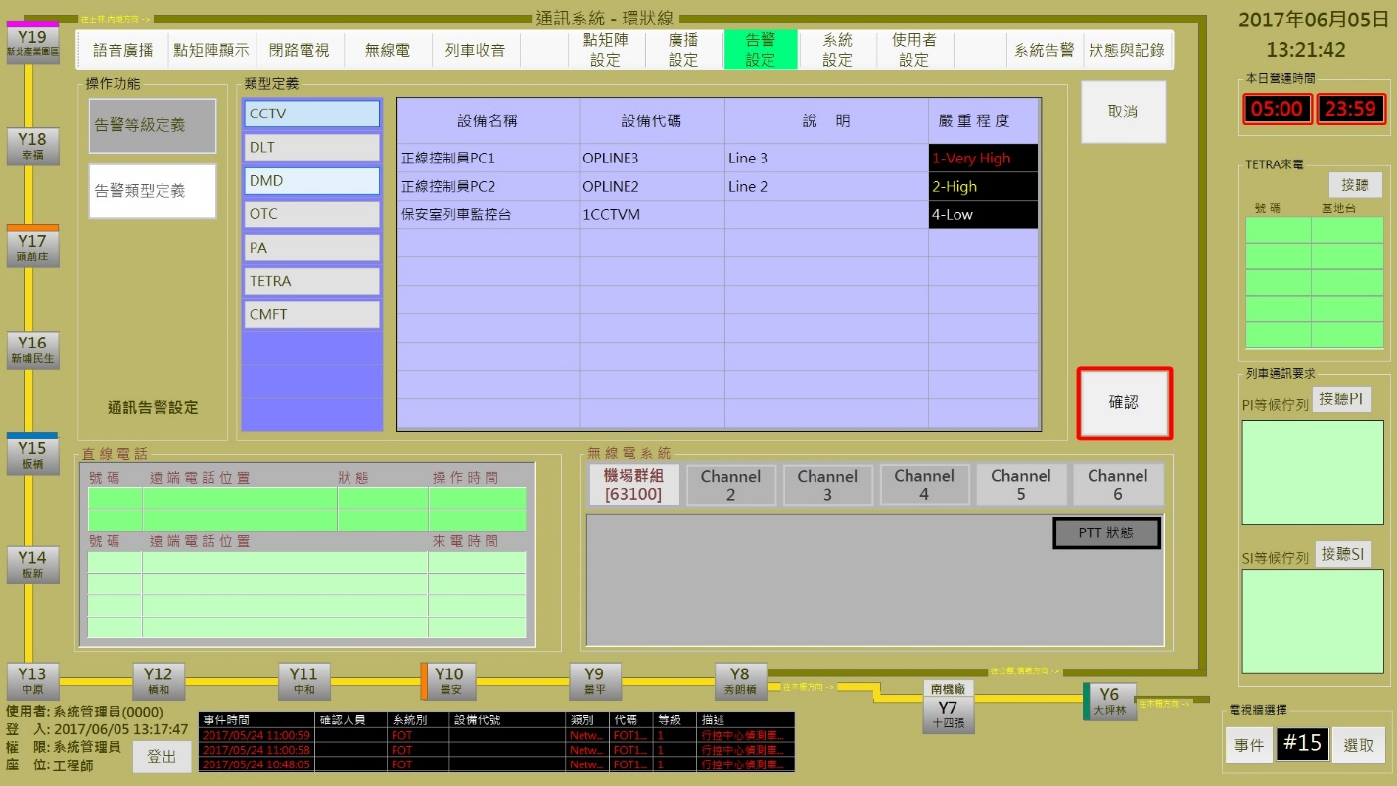

圖 3‑20: 告警類型定義設定作業

Figure 3‑20: Alarm Level Define setup assignment

警報類型依本系統定義為固定項目，操作人員可選取**類型定義**區塊內第一行的項目以取得相關設備資訊，為其設定/變更警報等級。“**確認**” 按鈕是用來儲存設定值；“**取消**” 按鈕則是復原設定值。

There are fixed items for alarm type in CMFT system. Opeartor shall choose alarm type at the the 1st column in “**類型定義**” (Type Define) block to get all the equipments information and setp/change the alarm level for specified one. “**確認**” (Confirm) button can store the setup result. “**取消**” (Cancel) button can recover the original setup value.

### 廣播設定 PA Program Assign

本作業含**預錄語音、語音排程、播放設備**及**廣播時段調整**四個功能

This function include **Voice Data Group Process, Broadcast Schedul Setup, Broadcast Equipment Control** and **Public Broadcast Time Periods Adjust** four sub-functions

#### 預錄語音 Voice Data Group Process

預錄語音設定作業主要是提供操作人員依語音檔內容將其組合 (如圖 3‑21)，於播放時可以節省選取檔案時間。

Voice Data Group Process assignment is used for operator to group voice files according their contents (as Figure 3‑21). This can save select time when broadcast.

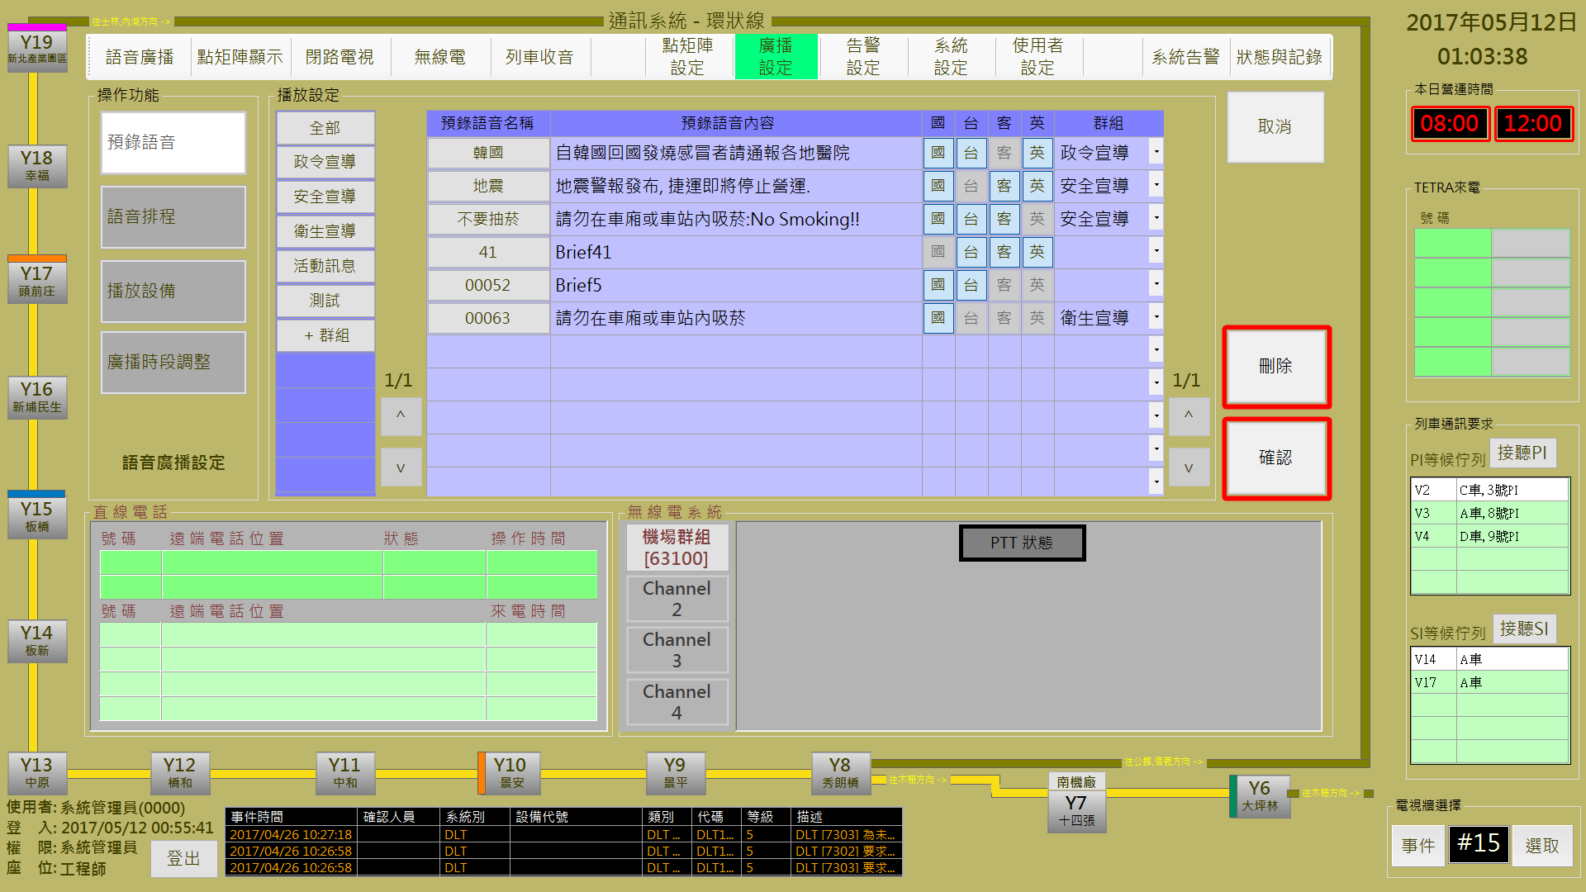

圖 3‑21: 預錄語音設定作業

Figure 3‑21: Voice data group setup assignment

所有語音資料皆來自PA 主機，CMFT系統只能選取播放，沒有編輯、修改及刪除的權限。

All the voice data come from the PA server, CMFT system can only use them without edit, update and delete rights.

操作人員可透過**播放設定**區塊內的**群組**下方第一行的 “**+群組**” 按鈕來建立新的語音群組及其成員 (語音檔)；或直接選取既有群組修改成員。“**確認**” 按鈕是用來儲存設定值；“**取消**” 按鈕則是復原設定值；“**刪除**” 按鈕則是用來刪除指定群組(只有群組名稱, 不含檔案)。

Opeartor can use the “**+群組**” (Add Group.) button at the 1st column in “**播放設定**” (Broadcast Setup) block to build a new group and select the group member (Voice files). Operator can also directly select the listed group to change its member. “**確認**” (Confirm) button can store the setup result. “**取消**” (Cancel) button can recover the original setup value. “**刪除**” (Delete) button is used to delete a specified group (only the group name, not include the voice files in group).

#### 語音排程 Broadcast Schedul Setup

語音排程設定作業主要是提供操作人員設定定時語音播放處理。

Broadcast Schedul Setup assignment is used for operator to setup the fix-time broadcast.

操作人員可參考**前日排程預覽**區塊內的排程建立當日排程，如果當日播放排程內容與前一日相同，操作人員可透過**排程名稱**區塊內的的 “**套用前日排程**” 按鈕來複製前一日排程 (如圖 3‑22)。

Operator can refer the schedule contents of “**前日排程預覽**” (Preview Schedule of Yesterday) block for building the schedule of current day. If there are no change necessary, operator can just click the “**套用前日排程**” (Copy The Schedule of Yesterday) button in “**排程名稱**” (Schedule Name) block to create current day schedule (as Figure 3‑22).

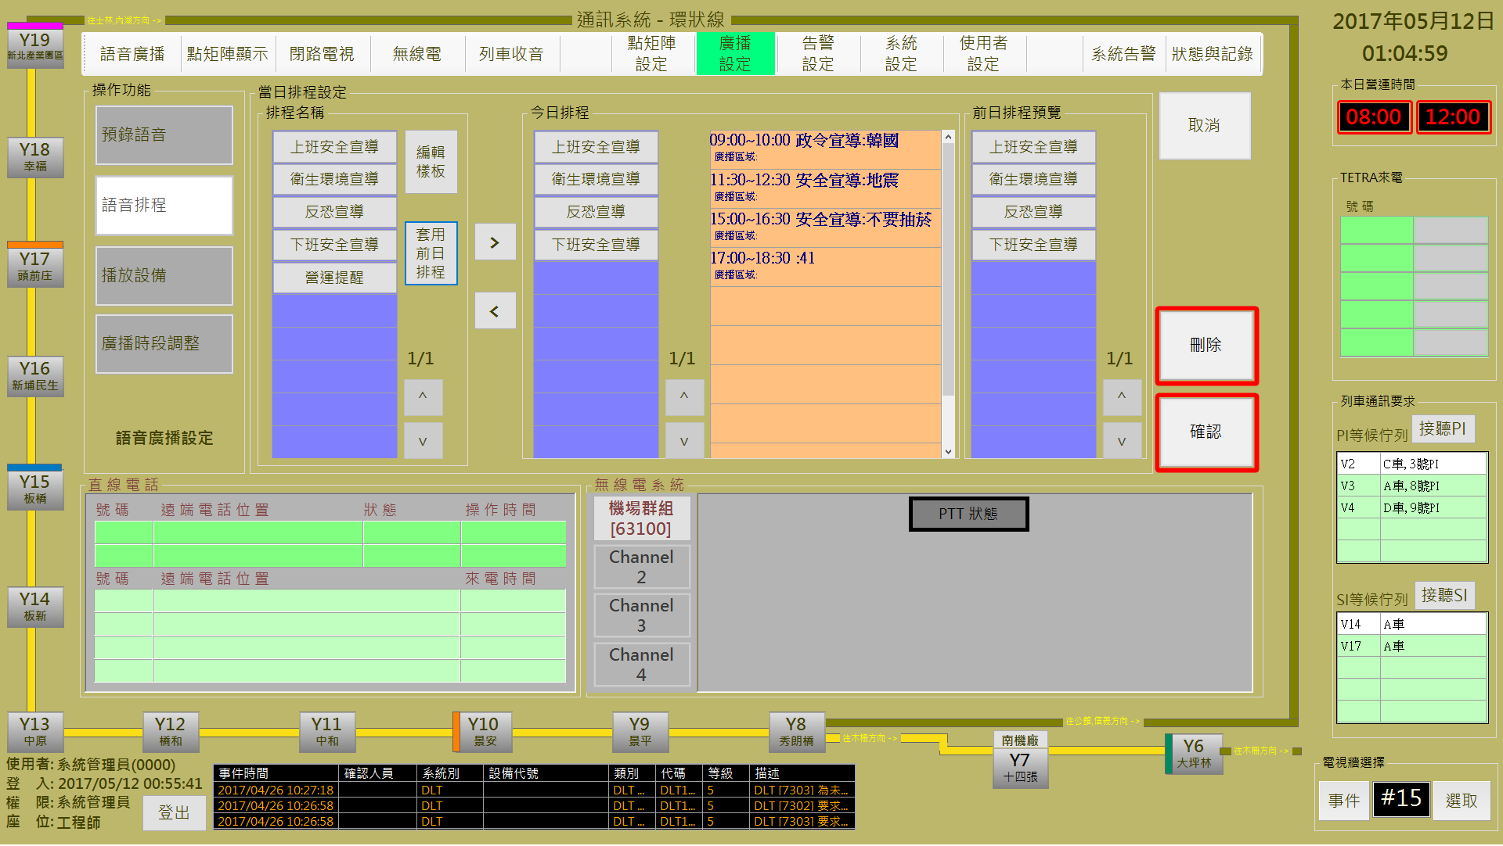

圖 3‑22: 語音排程內容設定作業

Figure 3‑22: Voice data schedule setup assignment

“**確認**” 按鈕是用來儲存設定值；“**取消**” 按鈕則是復原設定值。

“**確認**” (Confirm) button can store the current setup result. “**取消**” (Cancel) button will clear current setup result.

操作人員如果要修改排程內容，可以按 “**編輯樣版**” 鈕，進入修改語音排程畫面 (如圖 3‑23)。

Operator can use “**編輯樣版**” (Edit Sample) bottun switch to the broadcast schedule edit mode (as Figure 3‑23).

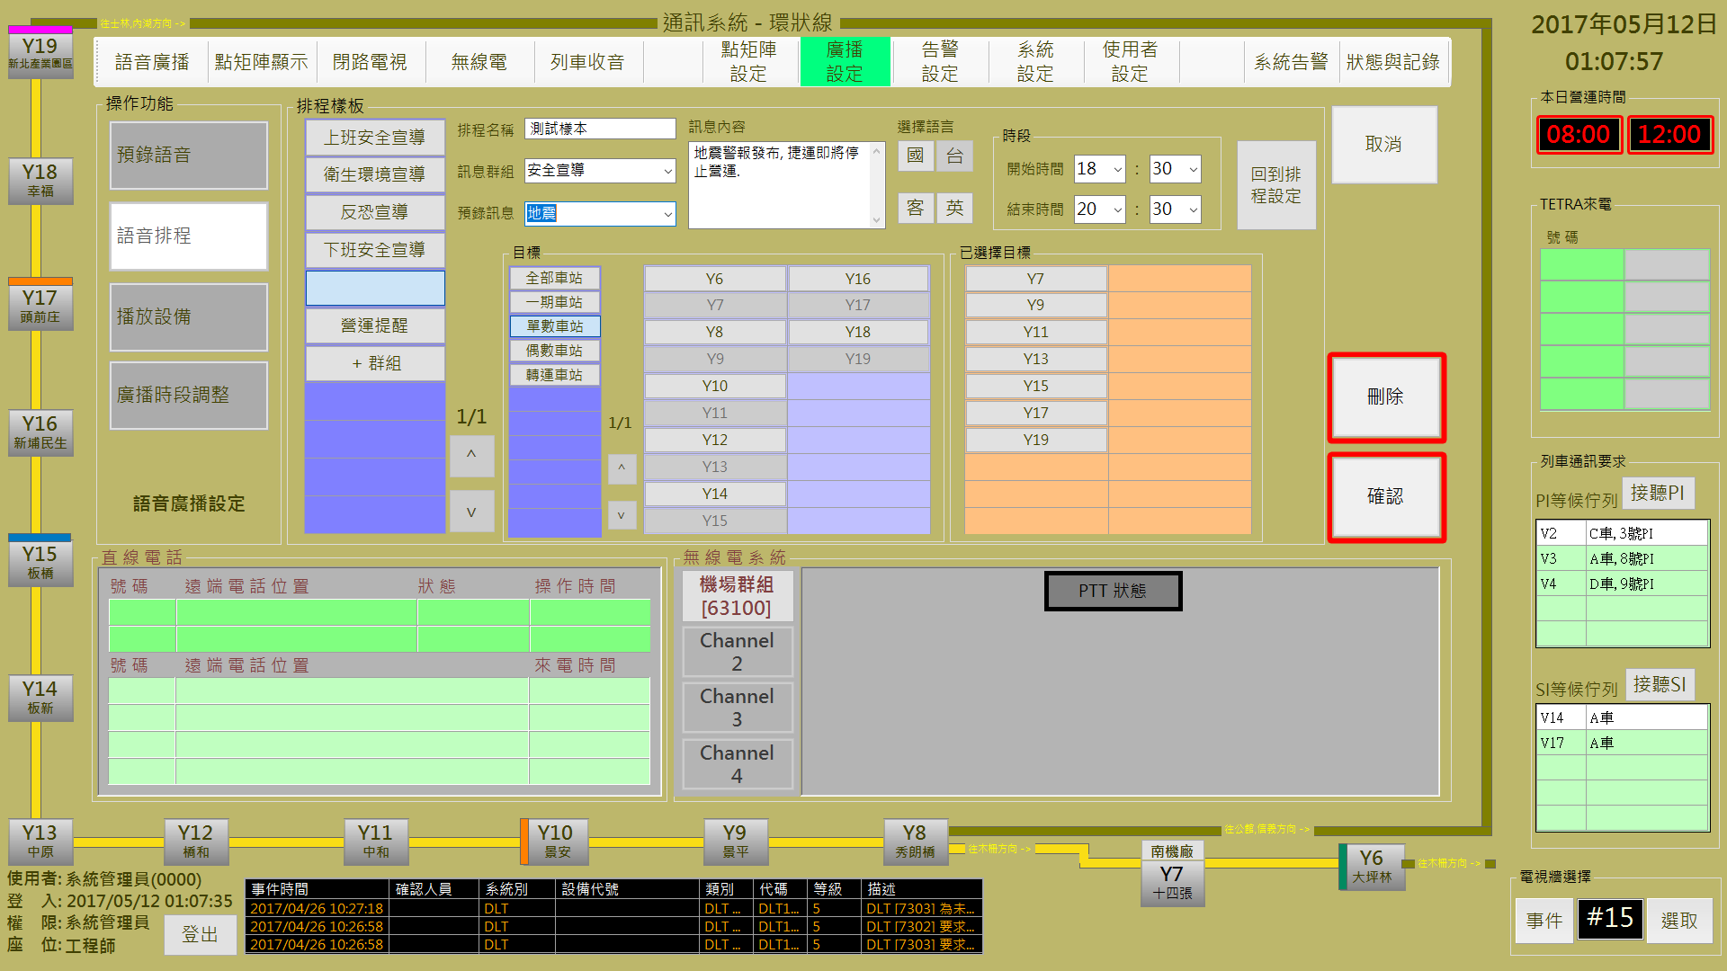

圖 3‑23: 修改語音排程處理作業

Figure 3‑23: Broadcast schedule process assignment

操作人員可透過**排程樣版**區塊內第一行的 “**+群組**” 按鈕來建立新的排程群組及其內容；或直接選取既有群組修改內容。“**確認**” 按鈕是用來儲存設定值；“**取消**” 按鈕則是復原設定值；“**刪除**” 按鈕則是用來刪除指定排程群組。

Opeartor can use the “**+群組**” (Add Group.) button at the 1st column in “**排程樣版**” (Sample Schedule) block to build a new schedule group and its contents. Operator can also directly select the listed schedule group to change its contents. “**確認**” (Confirm) button can store the setup result. “**取消**” (Cancel) button can recover the original setup value. “**刪除**” (Delete) button is used to delete a specified schedule group.

操作人員可透過**排程樣版**區塊內的 “**回到排程設定**” 按鈕結束編輯作業並回到語音排程設定頁面。

Operator can use the “**回到排程設定**” (Back to Previous Page) button in “**排程樣版**” (Sample Schedule) block to finish the edit process and back to the Voice Data Schedule Setup page.

#### 播放設備控制設定 Broadcast equipment Controll Setup

播放設備控制設定作業主要是設定允許進行語音播放處理的主控台 (如圖 3‑24)。

Broadcast Equipment Controll Setup assignment is used for assigning the consoles which are allowed to progress broadcast related operation (as Figure 3‑24).

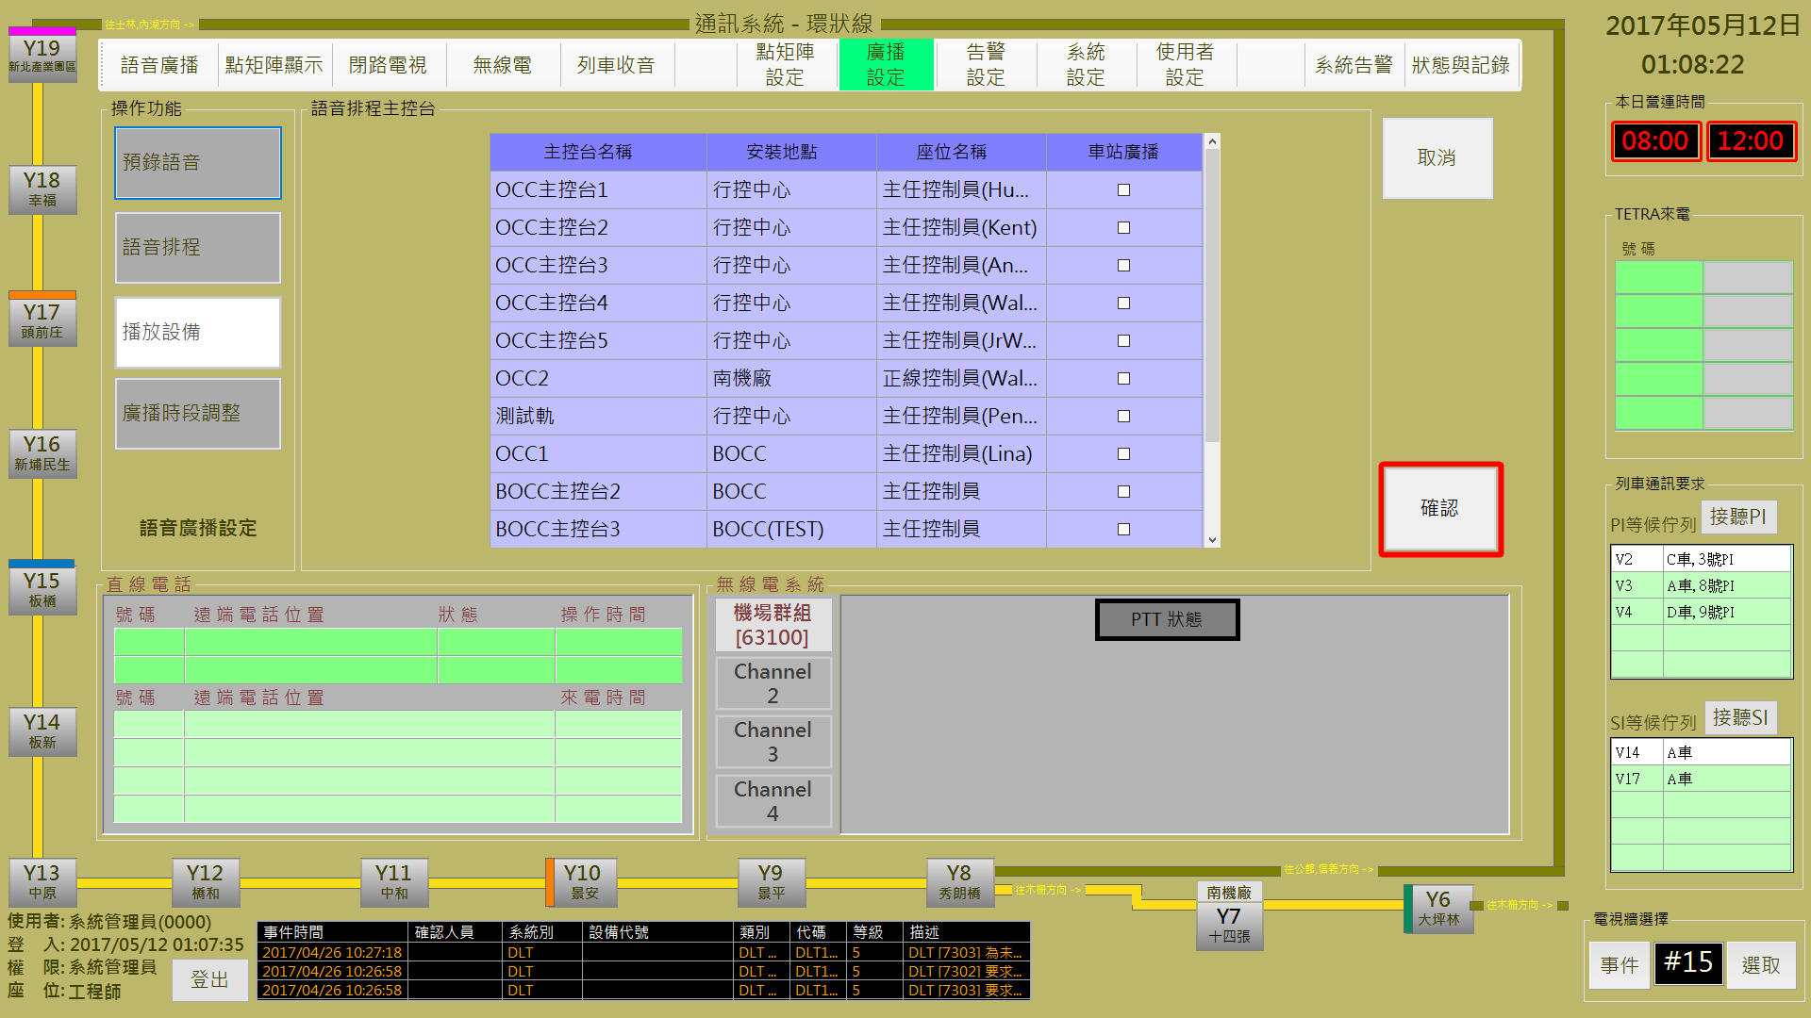

圖 3‑24: 播放設備控制設定作業

Figure 3‑24: Broadcast Equipment Controll Setup assignment

操作人員直接選取主控台設定該主控台是否可以進行語音廣播處理．“**確認**” 按鈕是用來儲存設定值；“**取消**” 按鈕則是復原設定值。

Opeartor directly select the listed console to set broadcast process right. “**確認**” (Confirm) button can store the setup result. “**取消**” (Cancel) button can recover the original setup value.

#### 廣播時段調整 Public Broadcast Time Periods Adjust

廣播時段調整主要是提供操作人員設定車站的廣播時段處理作業 (如圖 3‑25)。

Broadcast Time Periods Adjust assignment is used to setup the station public broadcast time periods (as Figure 3‑25).

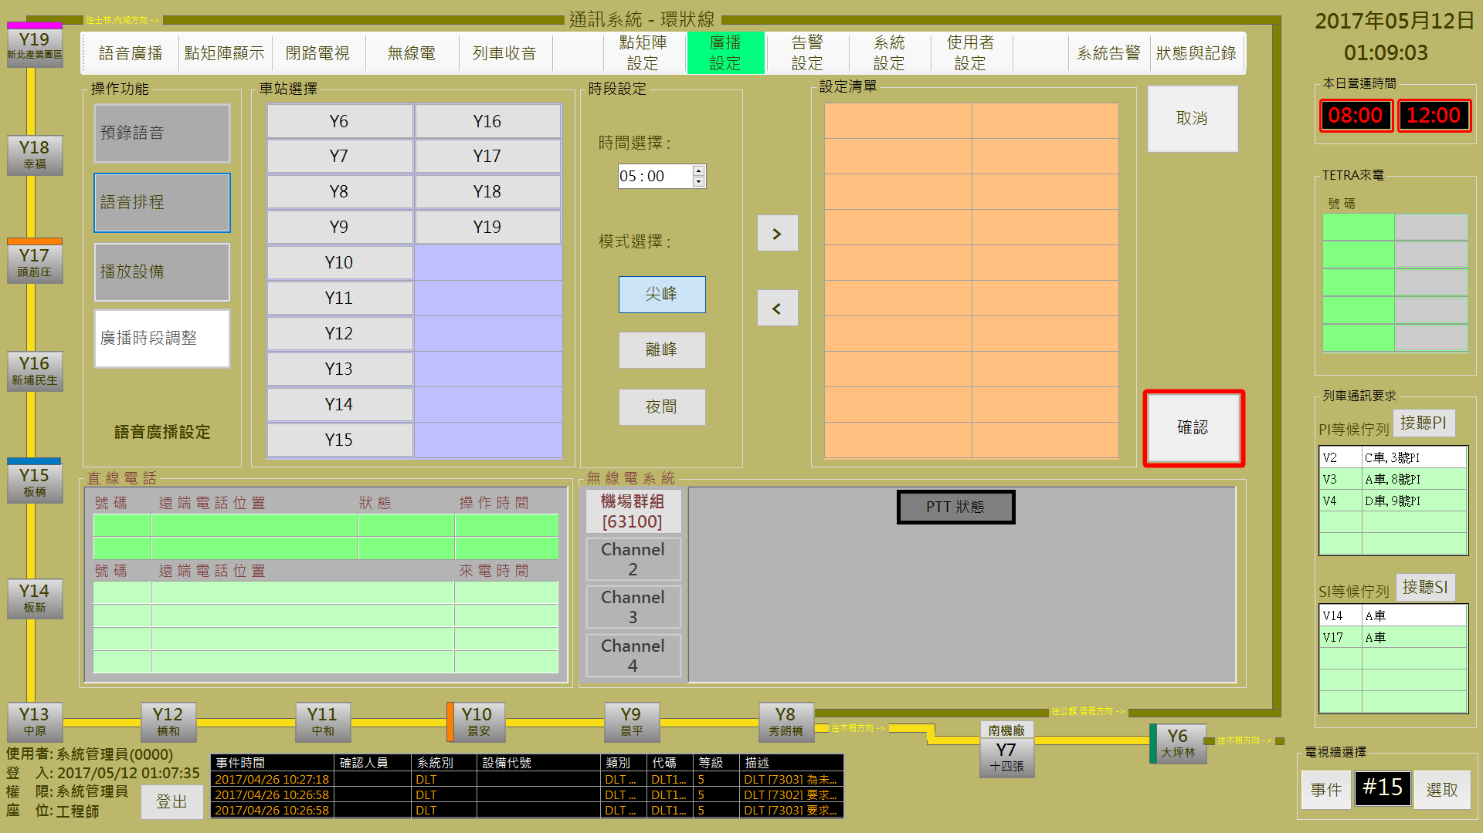

圖 3‑25: 廣播時段調整作業

Figure 3‑25: Public broadcast time periods adjust assignment

操作人員可以設定廣播時段並選取車站完成本項設定。“**確認**” 按鈕是用來儲存設定值；“**取消**” 按鈕則是清除設定值。

Opeartor can setup the broadcast time periods and select station(s) to complete this operation. “**確認**” (Confirm) button can store the setup result. “**取消**” (Cancel) button will clear the setup value.

### 點矩陣設定 DMD Program Assign

本作業含**ATS訊息、預錄訊息、訊息排程**及**顯示模式設定**四個功能

This function include **ATS Message Display Setup, Pre-record Message Management, DMD Message Schedule Setup** and **DMD Display Mode Setup** four sub-functions

#### ATS訊息 ATS Message Display Setup

ATS訊息設定主要是提供操作人員設定CDU及PDU顯示接收ATS訊息內容 (如圖 3‑26)。

ATS Message Display Setup assignment is used to setup the CDU and PDU display contents when receive ATS message (as Figure 3‑26).

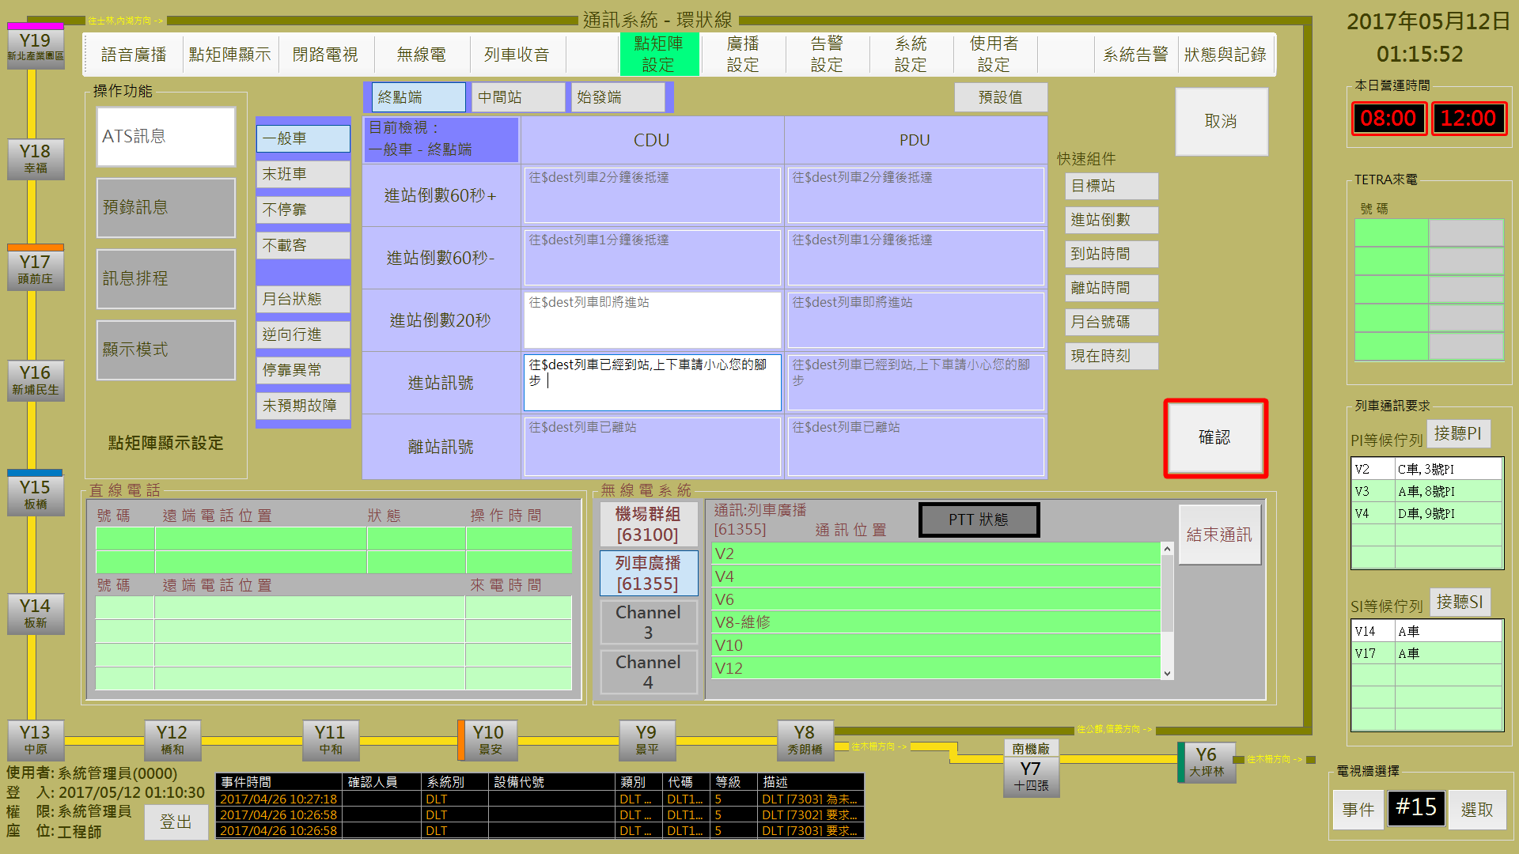

圖 3‑26: ATS訊息設定作業

Figure 3‑26: ATS message display setup assignment

操作人員可以依站序、列車狀況設定對應ATS訊息的DMD顯示內容，直接點擊DMD顯示內容則可以進行內容修改。“**確認**” 按鈕是用來儲存設定值；“**取消**” 按鈕則會恢復原設定值。

Opeartor can setup the display contents according the station order or car(s) status.Operator can also directly click the Display content to change. “**確認**” (Confirm) button can store the setup result. “**取消**” (Cancel) button will recover the original setup value.

#### 預錄訊息管理 Pre-record Message Management

預錄訊息管理作業主要是提供操作人員規劃DMD顯示訊息群組及建立/修改顯示內容處理 (如圖 3‑27)。

Pre-record Message Manage assignment is used to build/update the DMD display message group and its display content member (as Figure 3‑27).

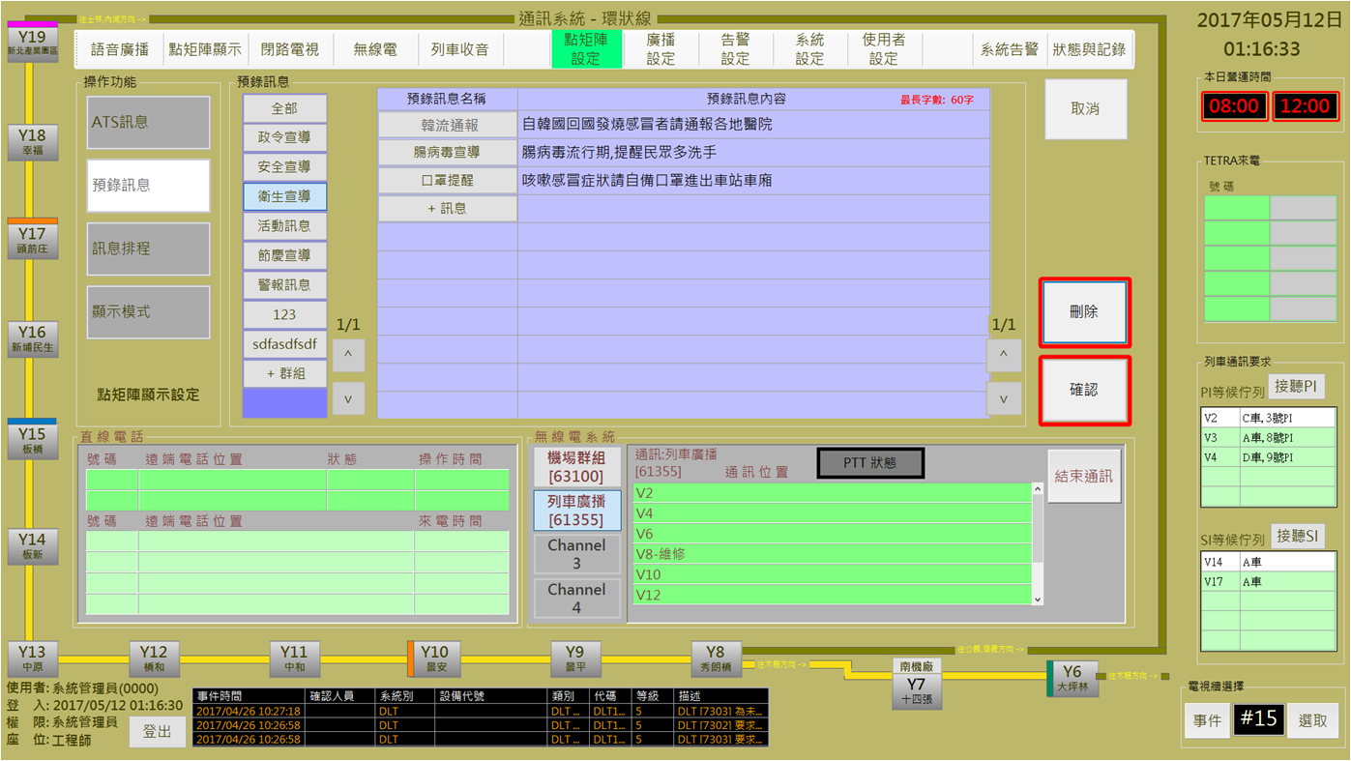

圖 3‑27: 預錄訊息管理作業

Figure 3‑27: Pre-record message manage assignment

操作人員可透過**預錄訊息**區塊內第一行的 “**+群組**” 按鈕來建立新的顯示群組。再透過 ”**預錄訊息名稱**” 欄位內的 ”**+訊息**” 按鈕來建立新的顯示訊息。

Opeartor can use the “**+群組**” (Add Group) button at the 1st column in “**預錄訊息**” (Pre-record Message) block to build a new display group, then use the “**+訊息**” (Add Message) button at the “**預錄訊息名稱**” (Pre-record Message Name) field to build a new display message.

操作人員也可直接選取群組進行訊息內容的修改及增加顯示訊息。

Opeartor can also directly select a listed display group to update related message(s) and build new display message(s).

操作人員也可直接選取訊息進行訊息內容的修改。

Opeartor can also directly select a listed message name to update its content.

“**確認**” 按鈕是用來儲存設定值；“**取消**” 按鈕則是復原設定值；“**刪除**” 按鈕則是用來刪除指定群組或訊息名稱 (依其編輯項目決定)。

“**確認**” (Confirm) button can store the setup result. “**取消**” (Cancel) button can recover the original setup value. “**刪除**” (Delete) button is used to delete a specified group訊息排程設定or message (according to the operating item).

#### 訊息排程設定 Message Schedule Setup

訊息排程設定作業主要是提供操作人員設定定時訊息播放處理。

Message Schedul Setup assignment is used for operator to setup the fix-time DMD message(s) dislay.

操作人員可參考**前日排程預覽**區塊內的排程建立當日排程，如果當日排程內容與前一日相同，操作人員可透過**排程名稱**區塊內的的 “**套用前日排程**” 按鈕來複製前一日排程 (如圖 3‑28)。

Operator can refer the schedule contents of “**前日排程預覽**” (Preview Schedule of Yesterday) block for building the message schedule of current day. If there are no change necessary, operator can just click the “**套用前日排程**” (Copy The Schedule of Yesterday) button in “**排程名稱**” (Schedule Name) block to create current day schedule (as Figure 3‑28).



圖 3‑28: 訊息排程內容設定作業

Figure 3‑28: DMD message display schedule setup assignment

“**確認**” 按鈕是用來儲存設定值；“**取消**” 按鈕則是復原設定值。

“**確認**” (Confirm) button can store the current setup result. “**取消**” (Cancel) button will clear current setup result.

操作人員如果要修改排程內容，可以按 “**編輯樣版**” 鈕，進入修改訊息排程畫面 (如圖 3‑29)。

Operator can use “**編輯樣版**” (Edit Sample) bottun switch to the message display schedule edit mode (as Figure 3‑29).

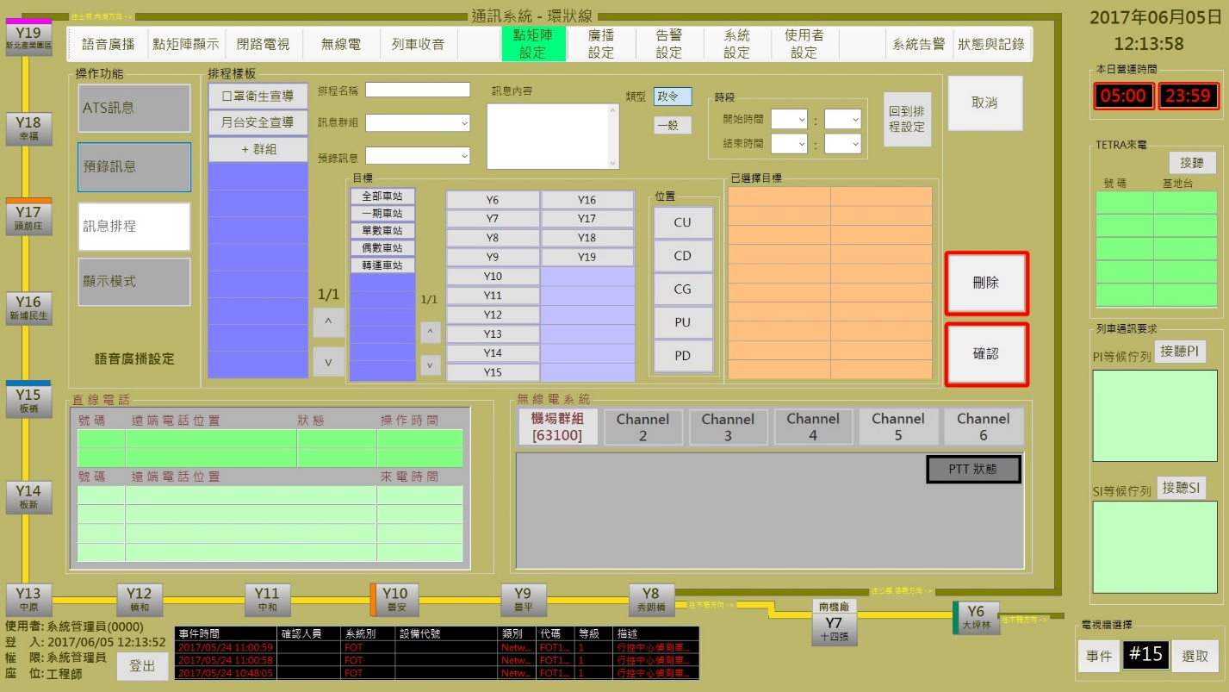

圖 3‑29: 修改訊息排程處理作業

Figure 3‑29: Message display schedule process assignment

操作人員可透過**排程樣版**區塊內第一行的 “**+群組**” 按鈕來建立新的排程群組及其內容；或直接選取既有群組修改內容。“**確認**” 按鈕是用來儲存設定值；“**取消**” 按鈕則是復原設定值；“**刪除**” 按鈕則是用來刪除指定排程群組。

Opeartor can use the “**+群組**” (Add Group.) button at the 1st column in “**排程樣版**” (Sample Schedule) block to build a new schedule group and its contents. Operator can also directly select the listed schedule group to change its contents. “**確認**” (Confirm) button can store the setup result. “**取消**” (Cancel) button can recover the original setup value. “**刪除**” (Delete) button is used to delete a specified schedule group.

操作人員可透過**排程樣版**區塊內的 “**回到排程設定**” 按鈕結束編輯作業並回到語音排程設定頁面。

Operator can use the “**回到排程設定**” (Back to Previous Page) button in “**排程樣版**” (Sample Schedule) block to finish the edit process and back to the DMD Message Display Schedule Setup page.

#### 顯示模式設定 Display Mode Setup

顯示模式設定作業主要是提供操作人員設定車站內CDU及PDU的DMD訊息顯示方式(如圖 3‑30)。

Display Mode Setup assignment is used for operator to setup the DMD message display mode of CDU and PDU in station(s) (as Figure 3‑30).

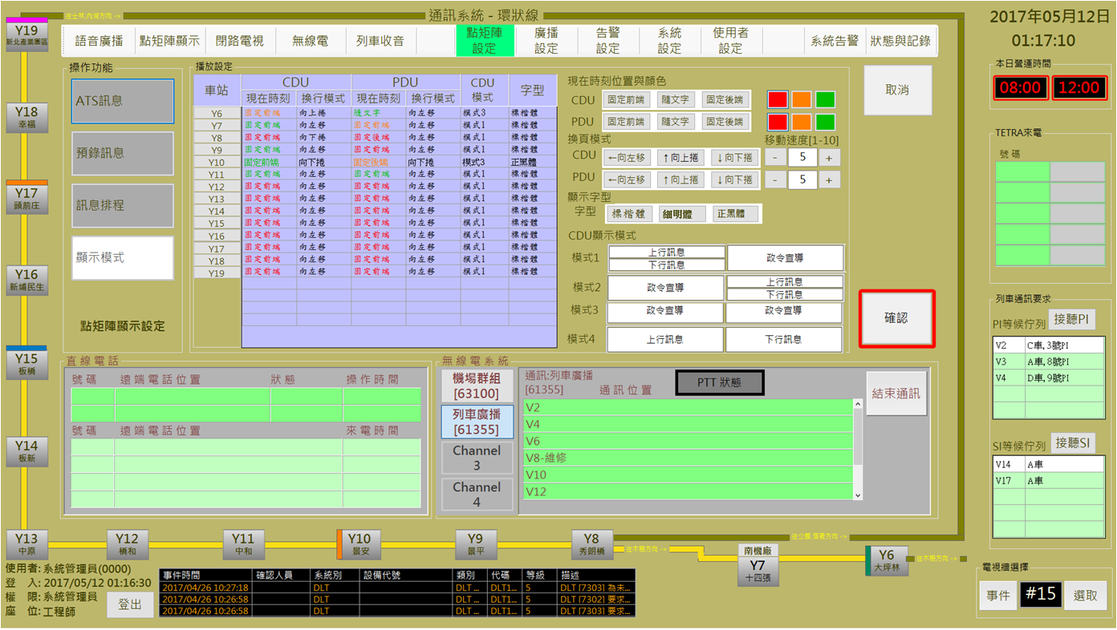

圖 3‑30: DMD 訊息顯示模式設定作業

Figure 3‑30: DMD message display mode setup assignment

操作人員可直接選取車站，編輯CDU及PDU的訊息資訊顯示模式。“**確認**” 按鈕是用來儲存設定值；“**取消**” 按鈕則是復原設定值

Opeartor can directly select a listed station to edit the message display mode of CDU and PDU. “**確認**” (Confirm) button can store the setup result. “**取消**” (Cancel) button can recover the original setup value.

### 列車收音 Voice Monitoring of Passenger Movement

進行本作業，請依 “**選擇列車**→**選擇位置**→**閞始收音**” 三個步驟進行。

Progress this function, please follow “**Select Car→Select PI→Start record**” the three steps to operate.

**步驟1** **列車選取**: 操作人員每次只能選取一台列車 (如圖 3‑31)。車輛選取完成後，請按 “**下一步**” 按鈕進行下一步驟

**Step 1 Select Car**: Operator can select only one car every time (as Figure 3‑31). After selection complete, please click “**下一步**” (Next Step) button to next step.

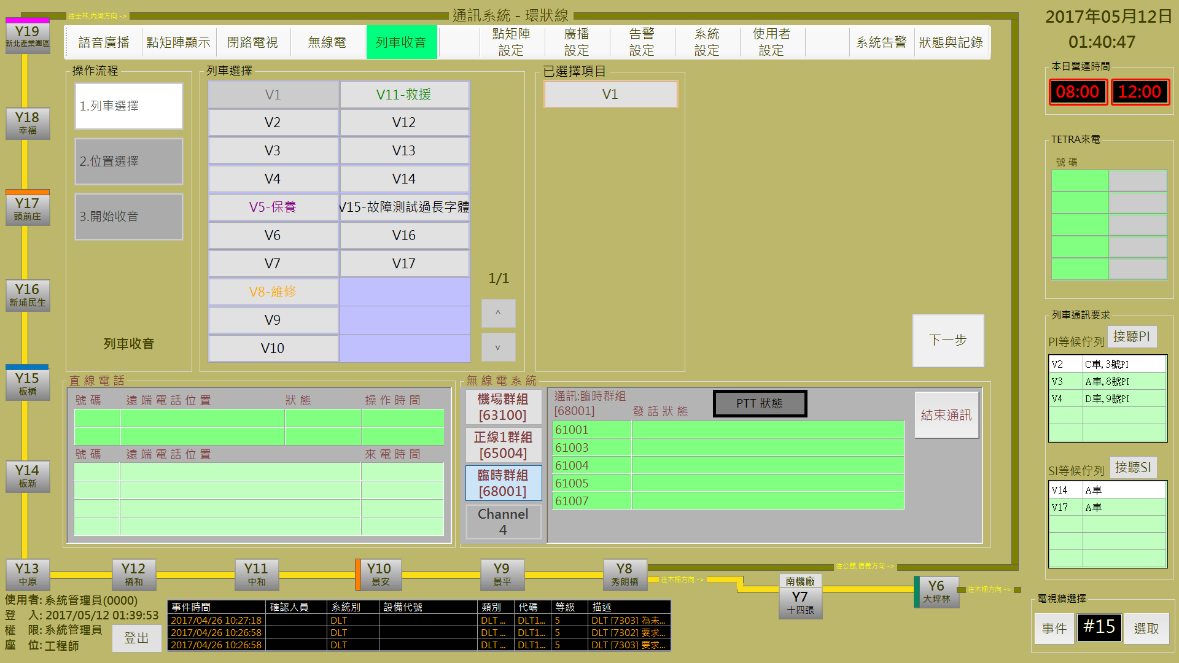

圖 3‑31: 列車收音操作程序1 (列車選取)

Figure 3‑31: Voice monitoring of passenger movement operation step 1 (select car)

**步驟2** **位置選取**: 操作人員選取**列車緊急電話**位置 (如圖 3‑32)。選取結果會顯示在 “**已選擇項目**” 區塊內，選取完成後；請按 “**收音**” 按鈕進行下一步驟。如果想換車，請按 “**上一步**” 按鈕回前一步驟。

**Step 2 Select PI**: Operator shall select one **PI** (as Figure 3‑32). Selection result will show in the “**已選擇項目**” (Choose Result) block. After selection complete, please click “**收音**” (Start Record) button to next step. If operator want to change car, please click “**上一步**” (Last Step) button back to last step.

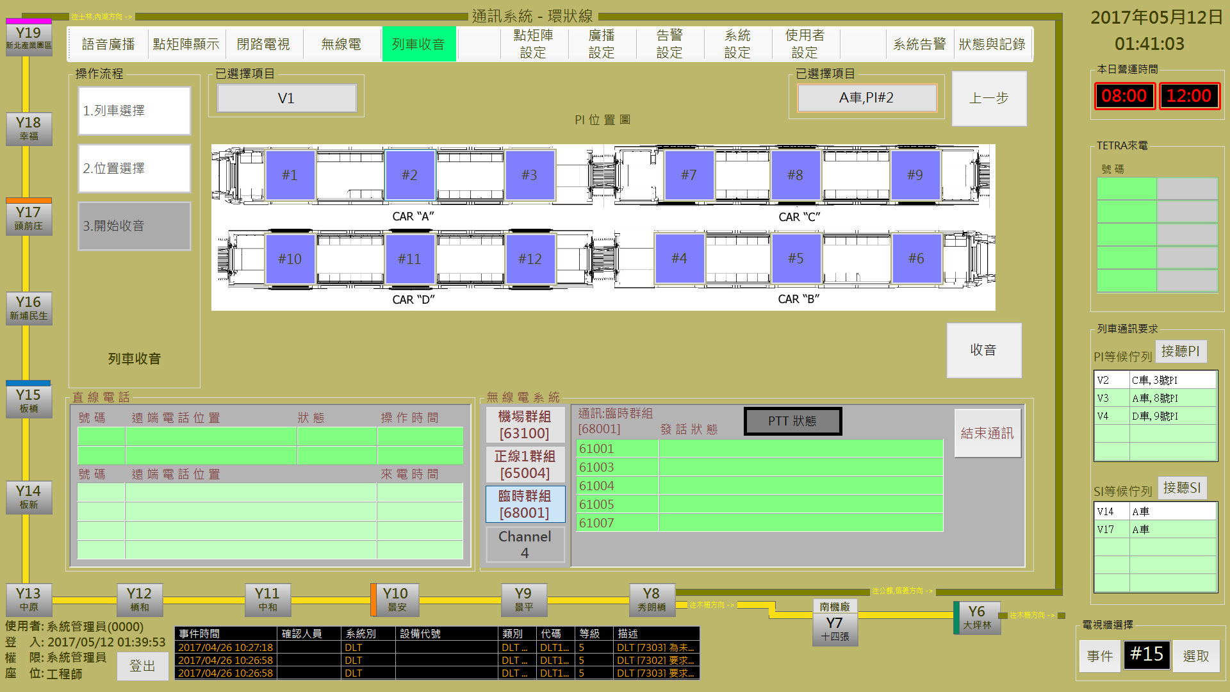

圖 3‑32: 列車收音操作程序2 (選取收音位置)

Figure 3‑32: Voice monitoring of passenger movement operation step 2 (select PI)

**步驟3** **開始收音**: 如果通訊頻道可以正常建立，操作人員會看到系統顯示操作結果如圖 3‑33。

**Step 3 Start Record**: If the system work well, operator will see the result as Figure 3‑33.

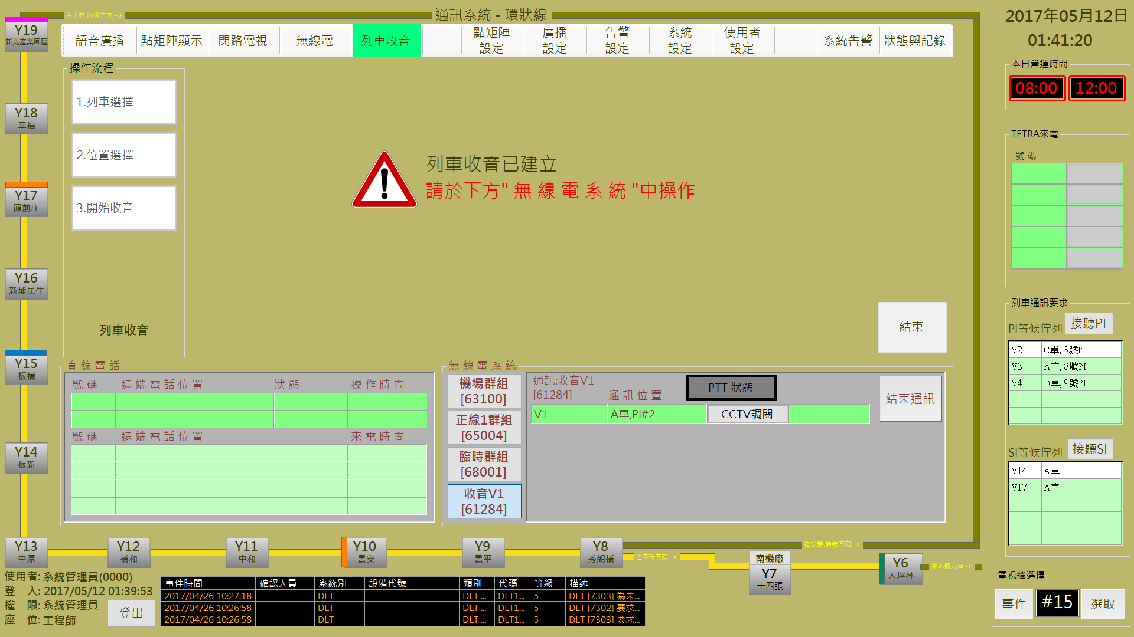

圖 3‑33: 列車收音操作程序3 (開始收音)

Figure 3‑33: Voice monitoring of passenger movement operation step 3 (Start Record)

錄音期間，操作人員可以透過 ”**無線電頻道明細區**” 的 ”**CCTV調閱**” 按鈕調閱CCTV關聯影像進行同步監控。如果想停止錄音，請按 ”**無線電頻道明細區**” 的 “**結束通訊**” 按鈕停止錄音。如果想結束本次操作，請按 “**結束**” 按鈕結束本次操作 (停止操作不代表同時停止錄音，兩者為獨立功能)。

During the recording time, operator can use the “**CCTV調閱**” (Play CCTV) button in the “**無線電頻道明細**” (Audio Channel Detail) block to open the related CCTV image for monitoring same time. If want to stop record, please click the “**結束通訊**” (Stop Communication) button in the “**無線電頻道明細**” (Audio Channel Detail) block to stop record. If want to stop operation, please click “**結束**” (Close) button to finish operation (stop operation does not mean stop record, they are independent functions to each other).

### 無線電 TETRA Communication

本作業含**群組呼叫、個別呼叫、撥號盤**三個操作項目 (如圖 3‑34)。

This function include **Group Call, Single Call** and **Dial** three operation items (as Figure 3‑34).

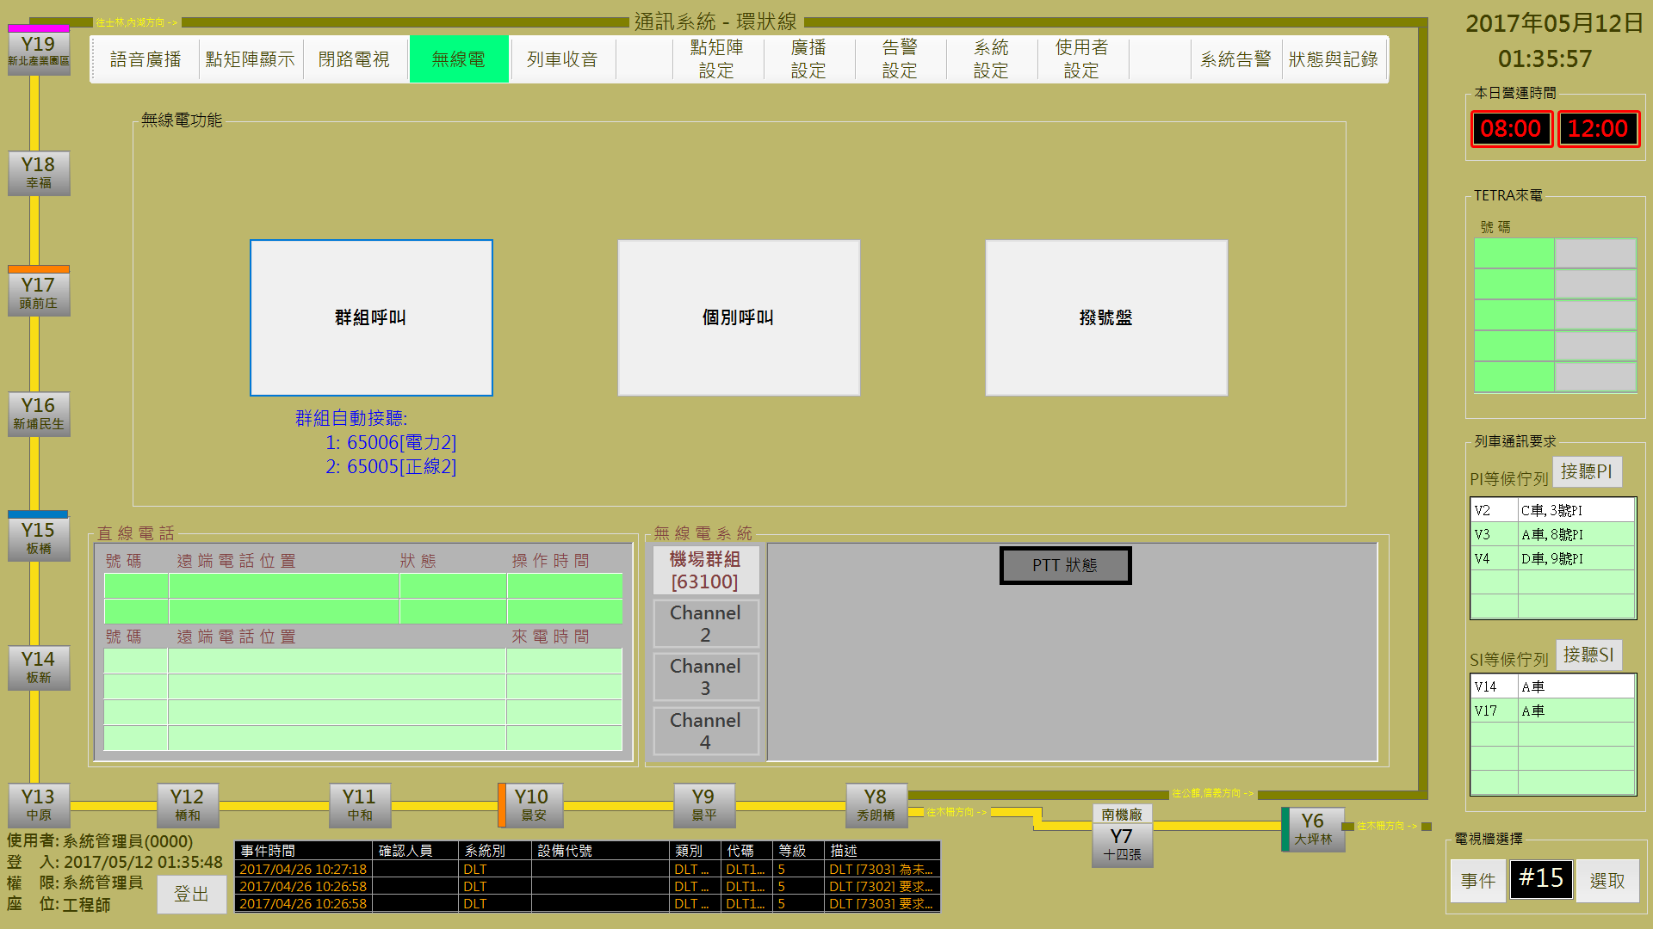

圖 3‑34: 無線電操作主頁

Figure 3‑34: Main page of TETRA Communication operation

#### 無線電群組呼叫操作 TETRA Group Call Operation

進行本作業，請依 “**項目選擇**→**通訊方式及內容**→**開始通訊**” 三個步驟進行。

Progress this function, please follow “**Select Group→Setup Communication →Start Communication**” the three steps to operate.

##### 步驟1項目選擇Step 1 Select Group

操作人員由**來源**列表內選取**通訊群組**，選取結果會顯示在**已選擇項目**區塊內 (如圖 3‑35)。選取完成後，請按 “**下一步**” 按鈕進行下一步驟，如果要變更作業項目，請按 “**下一步**” 按鈕回操作主頁。

Operator can select the TETRA group from the list in “**來源**” (Group Source) block. Selection result will show in the “**已選擇項目**” (Choosed Items) block. (as Figure 3‑35). After selection complete, please click “**下一步**” (Next Step) button to next step. If want to change operation item, please click “**上一步**” (Last Step) button back to the operation main page.

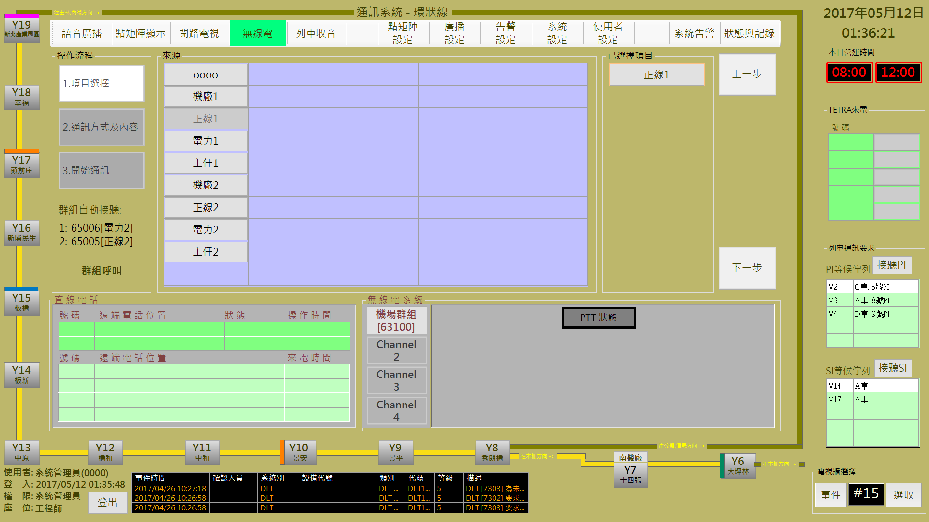

圖 3‑35: 無線電操作步驟1 (項目選擇)

Figure 3‑35: TETRA Communication operation step 1 (Select Group)

##### 步驟2通訊方式及內容Step 2 Setup Communication

操作人員可以透過**通訊方式**區塊的選項，選擇使用**語音通訊**或**傳簡訊**方式來建立通訊模式 (如圖 3‑36)。確認通訊方式後，請按 “**通訊**” 按鈕進行下一步驟，如果要變更通訊群組，請按 “**上一步**” 按鈕回前一個操作頁面。

Operator can select using **audio** or **send** **message** mode for communication in “**通訊方式**” (communication mode) block.. (as Figure 3‑36). After communication mode confirmed, please click “**通訊**” (communication) button to next step. If want to change communication group, please click “**上一步**” (Last Step) button back to the item select page.

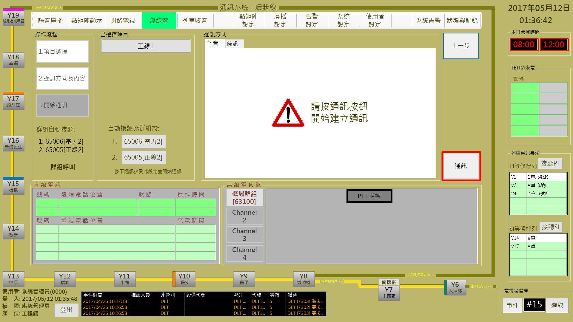

圖 3‑36: 無線電操作步驟2 (通訊方式及內容)

Figure 3‑36: TETRA Communication operation step 2 (Setup communication)

CMFT系統提供2個可**自動接聽**的通訊群組設定參數，操作人員可以在這個頁面的**自動接聽群組**項目，點擊變更其設定內容。

CMFT system privodes two parameter for auto-receive group. Operator can click items in “**自動接聽群組**” (Auto-receive groups) block to change.

##### 步驟3開始通訊Step 3 Start Communication

如果通訊頻道可以正常建立，操作人員會看到系統顯示操作結果如圖 3‑37。如果想停止通訊，請按 ”**無線電頻道明細區**” 的 “**結束通訊**” 按鈕停止通訊。如果想結束本次操作，請按 “**結束**” 按鈕結束本次操作 (停止操作不代表同時停止通訊，兩者為獨立功能)。

If the system work well, operator will see the result as Figure 3‑37. If want to stop communication, please click the “**結束通訊**” (Stop Communication) button in the “**無線電頻道明細**” (Audio Channel Detail) block to stop communication. If want to stop operation, please click “**結束**” (Close) button to finish operation (stop operation does not mean stop record, they are independent functions to each other).

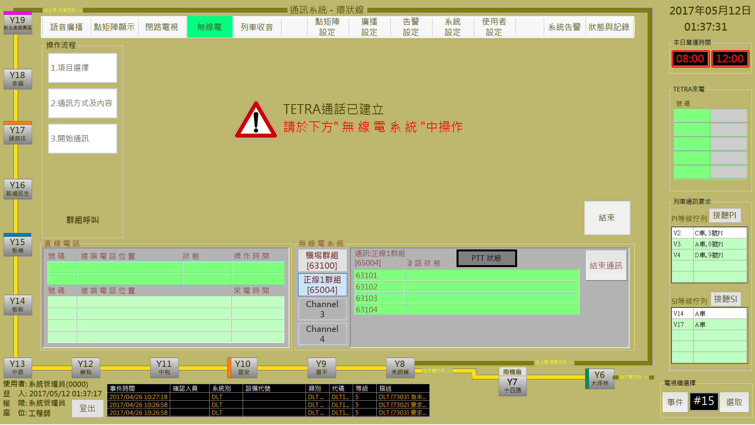

圖 3‑37: 無線電操作步驟3 (開始通訊)

Figure 3‑37: TETRA Communication operation step 3 (Start communication)

#### 無線電個別呼叫操作 TETRA Single Call Operation

進行本作業，請依 “**項目選擇**→**通訊方式及內容**→**開始通訊**” 三個步驟進行。

Progress this function, please follow “**Select TETRA No. →Setup Communication →Start Communication**” the three steps to operate.

##### 步驟1項目選擇Step 1 Select TETRA No.

操作人員由**來源**列表內選取**無線電編號** (允許多選)，選取結果會顯示在**已選擇項目**區塊內 (如圖 3‑38)。選取完成後，請按 “**下一步**” 按鈕進行下一步驟，如果要變更作業項目，請按 “**上一步**” 按鈕回操作主頁。

Operator can select the TETRA No.(s) from the list in “**來源**” (TETRA No. Source) block. Selection result will show in the “**已選擇項目**” (Choosed Items) block. (as Figure 3‑38). After selection complete, please click “**下一步**” (Next Step) button to next step. If want to change operation item, please click “**上一步**” (Last Step) button back to the operation main page.

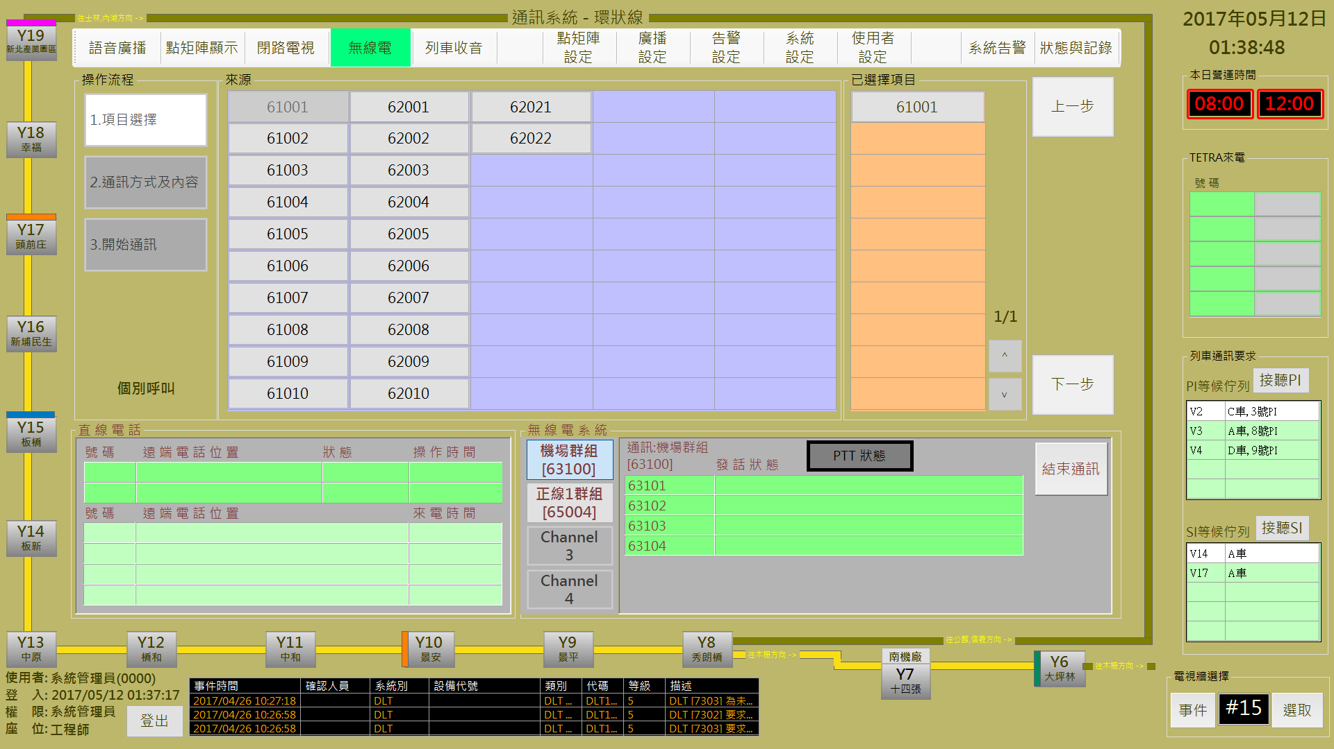

圖 3‑38: 無線電操作步驟1 (項目選擇)

Figure 3‑38: TETRA Communication operation step 1 (Select No.)

##### 步驟2通訊方式及內容Step 2 Setup Communication

本步驟操作方式同群組呼叫模式，請參考群組呼叫步驟2說明，本處不再累敘。

This step is similar group call, please refer group call step 2 and no more repeat here.

##### 步驟3開始通訊Step 3 Start Communication

如果通訊頻道可以正常建立，操作人員會看到系統顯示操作結果如圖 3‑39。如果想停止通訊，請按 ”**無線電頻道明細區**” 的 “**結束通訊**” 按鈕停止通訊。如果想結束本次操作，請按 “**結束**” 按鈕結束本次操作 (停止操作不代表同時停止通訊，兩者為獨立功能)。

If the system work well, operator will see the result as Figure 3‑39. If want to stop communication, please click the “**結束通訊**” (Stop Communication) button in the “**無線電頻道明細**” (Audio Channel Detail) block to stop communication. If want to stop operation, please click “**結束**” (Close) button to finish operation (stop operation does not mean stop record, they are independent functions to each other).

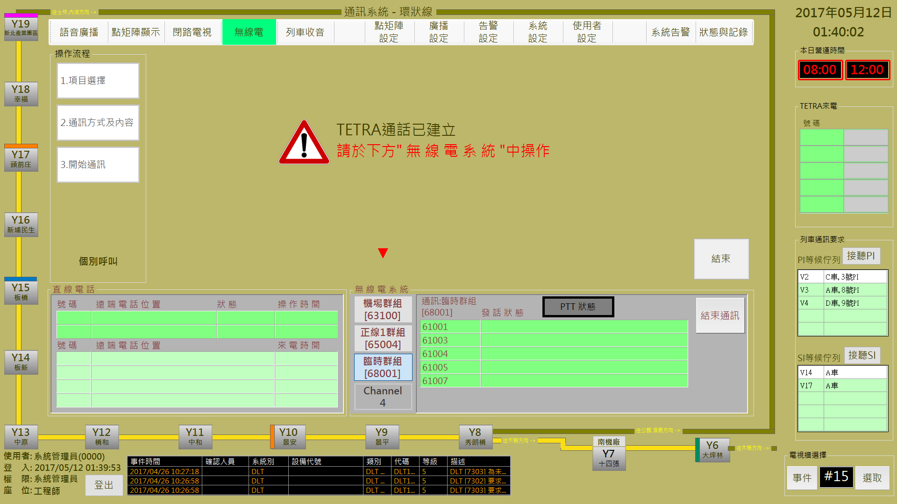

圖 3‑39: 無線電操作步驟3 (開始通訊)

Figure 3‑39: TETRA Communication operation step 3 (Start communication)

操作人員如果選取多個號碼，系統會自動產生**臨時群組**，依群組通訊方式進行通訊。

If operator select several TETRA No. in this operation, system will auto-create the **temple group** for group communication.

#### 撥號盤操作 TETRA Dial Operation

進行本作業，請依 “**項目選擇**→**通訊方式及內容**→**開始通訊**” 三個步驟進行。

Progress this function, please follow “**Dial →Setup Communication →Start Communication**” the three steps to operate.

##### 步驟1項目選擇Step 1 Dial

操作人員由**撥號盤**直接鍵入無線電號碼 (如圖 3‑40)。號碼輸入後，請按 “**下一步**” 按鈕進行下一步驟，如果要變更作業項目，請按 “**上一步**” 按鈕回操作主頁。

Operator directly key in the TETRA No. from the dial (as Figure 3‑40). When complete, please click “**下一步**” (Next Step) button to next step. If want to change operation item, please click “**上一步**” (Last Step) button back to the operation main page.

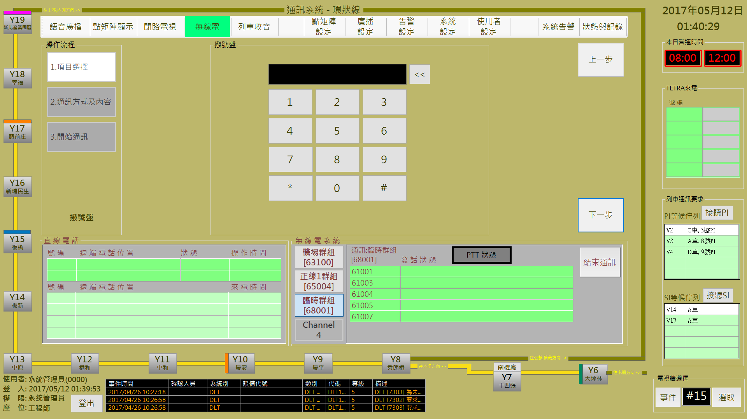

圖 3‑40: 無線電操作步驟1 (項目選擇)

Figure 3‑40: TETRA Communication operation step 1 (Select No.)

後續操作方式同群組呼叫模式，請參考群組呼叫說明，本處不再累敘。

The continuous step is similar group call, please refer group call step and no more repeat here.

### 閉路電視 CCTV Monitoring

本作業含**歷史影像調閱、PTZ攝影機控制、即時影像設定**三個操作項目 (如圖 3‑41)。

This function include **Historical Image Review, PTZ Camera Control** and **Real-tIme Image Setup** three operation items (as Figure 3‑41).

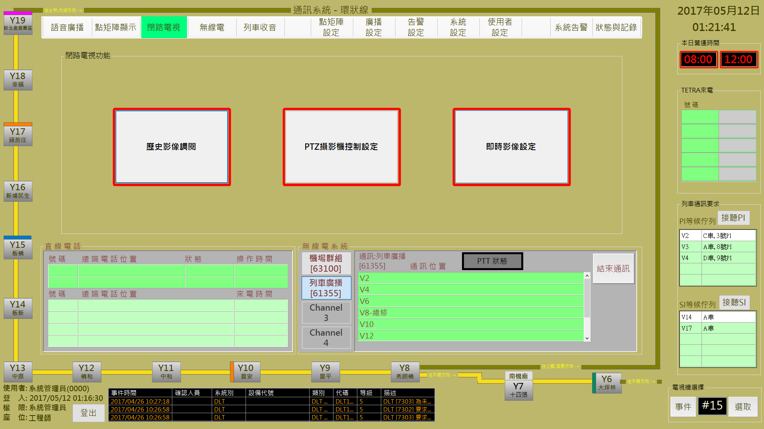

圖 3‑41: 閉路電視操作主頁

Figure 3‑41: Main page of CCTV operation

#### 歷史影像調閱 Historical Image Review

進行本作業，請依 “**電視牆選擇**→**攝影機選擇**→**輪播設定**” 三個步驟進行。

Progress this function, please follow “**Select TV from TV Wall→Select Camera →Display Setup**” the three steps to operate.

##### 步驟1電視牆選擇 Step 1 Select TV from TV Wall

操作人員由**電視牆選擇**區塊內選取**電視編號**，系統會在**播放清單**列表內帶出該電視正在播放的影像清單 (如圖 3‑42)。選取完成後，請按 “**下一步**” 按鈕進行下一步驟，如果要變更作業項目，請按 “**上一步**” 按鈕回操作主頁。清除**播放清單**列表請按 ”**取消鎖定**” 鈕。

Operator select the display TV No. from the “**電視牆選擇**” (TV Wall Selection) block, system will show the camera list in the “**播放清單**” (DIsplay List) block (as Figure 3‑42). After selection complete, please click “**下一步**” (Next Step) button to next step. If want to change operation item, please click “**上一步**” (Last Step) button back to the operation main page. To clear the selected camera, please click “**取消鎖定**” (Cancel Selection) button.

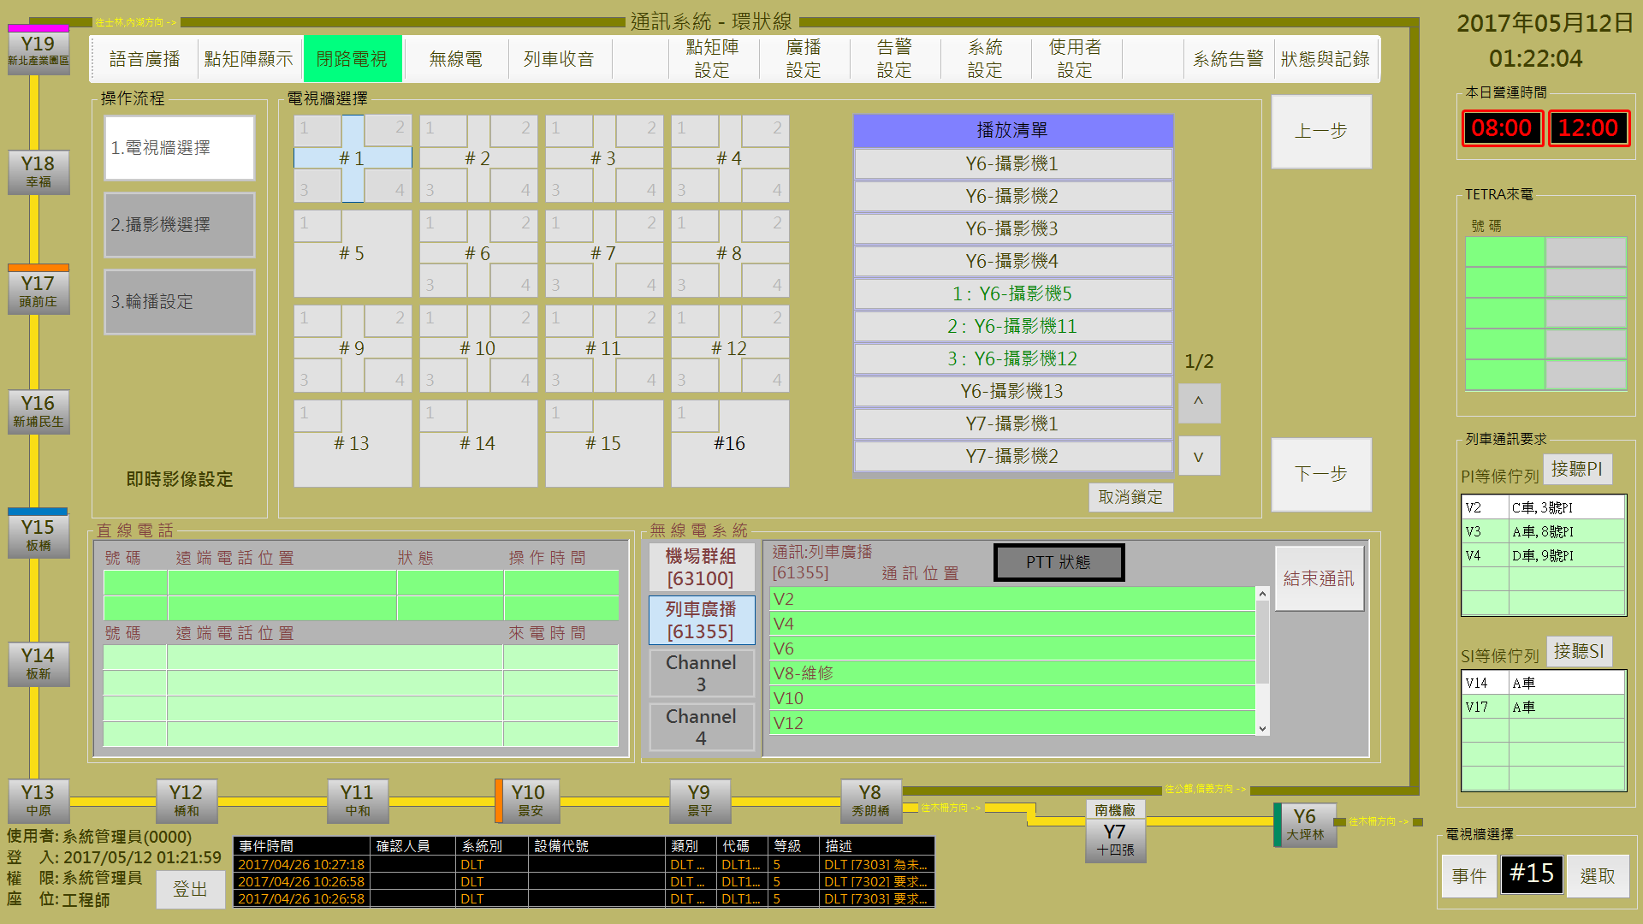

圖 3‑42: 閉路電視操作步驟1 (電視牆選擇)

Figure 3‑42: CCTV operation step 1 (TV Wall Select)

##### 步驟2攝影機選擇Step 2 Select Camera

操作人員先透過**車站**列表選擇車站，再選擇**攝影機選擇**列表的攝影機群組，所選的攝影機群組會和原有已在播放的攝影機一起顯示在**已選擇項目**的列表內 (如圖 3‑43)。確認選取後，請按 “**下一步**” 按鈕進行下一步驟，如果要變更播放電視，請按 “**上一步**” 按鈕回前一個操作頁面。

Operator select station in the “**車站**” (Station List) table first, then select the camera group in the “**攝影機選擇**” (Camera Group) table. The selected camera will list in the “**已選擇項目**” (Selected Camera) block together with the already selected cameras (as Figure 3‑43). After selection confirmed, please click “**下一步**” (Next Step) button to next step. If want to change TV, please click “**上一步**” (Last Step) button back to the TV select page.

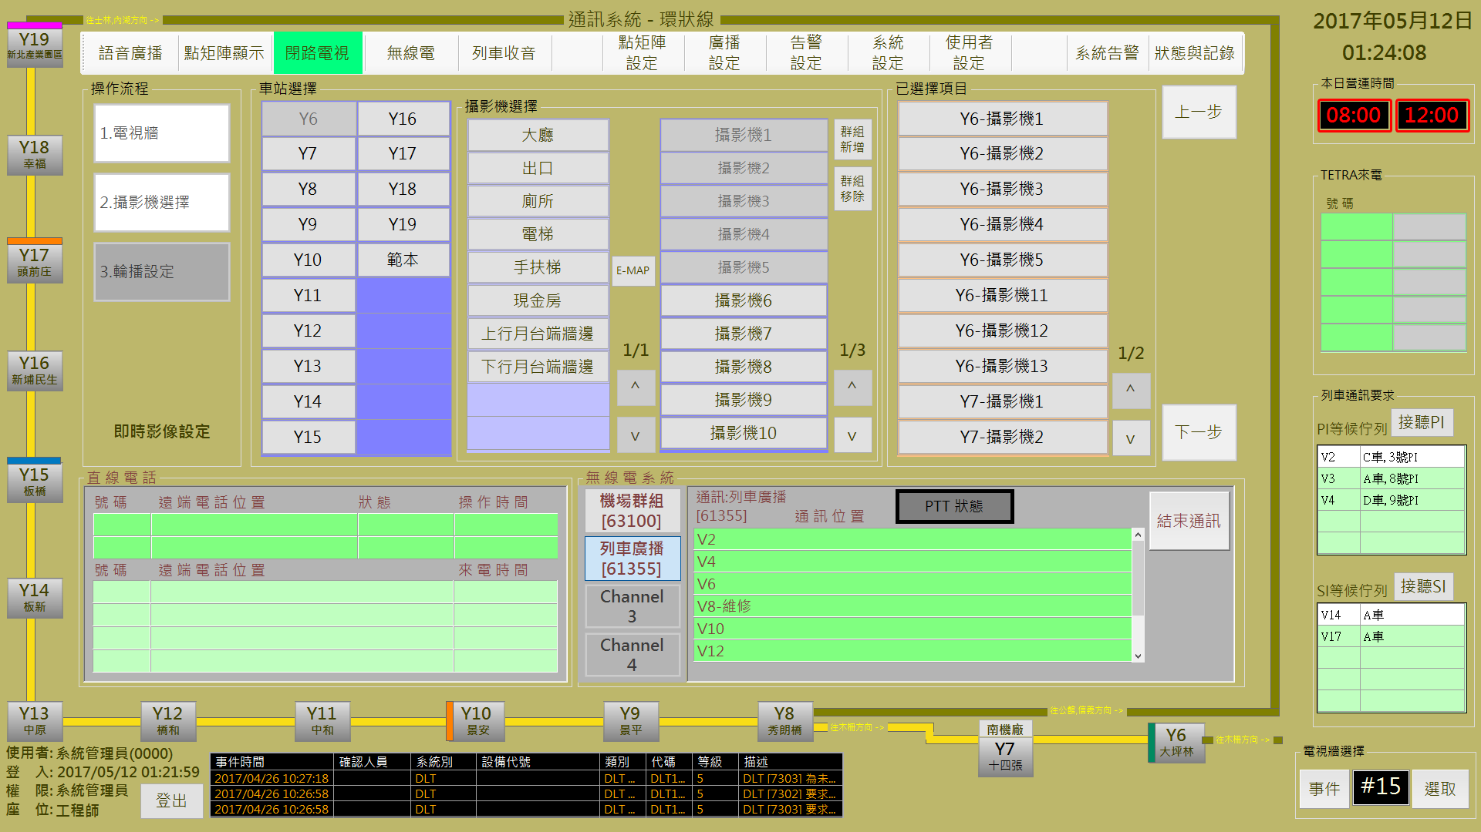

圖 3‑43: 閉路電視操作步驟2 (攝影機選擇)

Figure 3‑43: CCTV operation step 2 (Select Camera)

操作人員可以在**攝影機選擇**列表的攝影機群組內，使用 ”**群組新增**” 功能建立新群組；或 ”**群組刪除**” 功能刪除指定群組。

Operator can use “**群組新增**” (Add Group) button in “**攝影機選擇**” (Camera Group ) block to build new group or using “**群組刪除**” (Delete Group) button to delete a specified group.

##### 使用E-MAP設定攝影機 Using E-MAP Choosing Camera

操作人員也可以用**攝影機選擇**區塊內的 “**E-MAP**” 功能，進行攝影機選擇處理。

Operator can use “E-MAP” button to progress cameras selection.

###### 選擇攝影機 Choosing Camera

本作業會結合現場平面圖，以方便操作人員選擇要加入監控的攝影機。操作人員可於平面圖上直接點選攝影機進行選取或移除，選取結果會加入右側的**已選擇項目區塊**列表內。(如圖 3‑44)

This assignment will combine the floor plan to provide operator to choose cameras more easily.Operator can click the camera show on floor plan to select or remove. Select result will show in the list of “**已選擇項目**” (Selected List) block (as Figure 3‑44).

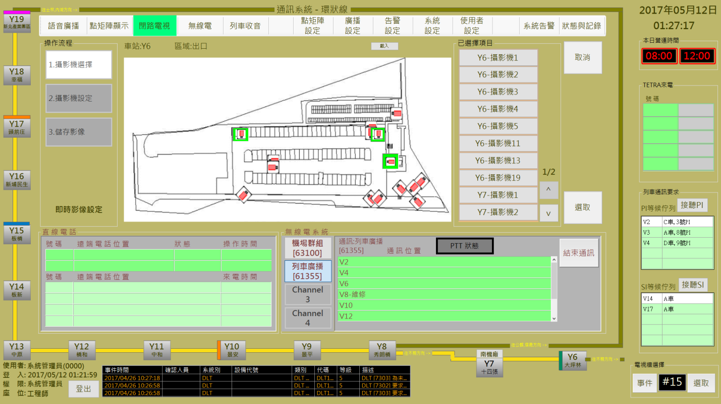

圖 3‑44: 使用E-MAP 選取攝影機

Figure 3‑44: Using E-MAP fuction for camera selection

確認選取後，請按 “**選取**” 按鈕進行下一步驟，如果要放棄操作，請按 “**取消**” 按鈕回前一個操作頁面。

After selection confirmed, please click “**選取**” (Confirm) button to next step. If want to abort operation, please click “**取消**” (Cancel) button back to last page.

###### 攝影機設定 Camera Record Setup

操作人員可於**播放設定**區塊內指定播放時段、播放方式及跳播時間。設定完成後請按 ”**確認**” 按鈕, 系統會將指定影像以指定方式於右側的播放區內播放。(如圖 3‑45)

Operator can replay the images for the specified cameras with the specified time period, display mode and display time in the “**播放設定**” (Display Setup) block. After setup complete, please click the “**確認**” (Confirm) button . System will show the images with specified mode in the right side of operation area. (as Figure 3‑45).

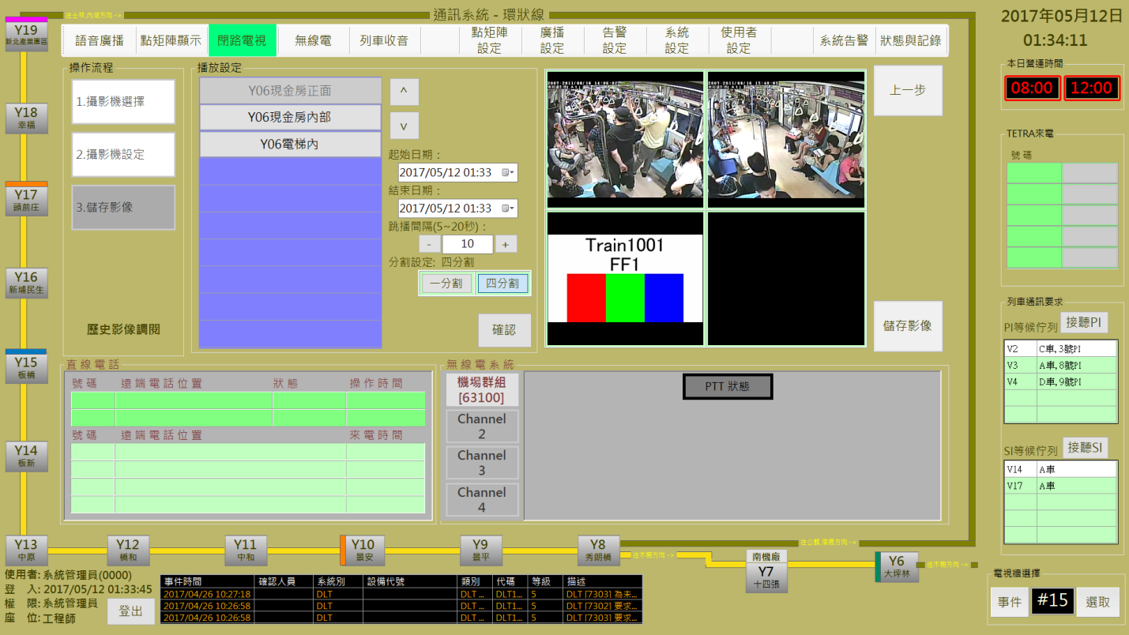

圖 3‑45: 攝影機影像檢視設定

Figure 3‑45: Camera images review setup

操作人員可用 “**儲存影像**” 按鈕到下一作業，或者按 “**上一步**” 按鈕回前一個操作頁面。

Operator can use “**儲存影像**” (Record Image) button to next step or use “**上一步**” (Last Step) button back to last page.

###### 儲存影像 Record Image

操作人員於檢視調播影像內容確認後，可按 ”**下載**” 按鈕將影像另外存檔。 (如圖 3‑46)

Operator can click**下載**“” (Download) button to store the replay images as independent file after review confirm (as Figure 3‑46).

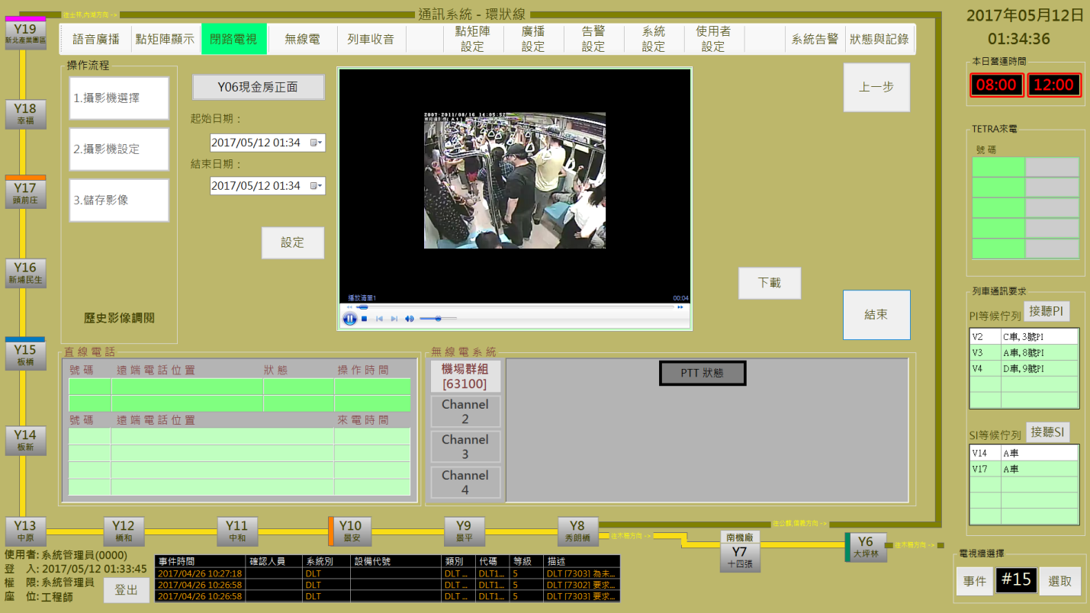

圖 3‑46: 攝影機檢視影像下載儲存

Figure 3‑46: Camera images review and download

操作人員可按 “**上一步**” 按鈕回前一個設定頁面。如果要結束操作，請按 ”**結束**” 按鈕。

Operator can use “**上一步**” (Last Step) button to Last step or use “**結束**” (Close) button to complete this operation.

##### 步驟3輪播設定 Step 3 Display by Turns Setup

操作人員可於本頁面設定**輪播間隔時間**及**畫面顯示方式** (全螢幕或1/4)。按 “**確認**” 鈕完成設定後,指定電視會開始依選取的攝影機進行播放，按 “**結束**” 鈕完成操作 (如圖 3‑47)。

**O**perator can set display time and select TV display mode (full screen or by quarter) for camera images display by turn. When operator click “**確認**” (Confirmed) button, specified TV will begin to work according to the setup conditions. If want to stop operation, please click “**結束**” (Close) button to finish operation (as Figure 3‑47).

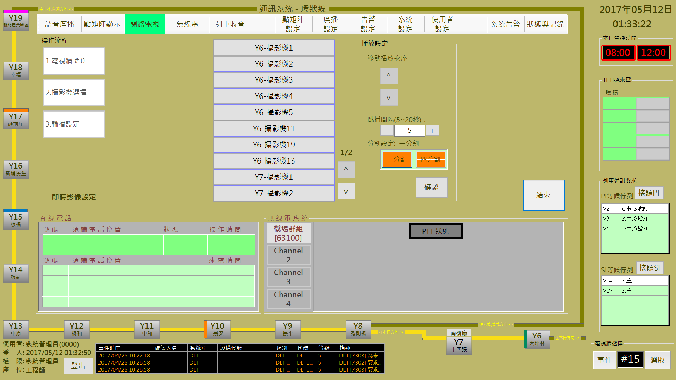

圖 3‑47: 閉路電視操作步驟3 (輪播設定)

Figure 3‑47: CCTV operation step 3 (Display by Turns Setup)

#### PTZ攝影機控制 PTZ Camera Control

本頁面用來進行球型攝影機的方向控制與錄像縮放距離，並且展示即時修改的攝影狀態。

This page is used to control the direction and zoom distance for PTZ camera, and display photographic status at the instantly modified

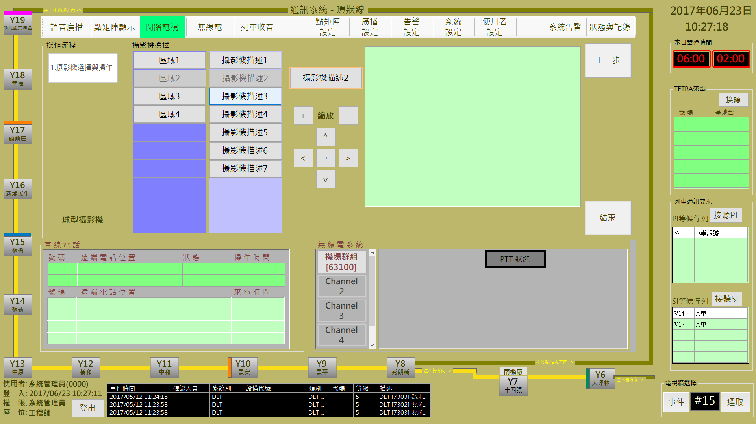

圖 3‑48: 球型攝影機操作設定

Figure 3‑48: The PTZ Setting

操作人員於PTZ操作業面中先進行攝影機選擇。攝影機選擇區域，將自動篩選含蓋球型攝影機的群組，當點選群組後將會顯示該群組內的所有球型攝影機清單。點選欲操控的攝影機如畫面中的橘色表格處，當影像顯示時表示連結成功，可以透過頁面中的上[↑]、下[↓]、左[←]、右[→]與縮[+]、放[-]等按鈕進行設定。

Operator must select the camera first on PTZ operation form。In Camera selection area, it will automatically filter the groups including the PTZ camera, and all PTZ camera of the group will display in list. Click the desired camera on the camera table, the camera will be shown on the orange table. When the image shows, it means that the link is successful.Operator can control the PTZ by the buttons including Up[↑], Down[↓], Right[←], Left[→], Zoom In [+] and Zoom Out [-] functions.

#### 即時影像設定 Real-time Image Setup

進行本作業, 請依 “**電視牆選擇**→**攝影機選擇**→**輪播設定**” 三個步驟進行。

Progress this function, please follow “**Select TV from TV Wall→Select Camera →Display Setup**” the three steps to operate.

##### 步驟1電視牆選擇 Step 1 Select TV from TV Wall

操作人員由**電視牆選擇**區塊內選取**電視編號**，系統會在**播放清單**列表內帶出該電視正在播放的影像清單 (如圖 3‑49)。選取完成後，請按 “**下一步**” 按鈕進行下一步驟，如果要變更作業項目，請按 “**上一步**” 按鈕回操作主頁。清除**播放清單**列表請按 ”**取消鎖定**” 鈕。

Operator select the display TV No. from the “**電視牆選擇**” (TV Wall Selection) block, system will show the camera list in the “**播放清單**” (DIsplay List) block (Figure 3‑49). After selection complete, please click “**下一步**” (Next Step) button to next step. If want to change operation item, please click “**上一步**” (Last Step) button back to the operation main page. To clear the selected camera, please click “**取消鎖定**” (Cancel Selection) button.



圖 3‑49: 閉路電視操作步驟1 (電視牆選擇)

Figure 3‑49: CCTV operation step 1 (TV Wall Select)

##### 步驟2攝影機選擇Step 2 Select Camera

操作人員先透過**車站**列表選擇車站，再選擇**攝影機選擇**列表的攝影機群組，所選的攝影機群組會和原有已在播放的攝影機一起顯示在**已選擇項目**的列表內 (如圖 3‑50。確認選取後，請按 “**下一步**” 按鈕進行下一步驟，如果要變更播放電視，請按 “**上一步**” 按鈕回前一個操作頁面。

Operator select station in the “**車站**” (Station List) table first, then select the camera group in the “**攝影機選擇**” (Camera Group) table. The selected camera will list in the “**已選擇項目**” (Selected Camera) block together with the already selected cameras (as Figure 3‑50). After selection confirmed, please click “**下一步**” (Next Step) button to next step. If want to change TV, please click “**上一步**” (Last Step) button back to the TV select page.



圖 3‑50: 閉路電視操作步驟2 (攝影機選擇)

Figure 3‑50: CCTV operation step 2 (Select Camera)

操作人員可以在**攝影機選擇**列表的攝影機群組內，使用 ”**群組新增**” 功能建立新群組；或 ”**群組刪除**” 功能刪除指定群組。

Operator can use “**群組新增**” (Add Group) button in “**攝影機選擇**” (Camera Group ) block to build new group or using “**群組刪除**” (Delete Group) button to delete a specified group.

操作人員也可以用**攝影機選擇**區塊內的 “**E-MAP**” 功能，進行攝影機選擇處理。詳細操作方式請參考 **3.2.10.1.3**節 “**使用E-MAP設定攝影機**”

Operator can use “E-MAP” button to progress cameras selection. Detail operation description please refer section **3.2.10.1.3 “Using E-MAP Choosing Camera”.**

##### 步驟3輪播設定 Step 3 Display by Turns Setup

操作人員可於本頁面設定**輪播間隔時間**及**畫面顯示方式** (全螢幕或1/4)。按 “**確認**” 鈕完成設定後,指定電視會開始依選取的攝影機進行播放，按 “**結束**” 鈕完成操作 (如圖 3‑51)。

**O**perator can set display time and select TV display mode (full screen or by quarter) for camera images display by turn. When operator click “**確認**” (Confirmed) button, specified TV will begin to work according to the setup conditions. If want to stop operation, please click “**結束**” (Close) button to finish operation (as Figure 3‑51).



圖 3‑51: 閉路電視操作步驟3 (輪播設定)

Figure 3‑51: CCTV operation step 3 (Display by Turns Setup)

### 點矩陣顯示 DMD Control

本作業含**列車PIDS**控制**、車站DMD**控制二個操作項目 (如圖 3‑52)。

This function include **Car PIDS Control** and **Station DMD Control** two operation items (as Figure 3‑52).

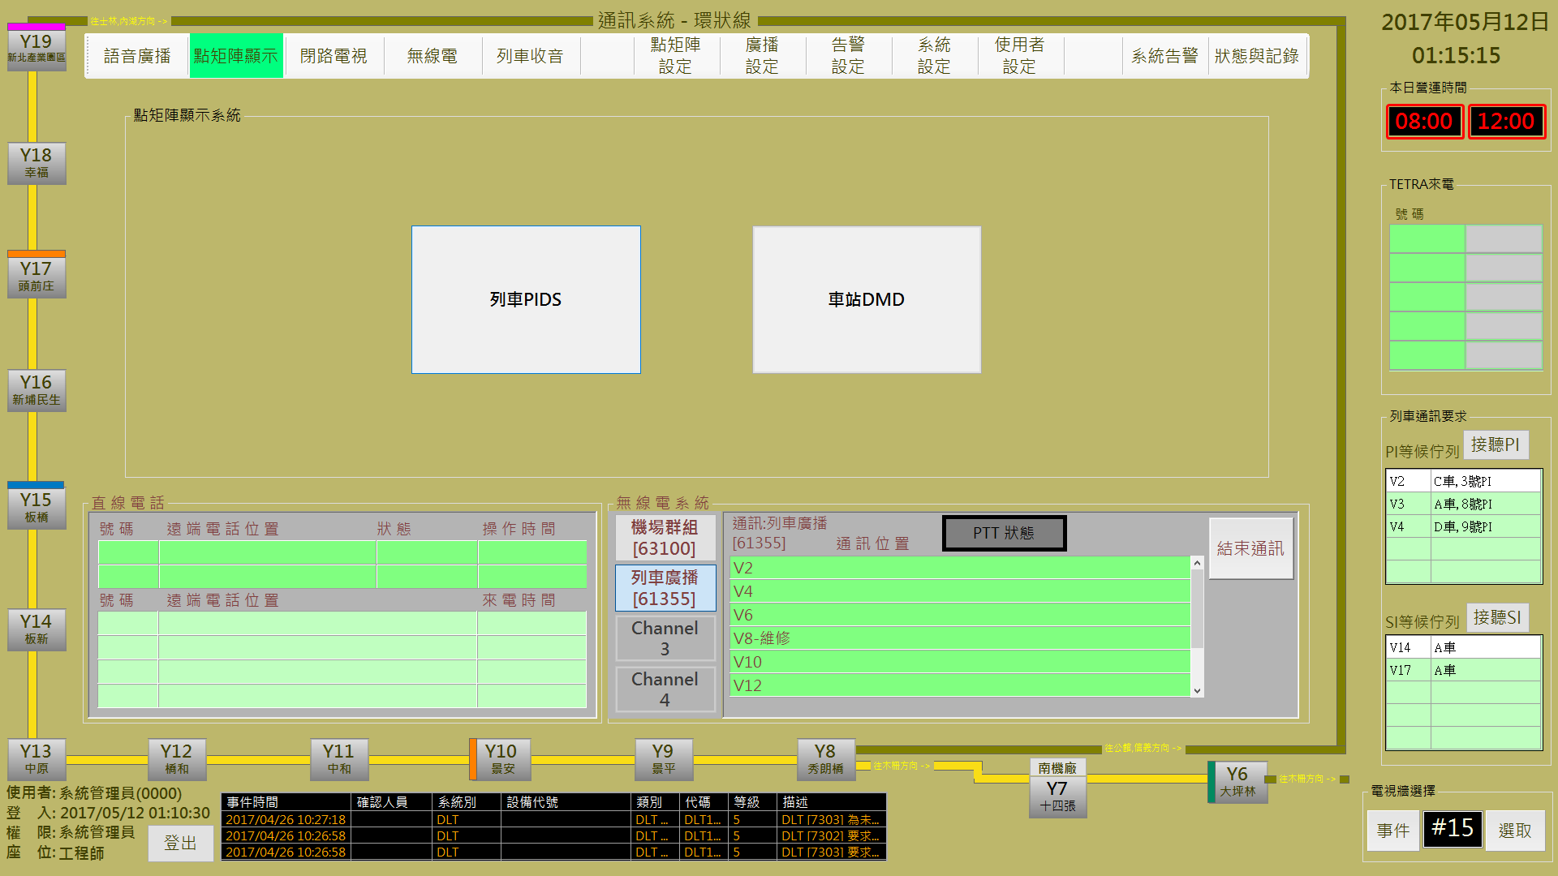

圖 3‑52: 點矩陣顯示器控制操作主頁

Figure 3‑52: Main page of DMD operation

#### 列車PIDS控制 Car PIDS Control

進行本作業，請依 “**位置群組選擇**→**廣播方式及內容**→**開始播放**” 三個步驟進行。

Progress this function, please follow “**Select Location →Select Content and Display Mode →Start Display**” the three steps to operate.

##### 步驟1位置群組選擇 Step 1 Select Position

操作人員於本程序內選取**列車** (可多選) (如圖 3‑53)。選取完成後，請按 “**下一步**” 按鈕進行下一步驟，如果要變更作業項目，請按 “**上一步**” 按鈕回功能主頁。

Operator select the car(s) in this step (as Figure 3‑53). After selection complete, please click “**下一步**” (Next Step) button to next step. If want to change operation item, please click “**上一步**” (Last Step) button back to the operation main page.

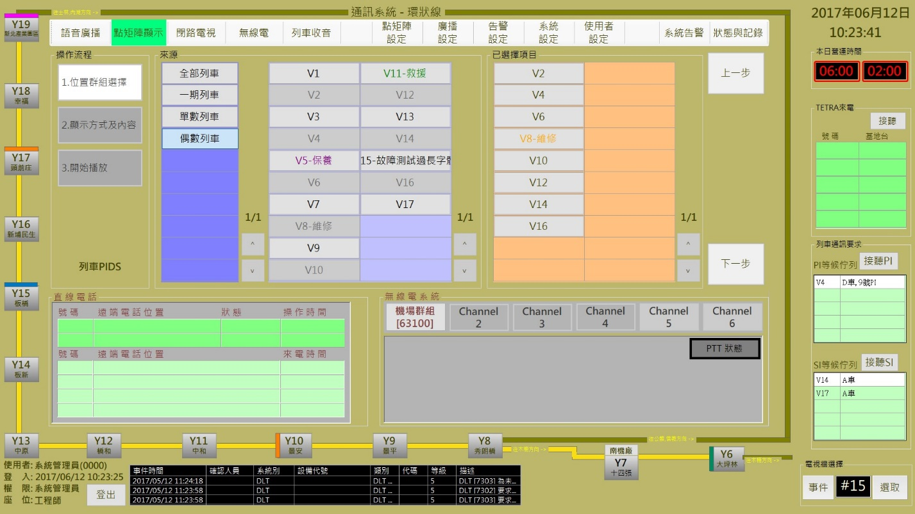

圖 3‑53: 列車PIDS控制 步驟1 (位置群組選擇)

Figure 3‑53: Car PIDS control step 1 (Select Location)

##### 預錄訊息與即時訊息 Pre-record Message and Real-time Message

操作人員可選擇播放**預錄訊息**或**即時訊息**，分別說明如后:

Operator can select to display pre-record essage or real-time message. Operation will be descripted as below:

###### 播放預錄訊息處理 Pre-record Message Display Process

**步驟2:** 操作人員點選 “**廣播方式及內容**” 區的 “**預錄訊息**” 頁簽後，可開啟播放預錄訊息操作頁面 (也是預設作業)。然後選擇準備播放的訊息，完成類型及播放次數設定，按 ”**播放**” 開始進行播放處理，按 ” **上一 步**” 回前一操作頁面(如圖 3‑54)

**Step 2:** Operator select “**預錄訊息**” (Pre-record Message) tab in “**廣播方式及內容**” (Select Content and Display Mode) block to open pre-record message display setup page (This is default operation page also). Then select message, set message type and the display times to complete operation. After operation finish, please click “**播放**” (Start) button to progress remote message display program. Click “**上一步**” (Last Step) button back to the last step (as Figure 3‑54).

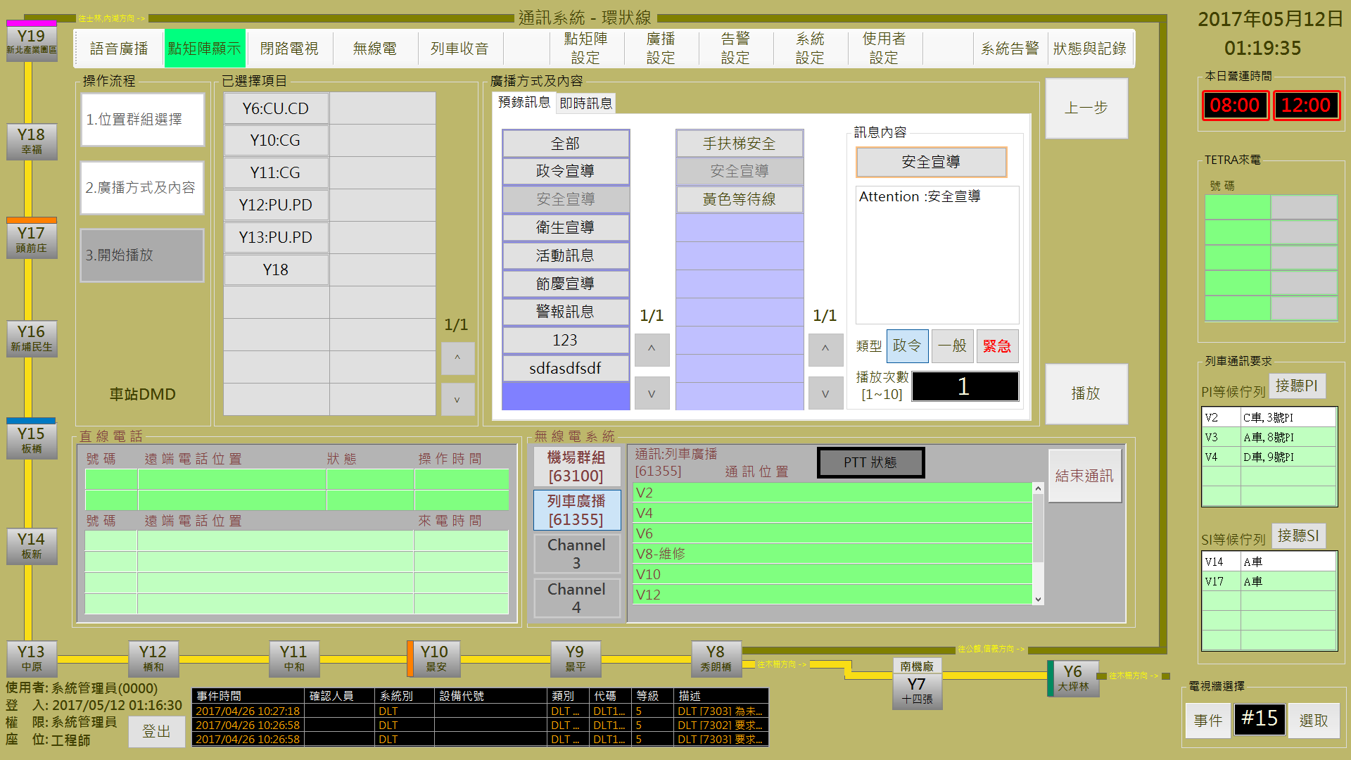

圖 3‑54: 預錄訊息播放操作

Figure 3‑54: Pre-record message display operation

如果**訊息類型**選取 “**緊急**”，顯示次數預設是 “**∞**” ，但是可以變更。

If **message type** is “**緊急**” (Emergency), the default display times is “**∞**” (unlimited) but can be changed.

**步驟3:**系統開始播放時會先連接指定車站系統，如果正常會在 “**已選擇項目**” 的指定車站及設備上顯示 “**成功**” 狀態，否則會顯示 “**失敗**”(如圖 3‑55)。結束作業請按 “**結束**” 按鈕。

**Step 3:** will response ”**成功**” (Success) status in the station(s) and equipment(s) table of “**已選擇項目**” (Selected Station) block. Otherwise, it will show “**失敗**” (Faild) status (as Figure 3‑55). To finish this operation, please click “**結束**” (Close) button.

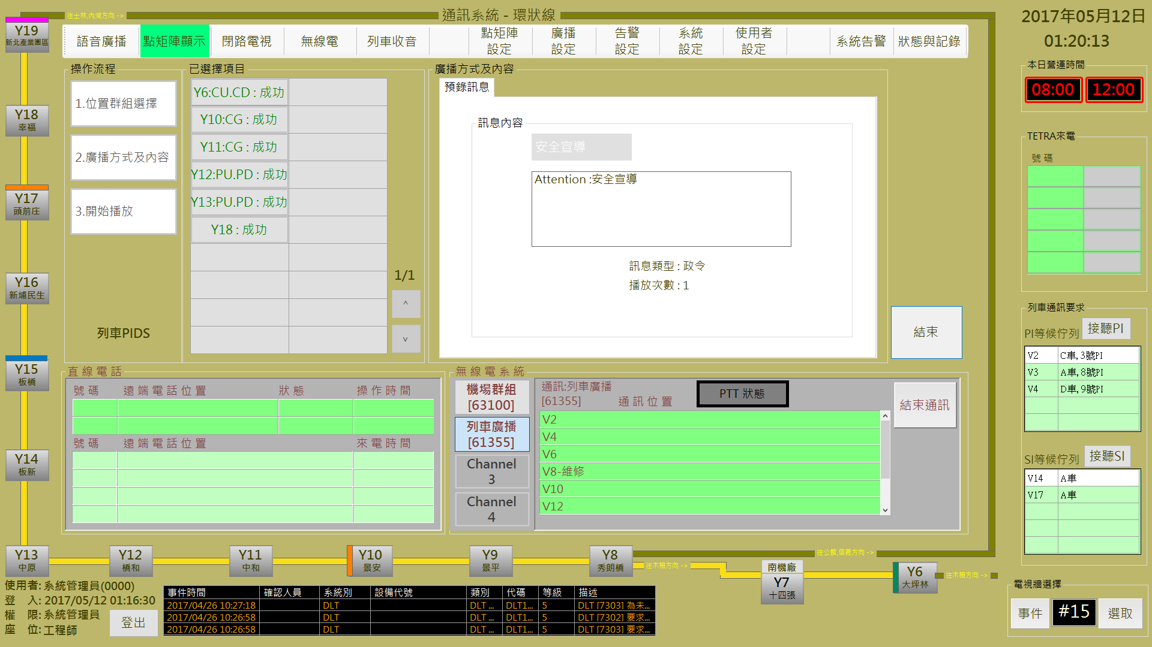

圖 3‑55: 預錄訊息播放結果回報

Figure 3‑55: Pre-record message display result

###### 播放即時訊息處理 Real-time Message Display Process

**步驟2:** 操作人員點選 “**廣播方式及內容**” 區的 “**即時訊息**” 頁簽後，可開啟播放即時訊息操作頁面。然後輸入準備播放的訊息，完成類型及播放次數設定後，按 ”**播放**” 開始進行播放處理，按 ” **上一步**” 回前一操作頁面(如圖 3‑56)

**Step 2:** Operator select “**即時訊息**” (Real-time Message) tab in “**廣播方式及內容**” (Select Content and Display Mode) block to open real-time message display setup page. Then input the message content, set message type and the display times to complete operation. After operation finish, please click “**播放**” (Start) button to progress remote message display program. Click “**上一步**” (Last Step) button back to the last step (as Figure 3‑56).

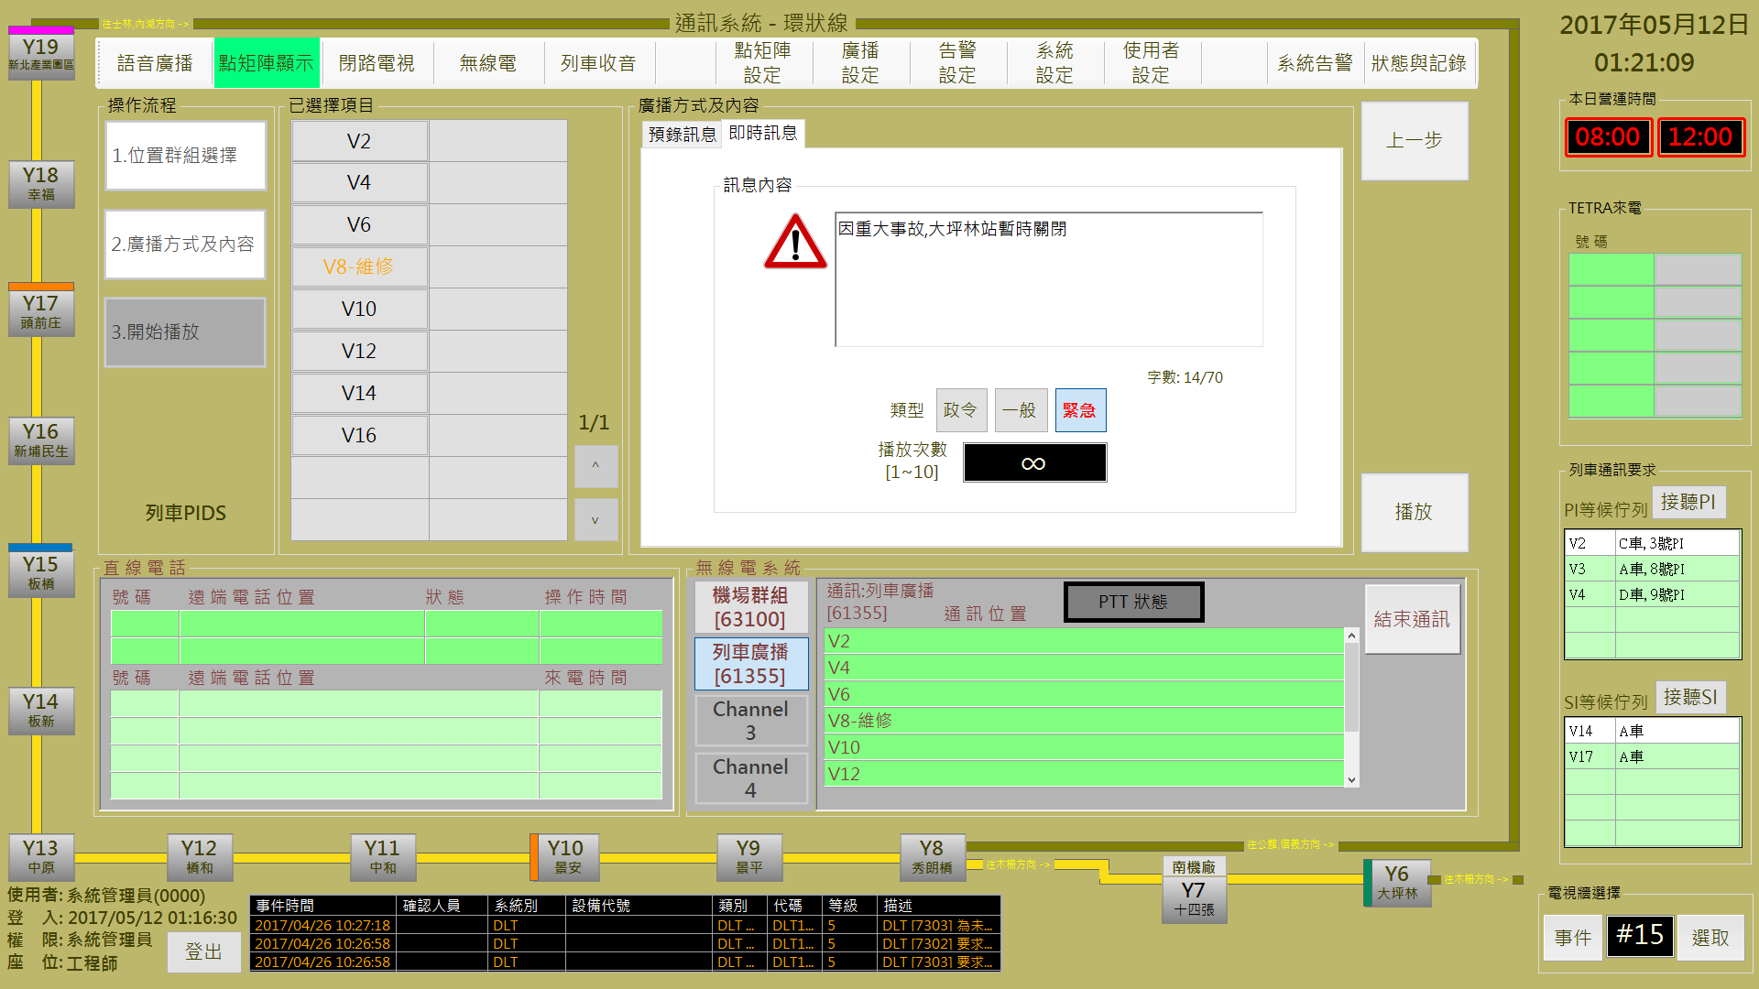

圖 3‑56: 播放即時訊息操作

Figure 3‑56: Display real-time message operation

即時訊息顯示次數預設是 “**∞**” ，但是可以變更。

The default display times for real-time message is “**∞**” (unlimited) but can be changed.

**步驟3:**系統開始播放時會先連接指定車站系統，如果正常會在 “**已選擇項目**”的指定車站及設備上顯示 “**成功**” 狀態，否則會顯示 “**失敗**”(如圖 3‑57)。結束作業請按 “**結束**” 按鈕。系統另外提供 “**重試**” 功能，可以再次嘗試傳送設定訊息。

**Step 3:** When system start to display message, it will try to connect to specified station(s) system. If success, it will response ”**成功**” (Success) status in the station(s) and equipment(s) table of “**已選擇項目**” (Selected Station) block. Otherwise, it will show “**失敗**” (Faild) status (as Figure 3‑57). To finish this operation, please click “**結束**” (Close) button. Additional function button “**重試**” (Retry) is provided for message resend

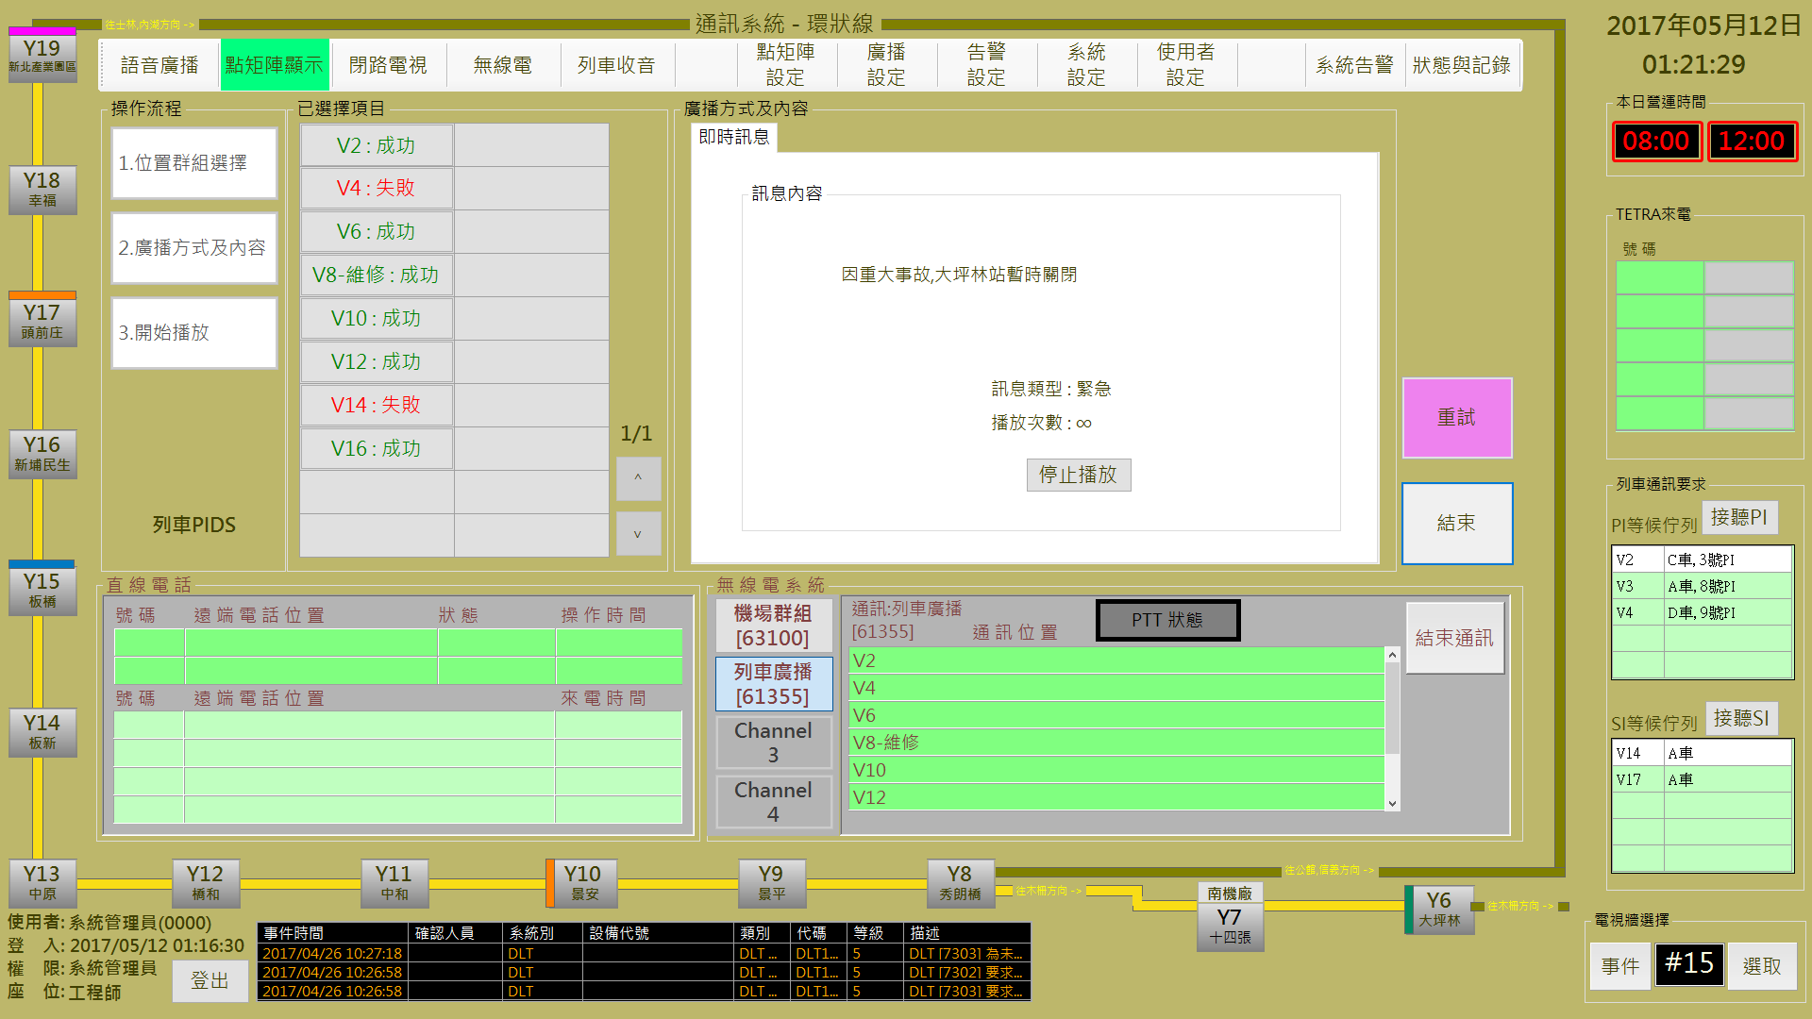

圖 3‑57: 即時訊息播放結果回報

Figure 3‑57: Real-time message display result

即時訊息播放過程中,可隨時按 “**停止播放**” 按鈕終止訊息播放。

Durring Real-time message display, operator can click “**停止播放**” (Stop display) to stop message display.

#### 車站DMD控制 Station DMD Control

進行本作業，請依 “**位置群組選擇**→**廣播方式及內容**→**開始播放**” 三個步驟進行。

Progress this function, please follow “**Select Location →Select content and Display Mode →Start Display**” the three steps to operate.

##### 步驟1位置群組選擇 Step 1 Select Position

操作人員於本程序內選取**車站**及**DMD**的位置 (可多選) (如圖 3‑58)。選取完成後，請按 “**下一步**” 按鈕進行下一步驟，如果要變更作業項目，請按 “**上一步**” 按鈕回功能主頁。

Operator select the station(s) and display DMD(s) position in this step (as Figure 3‑58). After selection complete, please click “**下一步**” (Next Step) button to next step. If want to change operation item, please click “**上一步**” (Last Step) button back to the operation main page.

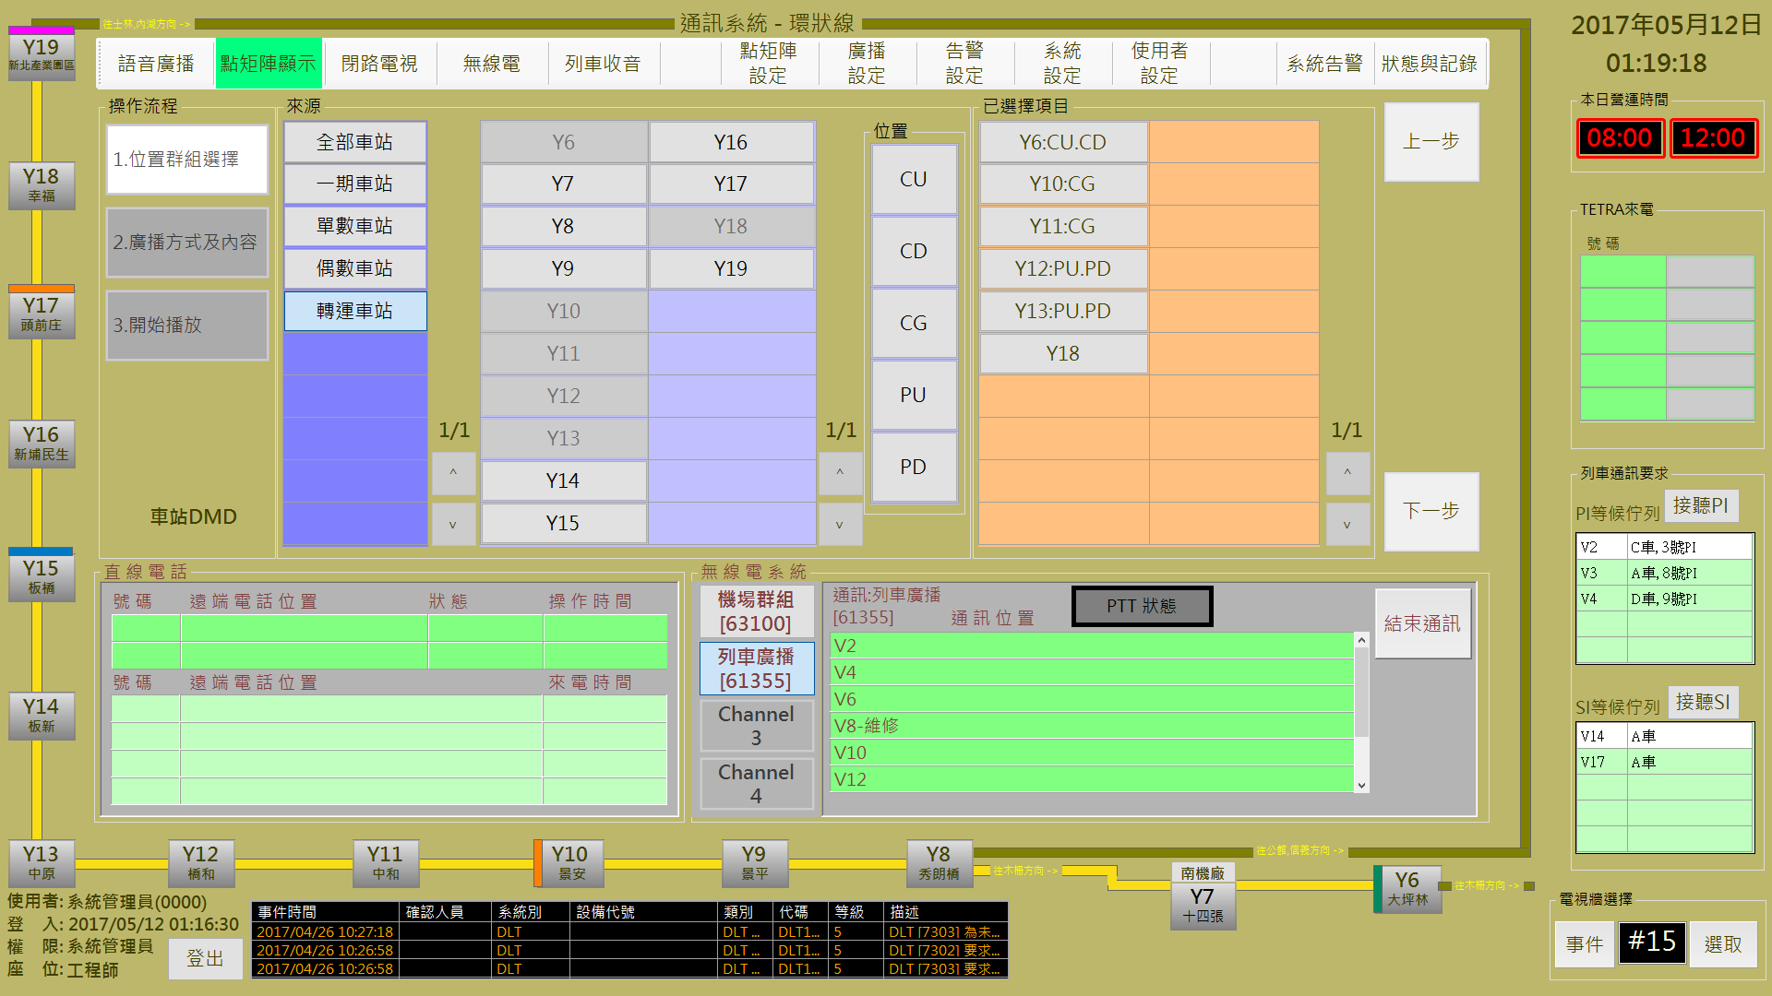

圖 3‑58: 車站DMD控制 步驟1 (位置群組選擇)

Figure 3‑58: Station DMD control step 1 (Select Location)

##### 預錄訊息與即時訊息 Pre-record Message and Real-time Message

操作人員可選擇播放**預錄訊息**或**即時訊息**，分別說明如后:

Operator can select to display pre-record message or real-time message. Operation will be descripted as below:

###### 播放預錄訊息處理 Pre-record Message Display Process

**步驟2:** 操作人員點選 “**廣播方式及內容**” 區的 “**預錄訊息**” 頁簽後，可開啟播放預錄訊息操作頁面 (也是預設作業)。然後選擇準備播放的訊息，完成類型及播放次數設定，按 ”**播放**” 開始進行播放處理，按 ” **上一 步**” 回前一操作頁面(如圖 3‑59)

**Step 2:** Operator select “**預錄訊息**” (Pre-record Message) tab in “**廣播方式及內容**” (Select Content and Display Mode) block to open pre-record message display setup page (This is default operation page also). Then select message, set message type and the display times to complete operation. After operation finish, please click “**播放**” (Start) button to progress remote message display program. Click “**上一步**” (Last Step) button back to the last step (as Figure 3‑59).



圖 3‑59: 預錄訊息播放操作

Figure 3‑59: Pre-record message display operation

如果**訊息類型**選取 “**緊急**”，顯示次數預設是 “**∞**” ，但是可以變更。

If **message type** is “**緊急**” (Emergency), the default display times is “**∞**” (unlimited) but can be changed.

**步驟3:**系統開始播放時會先連接指定車站系統，如果正常會在 “**已選擇項目**” 的指定車站及設備上顯示 “**成功**” 狀態，否則會顯示 “**失敗**”(如圖 3‑60)。結束作業請按 “**結束**” 按鈕。

**Step 3:** will response ”**成功**” (Success) status in the station(s) and equipment(s) table of “**已選擇項目**” (Selected Station) block. Otherwise, it will show “**失敗**” (Faild) status (as Figure 3‑60). To finish this operation, please click “**結束**” (Close) button.



圖 3‑60: 預錄訊息播放結果回報

Figure 3‑60: Pre-record message display result

###### 播放即時訊息處理 Real-time Message Display Process

**步驟2:** 操作人員點選 “**廣播方式及內容**” 區的 “**即時訊息**” 頁簽後，可開啟播放即時訊息操作頁面。然後輸入準備播放的訊息，完成類型及播放次數設定後，按 ”**播放**” 開始進行播放處理，按 ” **上一步**” 回前一操作頁面(如圖 3‑61)

**Step 2:** Operator select “**即時訊息**” (Real-time Message) tab in “**廣播方式及內容**” (Select Content and Display Mode) block to open real-time message display setup page. Then input the message content, set message type and the display times to complete operation. After operation finish, please click “**播放**” (Start) button to progress remote message display program. Click “**上一步**” (Last Step) button back to the last step (as Figure 3‑61).



圖 3‑61: 播放即時訊息操作

Figure 3‑61: Display real-time message operation

即時訊息顯示次數預設是 “**∞**” ，但是可以變更。

The default display times for real-time message is “**∞**” (unlimited) but can be changed.

**步驟3:**系統開始播放時會先連接指定車站系統，如果正常會在 “**已選擇項目**”的指定車站及設備上顯示 “**成功**” 狀態，否則會顯示 “**失敗**”(如圖 3‑62)。結束作業請按 “**結束**” 按鈕。系統另外提供 “**重試**” 功能，可以再次嘗試傳送設定訊息。

**Step 3:** When system start to display message, it will try to connect to specified station(s) system. If success, it will response ”**成功**” (Success) status in the station(s) and equipment(s) table of “**已選擇項目**” (Selected Station) block. Otherwise, it will show “**失敗**” (Faild) status (as Figure 3‑62). To finish this operation, please click “**結束**” (Close) button. Additional function button “**重試**” (Retry) is provided for message resend



圖 3‑62: 即時訊息播放結果回報

Figure 3‑62: Real-time message display result

即時訊息播放過程中,可隨時按 “**停止播放**” 按鈕終止訊息播放。

Durring Real-time message display, operator can click “**停止播放**” (Stop display) to stop message display.

### 語音通訊 Voice Communication

本作業含**列車語音廣播**控制**、車站語音廣播**控制二個操作項目 (如圖 3‑63)。

This function include **Car Broadcast Control** and **Station Broadcast Control** two operation items (as Figure 3‑63).

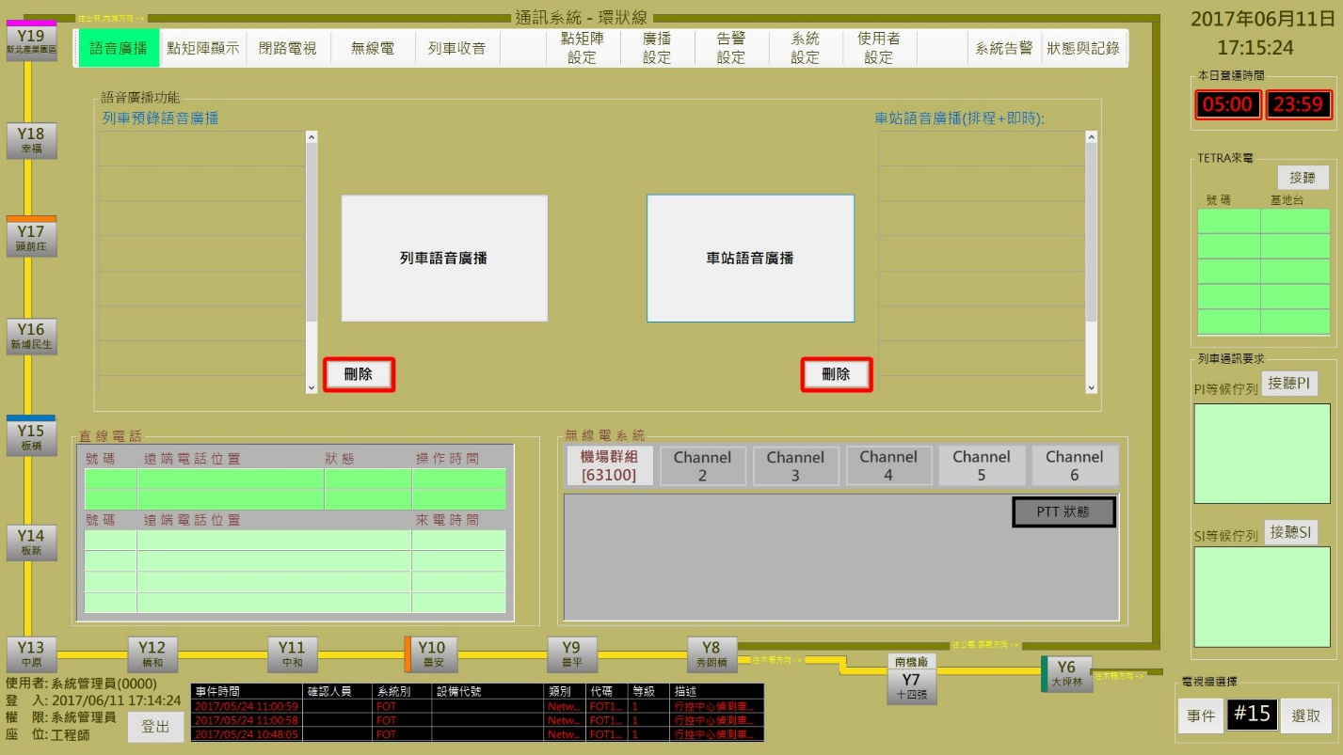

圖 3‑63: 語音通訊控制操作主頁

Figure 3‑63: Main page of voice communication operation

所有的列車語音廣播排程設定內容會列在**列車站語音廣播**功能項目左方的 ”**列車預錄語音廣播**” 列表內，所有的車站語音廣播排程設定內容則會列在**車站語音廣播**功能項目的右方，以供參考。系統允許操作人員選取非預定排程項目後，使用刪除按鈕將之移除.

All the car(s) broadcast schedule(s) will list at the left side of “**列車語音廣播**” (Car Broacast Control) function button and the station Broadcast schedule(s) will list at the right side of “**車站語音廣播**” (Station Broacast Control) function button for reference. Operator can select the non-scheduled items and use the “**刪除**” (Delete) button to stop and remove them from the list.

#### 列車語音廣播控制 Car Broadcast Control

進行本作業，請依 “**位置群組選擇**→**廣播方式及內容**→**開始播放**” 三個步驟進行。

Progress this function, please follow “**Select Car →Select Content and Language →Start Broadcast**” the three steps to operate.

##### 步驟1位置群組選擇 Step 1 Select Position

操作人員於本程序內選取**列車** (可多選) (如圖 3‑64)。選取完成後，請按 “**下一步**” 按鈕進行下一步驟，如果要變更作業項目，請按 “**上一步**” 按鈕回功能主頁。

Operator select the car(s) in this step (as Figure 3‑64). After selection complete, please click “**下一步**” (Next Step) button to next step. If want to change operation item, please click “**上一步**” (Last Step) button back to the operation main page.

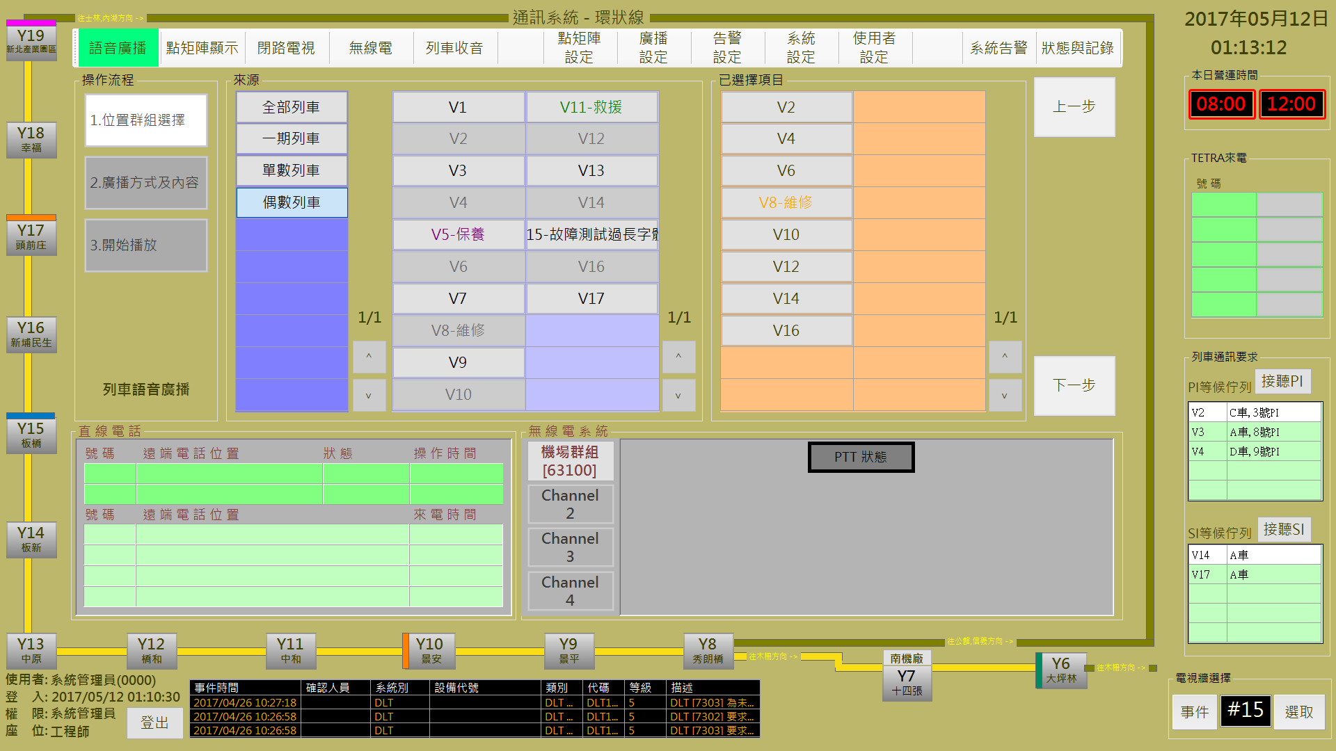

圖 3‑64: 列車語音廣播控制 步驟1 (位置群組選擇)

Figure 3‑64: Car broadcast control step 1 (Select Car)

##### 預錄廣播與即時廣播 Pre-record Broadcast and Real-time Broadcast

操作人員可選擇播放**預錄廣播**或**即時廣播**，分別說明如后:

Operator can select **pre-record broadcast** or **real-time broadcast** for broadcasting. Operation will be descripted as below:

###### 播放預錄廣播處理 Pre-record Message broadcast Process

**步驟2:** 操作人員點選 “**廣播方式及內容**” 區的 “**預錄廣播**” 頁簽後，可開啟播放預錄廣播操作頁面 (也是預設作業)。然後選擇準備播放的內容，完成**語言**及**播放次數**設定，按 ”**播放**” 開始進行播放處理，按 ” **上一 步**” 回前一操作頁面(如圖 3‑65)

**Step 2:** Operator select “**預錄廣播**” (Pre-record Broadcast) tab in “**廣播方式及內容**” (Select Content and Language) block to open pre-record message setup page (This is default operation page also). Then select message, set **language** and the **broadcast times** to complete operation. After operation finish, please click “**播放**” (Start) button to progress remote message broadcast program. Click “**上一步**” (Last Step) button back to the last step (as Figure 3‑65).

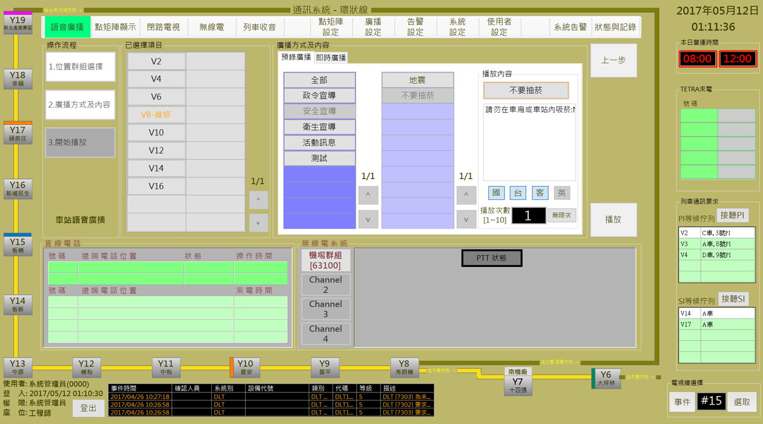

圖 3‑65: 預錄廣播廣播設定

Figure 3‑65: Pre-record message broadcast setup

**步驟3:**系統開始播放時會先連接指定列車，如果正常會在 “**已選擇項目**”的指定列車會顯示 “**連線**” 狀態，否則會顯示 “**失敗**”(如圖 3‑66)。結束作業請按 “**結束**” 按鈕。系統另外提供 “**重試**” 功能，可以再次嘗試傳送設定訊息。

**Step 3:** When system start to broadcast, it will try to connect to specified car(s). If success, it will response ” **連線**” (Connect) status in the car(s) table of “**已選擇項目**” (Selected Car) block. Otherwise, it will show “**失敗**” (Faild) status (as Figure 3‑66). To finish this operation, please click “**結束**” (Close) button. Additional function button “**重試**” (Retry) is provided for message resend

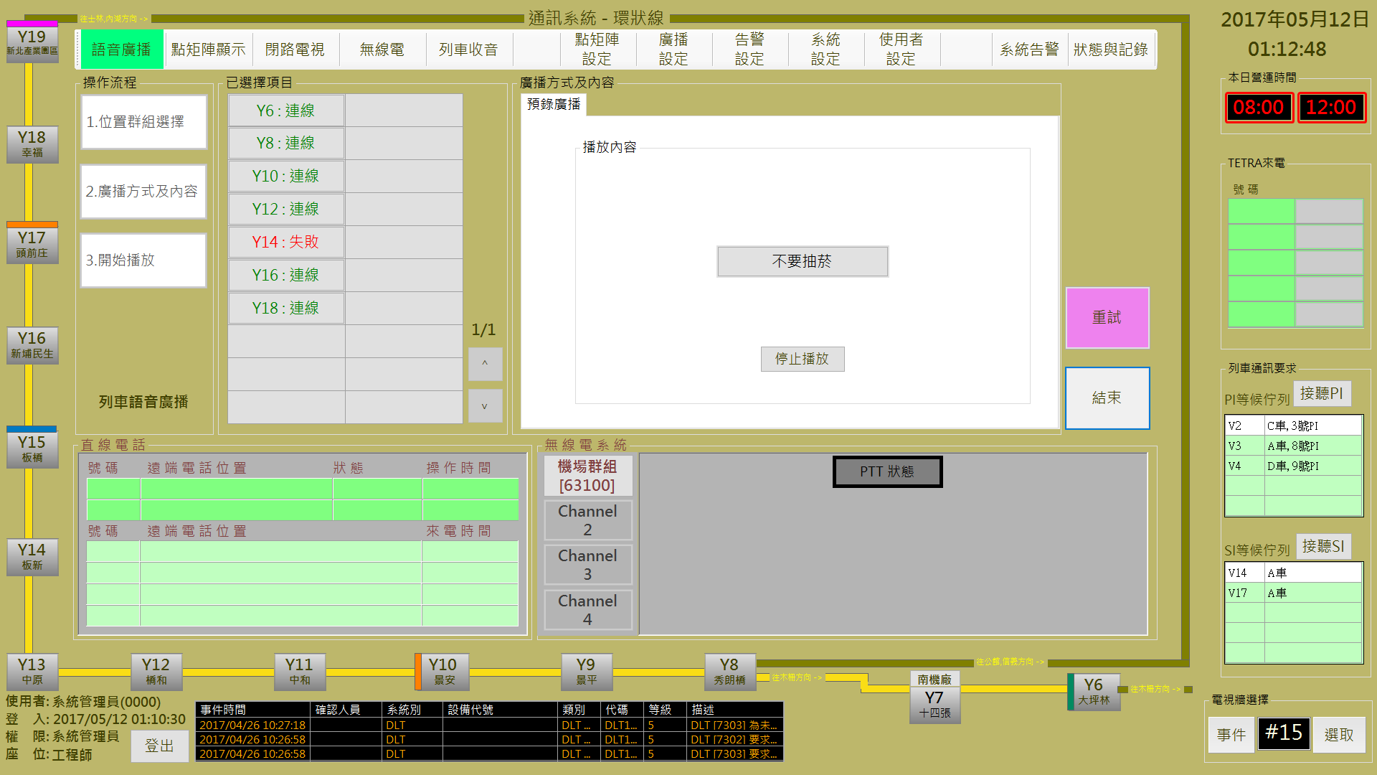

圖 3‑66: 預錄廣播播放結果回報

Figure 3‑66: Pre-record message broadcast result

訊息播放過程中,可隨時按 “**停止播放**” 按鈕終止訊息播放。

Durring message broadcasting, operator can click “**停止播放**” (Stop Broadcast) to stop.

###### 即時廣播處理 Real-time Broadcast Process

**步驟2:** 操作人員點選 “**廣播方式及內容**” 區的 “**即時訊息**” 頁簽後，可開啟播放即時廣播操作頁面。按 ”**播放**” 開始進行播放處理，按 ” **上一步**” 回前一操作頁面(如圖 3‑67)

**Step 2:** Operator select “**即時廣播**” (Real-time Broadcast) tab in “**廣播方式及內容**” (Select Content and Language) block to open real-time broadcast page. After operation finish, please click “**播放**” (Start) button to progress remote message display program. Click “**上一步**” (Last Step) button back to the last step (as Figure 3‑67).

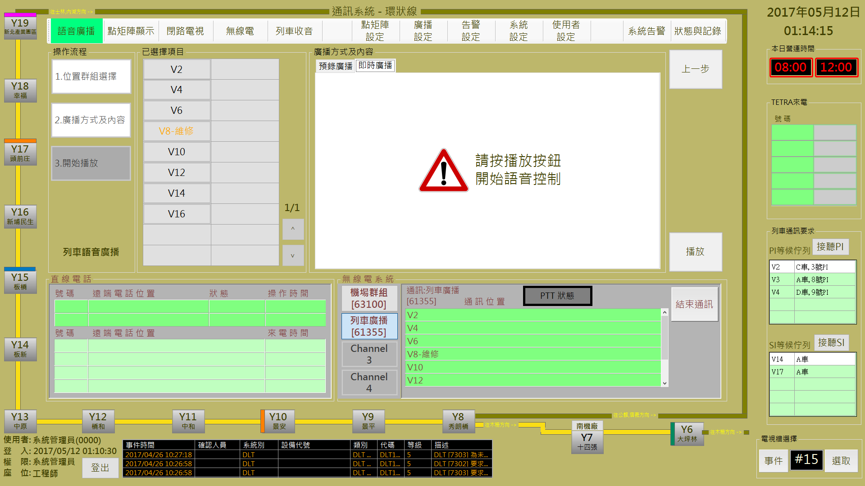

圖 3‑67: 播放即時訊息操作

Figure 3‑67: Display real-time message operation

操作人員按 ”**播放**” 後，系統會自動生成**列車廣播群組**，並開啟無線電列車廣播群組頻道，即可直接廣播。按 “**結束通訊**” 可關閉無線頻道，結束廣播。

When operator click “**播放**” (Start) button, system will auto-create the “**列車廣播**” (Car Broadcast) radio group and radio channel to progress car(s) broadcast. Click ” **結束通訊**” (Stop Communication) button can stop broadcast and release this radio channel.

#### 車站語音廣播控制 Station Broadcast Control

進行本作業，請依 “**位置群組選擇**→**廣播方式及內容**→**開始播放**” 三個步驟進行。

Progress this function, please follow “**Select Car →Select Content and Language →Start Broadcast**” the three steps to operate.

##### 步驟1位置群組選擇 Step 1 Select Position

操作人員於本程序內選取**車站** (可多選) (如圖 3‑68)。選取完成後，請按 “**下一步**” 按鈕進行下一步驟，如果要變更作業項目，請按 “**上一步**” 按鈕回功能主頁。

Operator select the station(s) in this step (as Figure 3‑68). After selection complete, please click “**下一步**” (Next Step) button to next step. If want to change operation item, please click “**上一步**” (Last Step) button back to the operation main page.

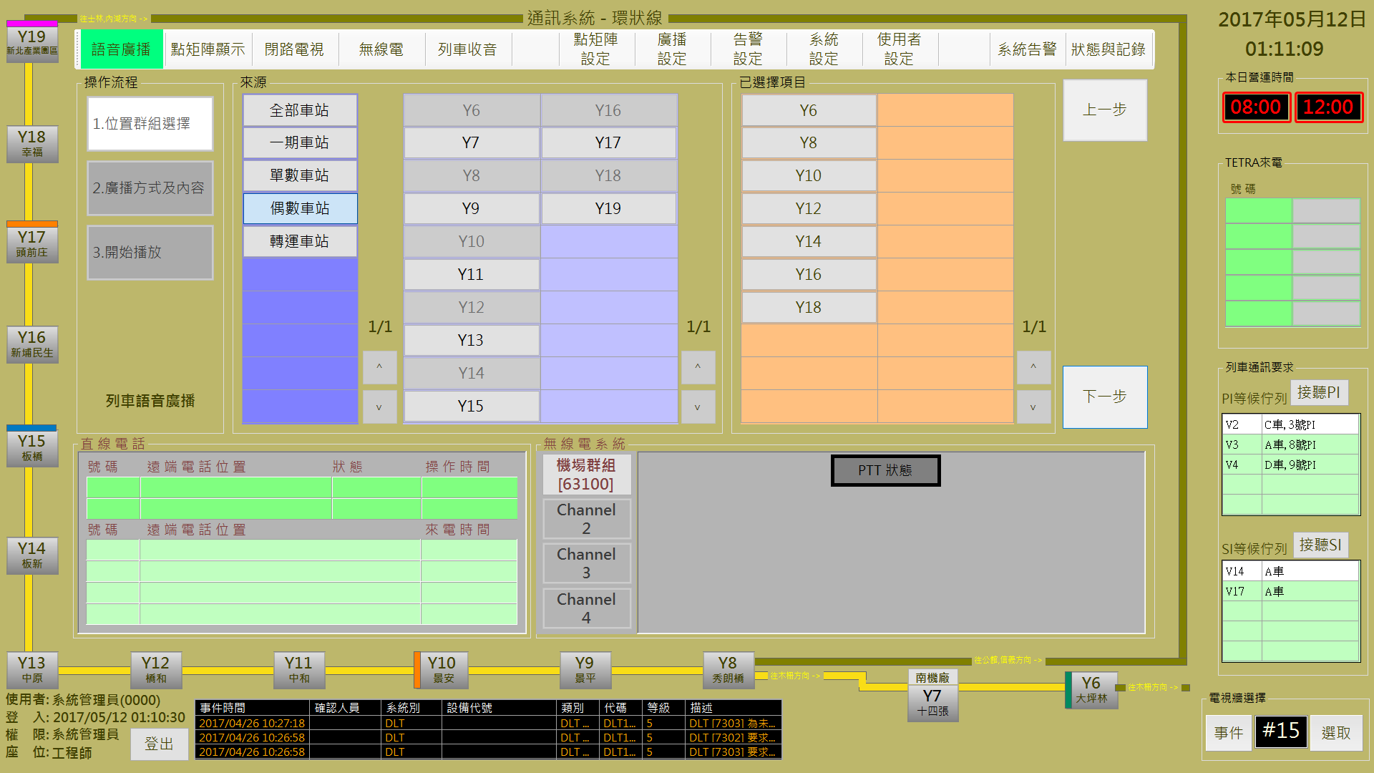

圖 3‑68: 車站語音廣播控制 步驟1 (位置群組選擇)

Figure 3‑68: Station broadcast control step 1 (Select Station)

##### 預錄廣播與即時廣播 Pre-record Broadcast and Real-time Broadcast

操作人員可選擇播放**預錄廣播**或**即時廣播**，分別說明如后:

Operator can select **pre-record broadcast** or **real-time broadcast** for broadcasting. Operation will be descripted as below:

###### 播放預錄廣播處理 Pre-record Message broadcast Process

**步驟2:** 操作人員點選 “**廣播方式及內容**” 區的 “**預錄廣播**” 頁簽後，可開啟播放預錄廣播操作頁面 (也是預設作業)。然後選擇準備播放的內容，完成**語言**及**播放次數**設定，按 ”**播放**” 開始進行播放處理，按 ” **上一 步**” 回前一操作頁面(如圖 3‑69)

**Step 2:** Operator select “**預錄廣播**” (Pre-record Broadcast) tab in “**廣播方式及內容**” (Select Content and Language) block to open pre-record message setup page (This is default operation page also). Then select message, set **language** and the **broadcast times** to complete operation. After operation finish, please click “**播放**” (Start) button to progress remote message broadcast program. Click “**上一步**” (Last Step) button back to the last step (as Figure 3‑69).

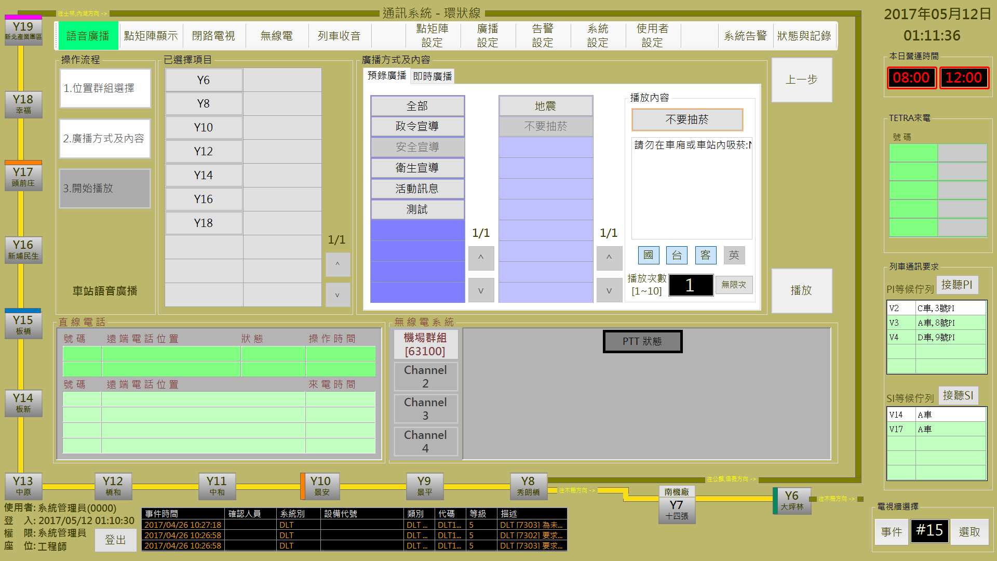

圖 3‑69: 預錄廣播廣播設定

Figure 3‑69: Pre-record message broadcast setup

**步驟3:**系統開始播放時會先連接指定車站，如果正常會在 “**已選擇項目**”的指定車站顯示 “**連線**” 狀態，否則會顯示 “**失敗**”(如圖 3‑70)。結束作業請按 “**結束**” 按鈕。系統另外提供 “**重試**” 功能，可以再次嘗試傳送設定訊息。

**Step 3:** When system start to broadcast, it will try to connect to specified station(s). If success, it will response ” **連線**” (Connect) status in the car(s) table of “**已選擇項目**” (Selected Car) block. Otherwise, it will show “**失敗**” (Faild) status (as Figure 3‑70). To finish this operation, please click “**結束**” (Close) button. Additional function button “**重試**” (Retry) is provided for message resend



圖 3‑70: 預錄廣播播放結果回報

Figure 3‑70: Pre-record message broadcast result

訊息播放過程中,可隨時按 “**停止播放**” 按鈕終止訊息播放。

Durring message broadcasting, operator can click “**停止播放**” (Stop Broadcast) to stop.

###### 即時廣播處理 Real-time Broadcast Process

**步驟2:** 操作人員點選 “**廣播方式及內容**” 區的 “**即時訊息**” 頁簽後，可開啟播放即時廣播操作頁面。按 ”**播放**” 開始進行播放處理，按 ” **上一步**” 回前一操作頁面(如圖 3‑71)

**Step 2:** Operator select “**即時廣播**” (Real-time Broadcast) tab in “**廣播方式及內容**” (Select Content and Language) block to open real-time broadcast page. After operation finish, please click “**播放**” (Start) button to progress remote message display program. Click “**上一步**” (Last Step) button back to the last step (as Figure 3‑71).

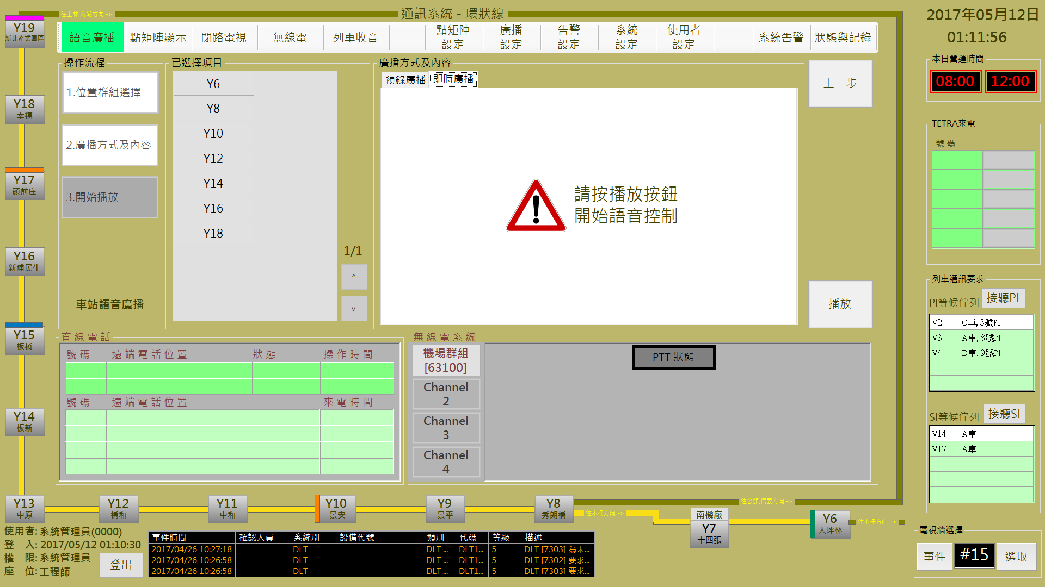

圖 3‑71: 播放即時訊息操作

Figure 3‑71: Display real-time message operation

即時廣播會透過PA系統進行，操作人員按 ”**播放**” 後，即可直接廣播。

Real-time broadcast work through PA system. Operator click “**播放**” (Start) button and directly use PA equipment to broadcast.

## DMD節能時間設定DMD Power Save Time Setup

DMD節能時間設定主要是在設定DMD的訊息顯示時段。操作人員可以點擊系統主頁的 “**本日營運時間**” 的顯示時間，開啟設定頁面 (如圖 3‑72) 後，進行調整。“**確認**” 按鈕是用來儲存設定值；“**取消**” 按鈕則是復原設定值。

DMD power save time setup is used to set the DMD work time. Operator can click the displayed time of “**本日營運時間**” (System Service Time) block to open the setup page (as Figure 3‑72) and progress system service time setup. “**確認**” (Confirm) button can store the setup result. “**取消**” (Cancel) button can recover the original setup value.



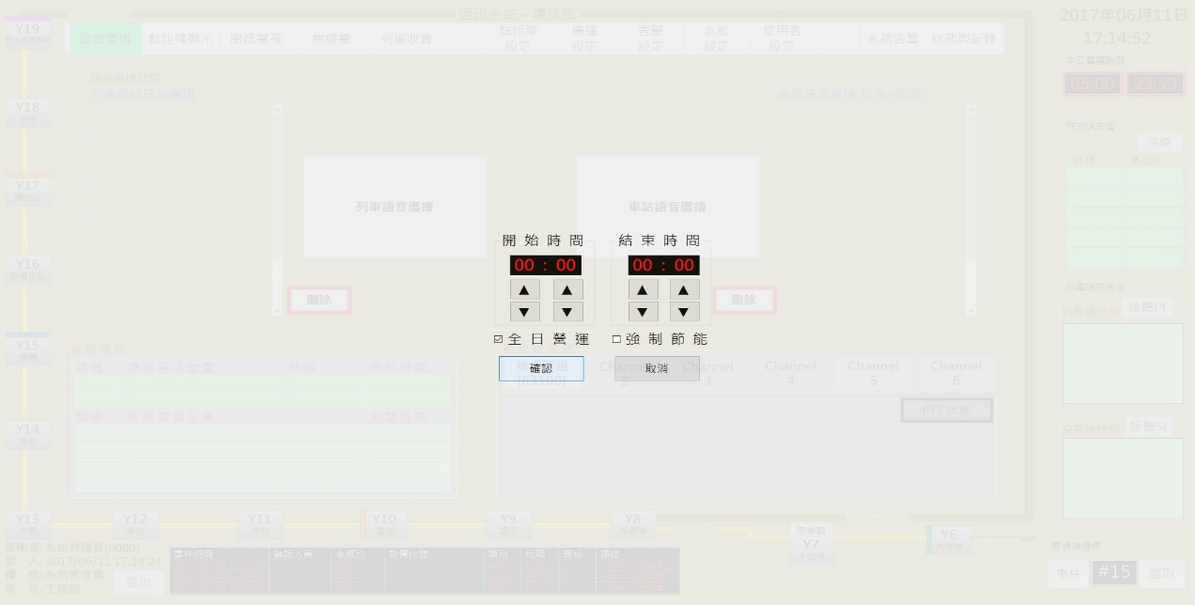

v

圖 3‑72: 系統營運時間設定

Figure 3‑72: System service time setup

## 無線電話事件處理 TETRA Call Event Process

無線電呼叫事件含TETRA/PI/SI呼叫事件，事件會顯示在CMFT的 “**TETRA來電**” / ”**列車通訊要求**” 的事件列表內，“**TETRA來電**” 的第一列為緊急呼叫會以紅色顯示 (如圖 3‑73)。

Radio call events include TETRA call, PI call and SI call. Events will show in the event list of “**TETRA來電**” (TETRA Call) and ”**列車通訊要求**” (Car Radio Call) block within CMFT monitor page. The 1st raw of “**TETRA來電**” (TETRA Call) is emergency call, will show with red color (as Figure 3‑73).

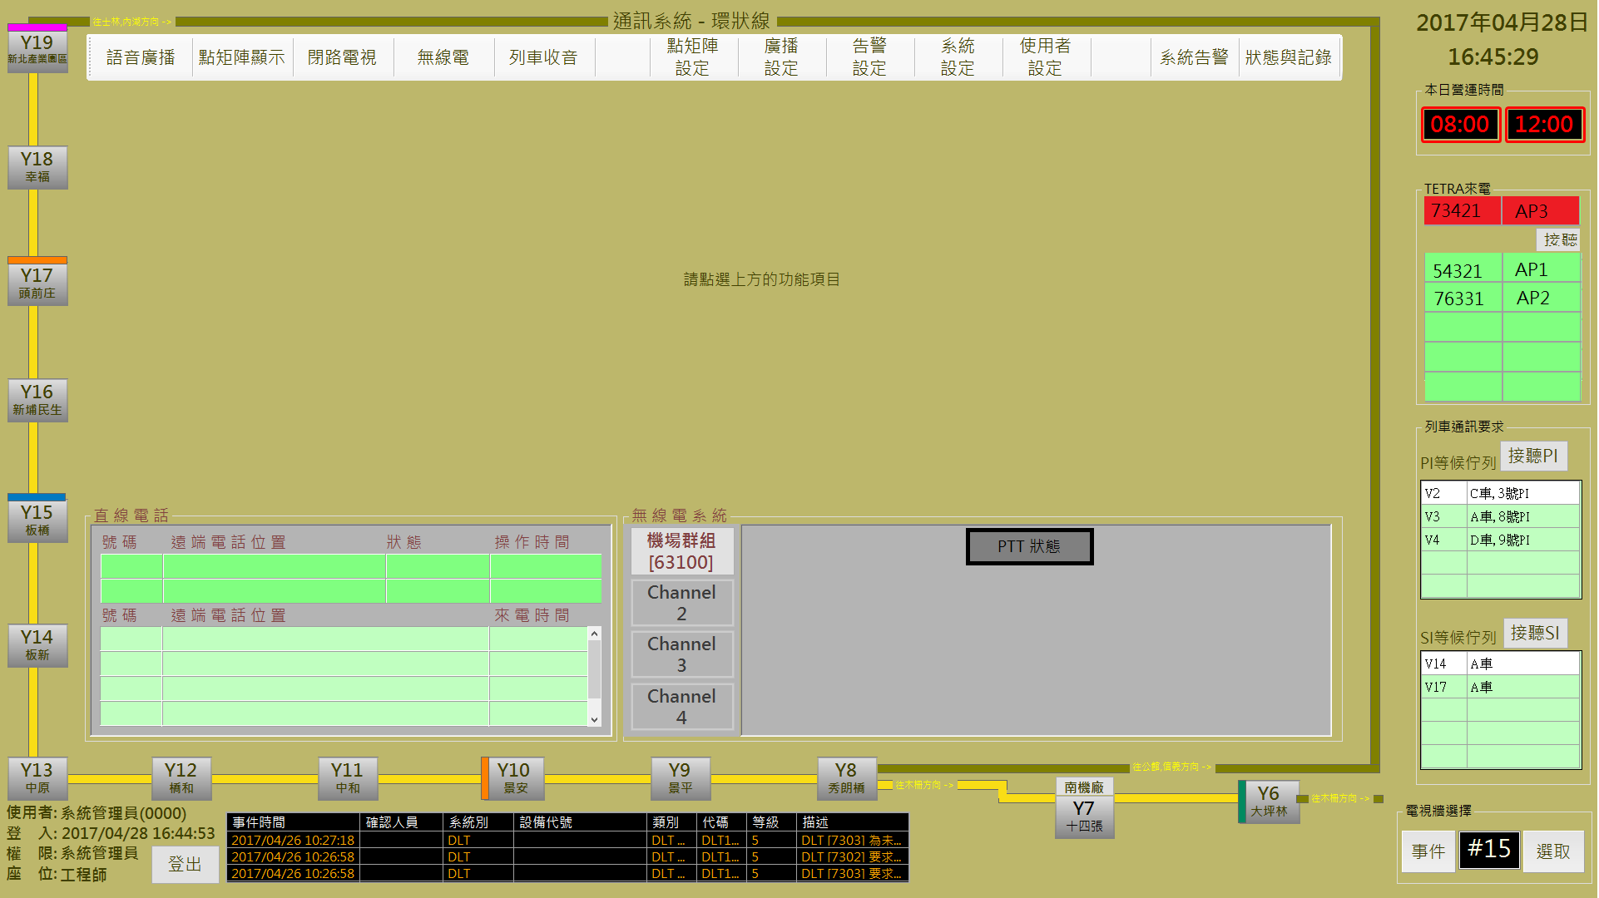

圖 3‑73: TETRA 呼叫事件

Figure 3‑73: TETRA call events

### TETRA 事件接聽 TETRA Call Receive

操作人員可以點擊TETRA呼叫列表中的事件進行接聽，系統會開啟指定接聽的無線電頻道 (如圖 3‑74)。無線電頻道開啟後，請由無線電通話設備進行雙方通話，已接聽的事件同時會自列表中移除。

Operator can click the event of “**TETRA來電**” (TETRA Call) to receive and process. Once operator has received TETRA call, system will create the radio channel for specified TETRA No.. (as Figure 3‑74). After radio channel created, operator should use radio equipments to start communication. Received event will be removed from the TETRA call list.

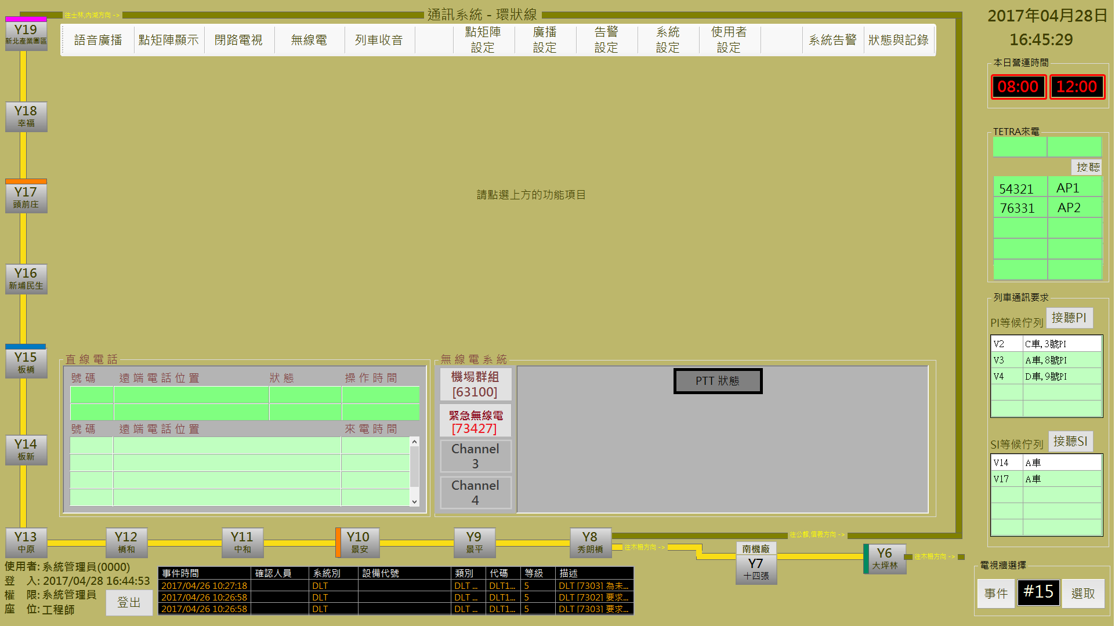

圖 3‑74: TETRA 呼叫接聽

Figure 3‑74: TETRA call events receive

### PI/SI 事件接聽 PI/SI Call Receive

PI/SI 的事件接聽與TETRA不同，操作人員點擊 ”**接聽PI**” / ”**接聽SI**” 按鈕，後系統會自行依佇列順序進行接聽處理，其餘操作則與TETRA 事件處理相同，本處不再累敘。

It is different with TETRA call receive process for PI/SI call events process. Operator click the ”**接聽PI**” / ”**接聽SI**” (PI Receive / SI receive) button, system will auto-receive the event from the PI/SI call event list by sequence. The other operation procedures are same with the TETRA call process and no more introduce here.

## 直線電話事件處理DLT Events Process

**直線電話事件**會顯示在CMFT的 “**直線電話**” 區的事件列表內，列表分為**處理中** (上半部) 及**等待中** (下半部) 兩個部份 (如圖 3‑75)。

**DLT call events** will show in the event list of “**直線電話**” (DLT Call) block within CMFT monitor page. Table is separated two parts : one is **processing** (Upper), and the other one is **waiting** **queue** (Lower) (as Figure 3‑75).



圖 3‑75: DLT 呼叫

Figure 3‑75: DLT call events

**直線電話**通話處理部份由直線電話設備操控，CMFT 系統可以結合設備處理狀況顯示進度於 “**狀態**” 欄位，如果通話結束，事件會自列表內移除。

**DLT communication** controlled by DLT equipment. CMFT System can access the equipment progress status and response in the event list “**狀態**” (Status) field . When DLT communication finish, the related events will be removed.

# CMFT系統維護概述CMFT SYSTEM MAINTAINANCE summary

CMFT系統維護需求如下：

Surveillance workstation provides operating function for operator as following:

* 資料庫檔案備份處理

Database and files backup process.

* CMFT 軟體更新處理

CMFT software upgrade.

## 資料庫/檔案備份處理 Database and Files Backup Process.

### 資料庫備份排程建立Database backup schedule establishment

1. 建立維護計畫：

開啟SSMS=>管理=>維護計畫=>新增維護計畫，步驟如下圖。

Establish maintenance plan:

Open SSMS => Manage => Maintenance Plan => Add Maintenance Plan, as shown in the following figure.

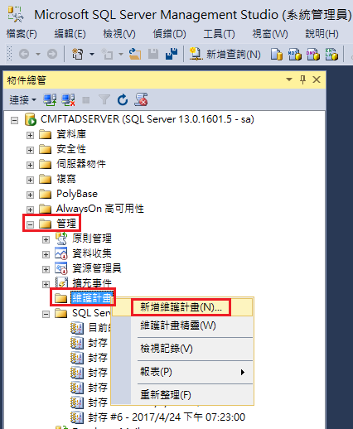

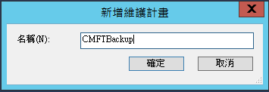

1. 建立子計畫-備份資料庫工作。

先使用「加入子計畫」功能建立子計畫。

Build the subprogram - Backup Database Work.

Create a subprogram using the Join Subprograms feature.

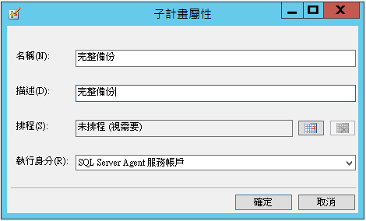

再由工具箱中拖曳「備份資料庫工作」。

Then drag the " Backup Database Work " from the toolbox.

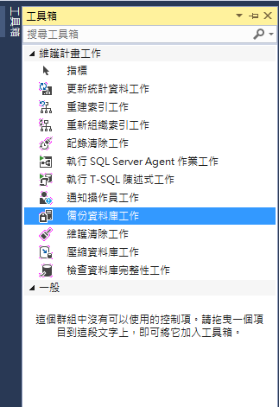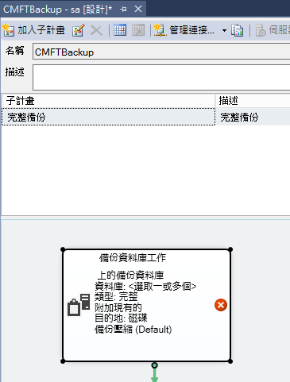

點擊備份資料庫工作圖框按右鍵=>編輯。

Right click on 'Backup Databas Work' Figure => Edit.

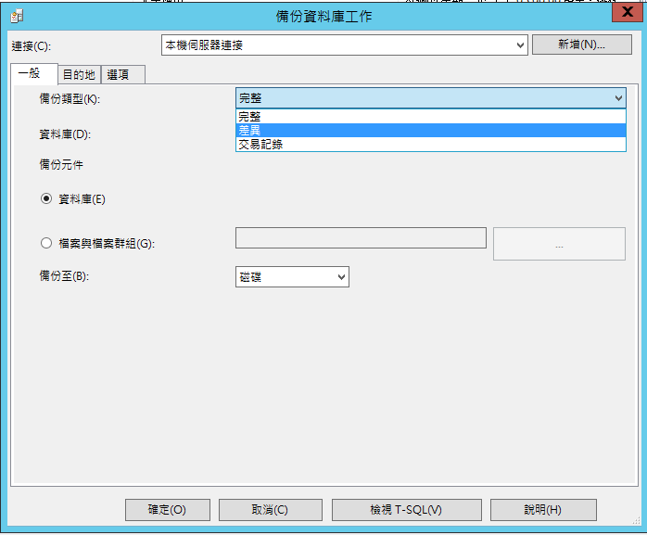

1. 設定排程時間。

Set the schedule.

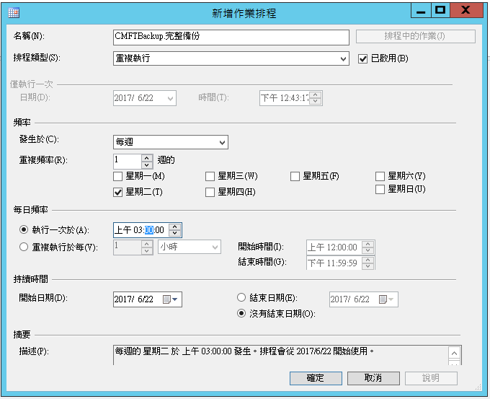

1. CMFT資料庫建立三種子計畫-完整備份、差異備份及交易備份。請重複步驟(1)~(3)

The CMFT database builds three subprograms - Full Backup, Differential Backup and Transaction Backup. Please repeat steps (1) to (3)

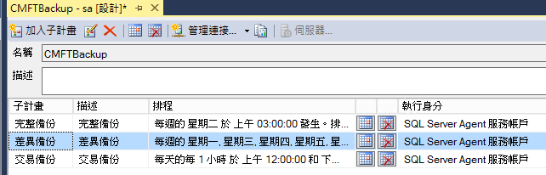

1. 排程設定:

完整備份 : 每周二凌晨3點。

差異備份 : 每周一三四五六日凌晨3點，下午3點。

交易備份 : 每3小時。

Schedule Setting:

Full Backup: At 3 am of every Tuesday.

Differential Backup: At 3 am and 3 pm of Every Monday, Wednesday, Thursday ,Friday, Saturday, Sunday.

Transaction backup: Every 3 hours.

### 資料庫備份資料刪除設定Database backup data deletion settings

1. 於完整備份後建立子計畫-維護清除工作。

由工具箱中拖曳「維護清除工作」，建立BAK檔清除規則,每次完整備份後刪除前七日的差異備份與完整備份。

Create a subprogram after a full backup - maintenance cleanup.

Drag the "Maintenance Cleanup" from the toolbox, create a BAK file cleanup rule, and after each full backup, to delete the the differential backup and the full backup these built first seven days ago.

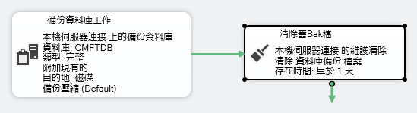

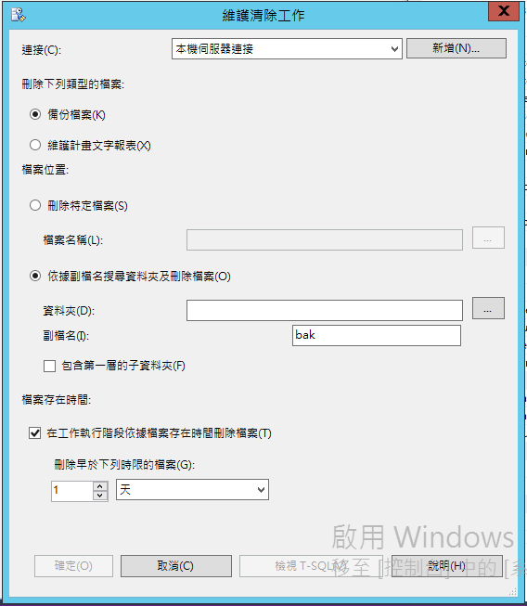

1. 於差異備份後建立子計畫-維護清除工作。

由工具箱中拖曳「維護清除工作」，建立TRN檔清除規則,每次差異備份後刪除前12小時的交易備份。

Create subprograms after differential backup - maintenance cleanupDrag the "Maintenance Cleanup" from the toolbox, create a TRN file cleanup rule, and delete the 12-hours-ago transaction backup after each differential backup.

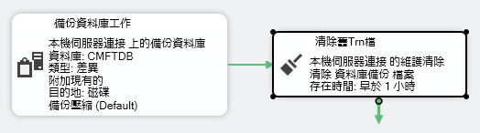

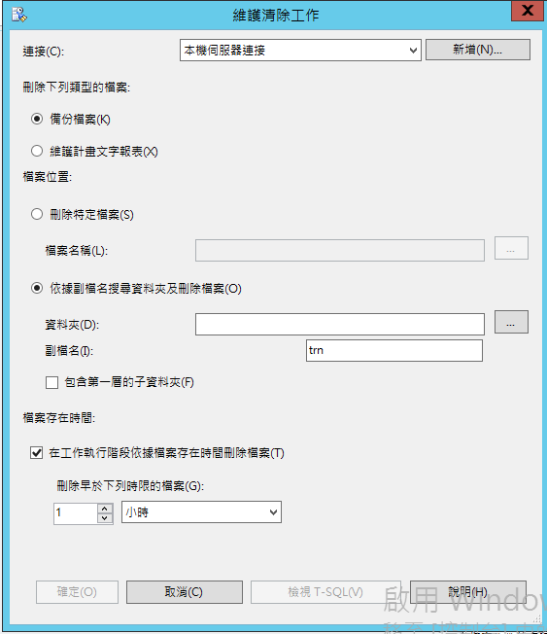

### 檢視排程執行狀態View the schedule execution status

1. 檢視計畫內容。

可以在下圖看到建立的「維護計畫」和「子計畫」。

View the contents of the program.

You can see the "Maintenance Plan" and "Subprograms" created in the following figure.

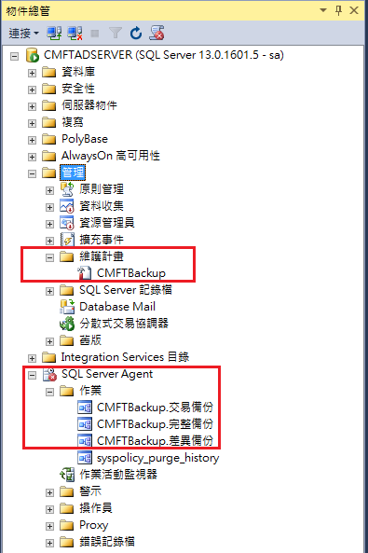

1. 啟用SQL Server Agent。

Enable SQL Server Agent.

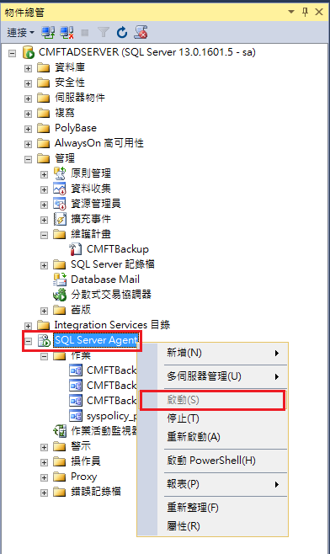

1. 啟動子計畫排程作業。

Start the subprogram job.

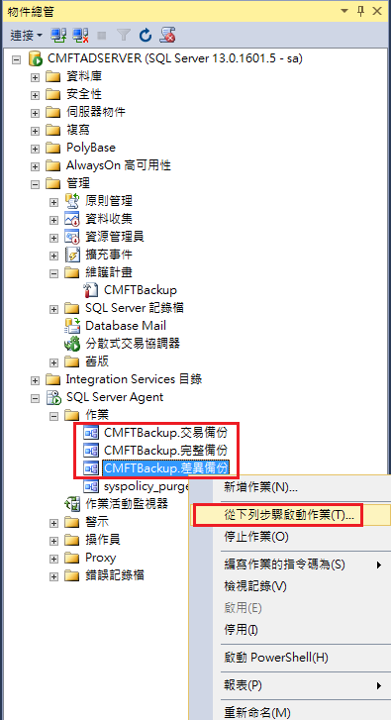

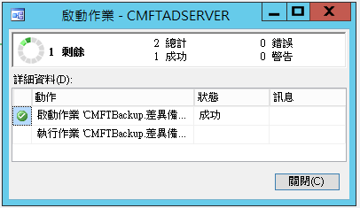

1. 檢視計畫執行狀態。

點擊「作業活動監視器」可以查看所有計畫的執行狀況。

View the execution status of the project

Click "Activity Monitor" to view the status of all your projects.

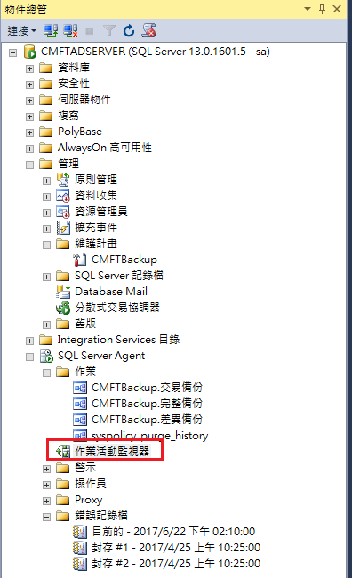

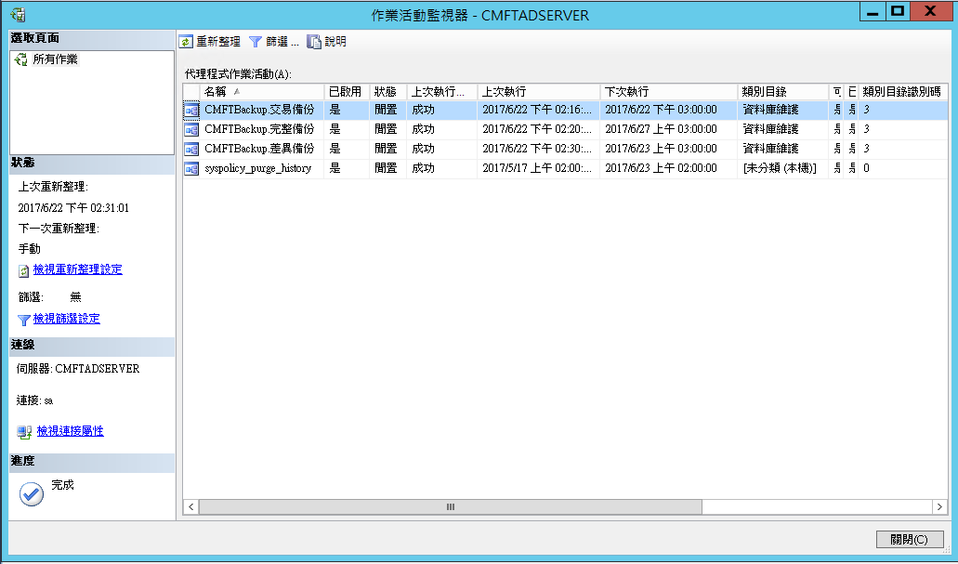

### 資料庫郵件通知設定 Database Mail Notification Settings

1. 建立 Database Mail設定。

開啟SSMS=>管理=>Database Mail=>設定Database Mail，步驟如下Establish Database Mail settings

Open SSMS => Admin => Database Mail => Set Database Mail, the steps are as follows

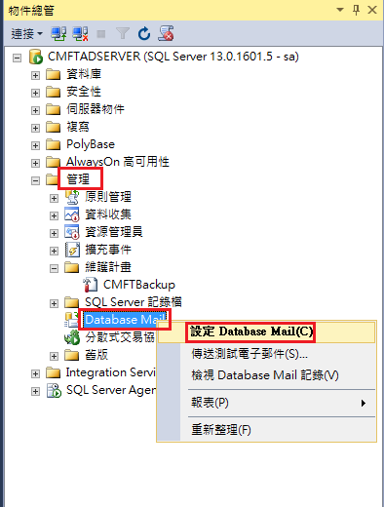

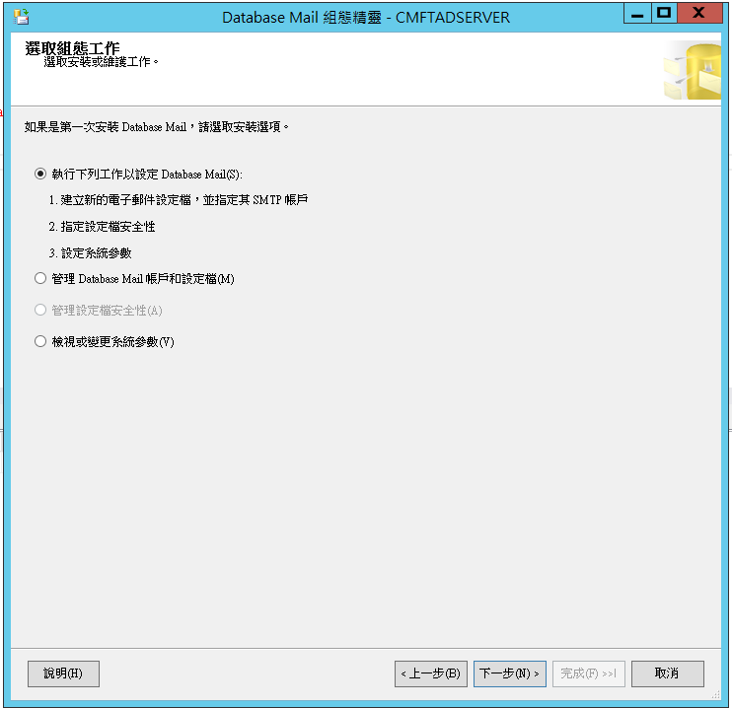

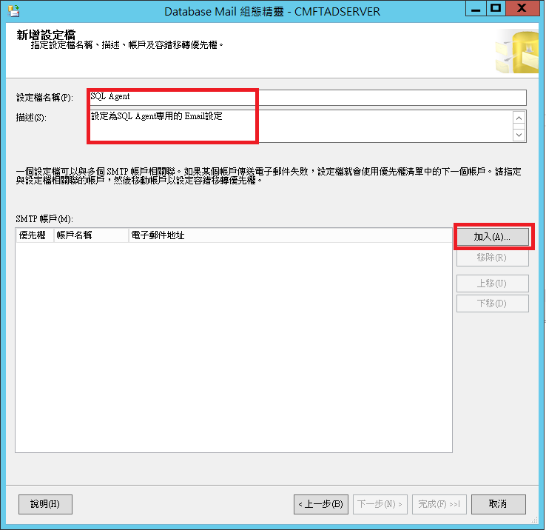

建置收件者相關資料。

Build recipients information.

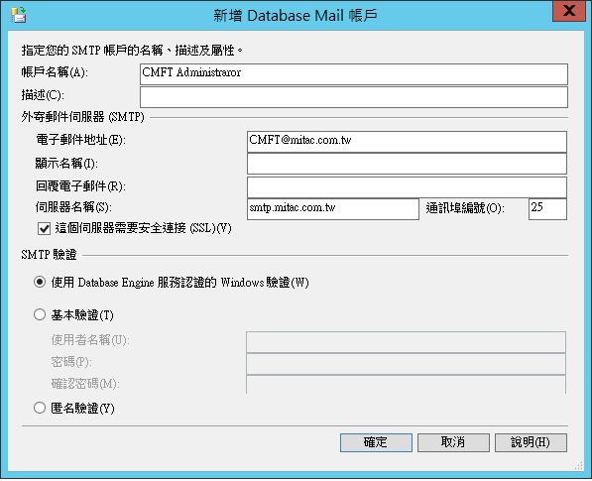

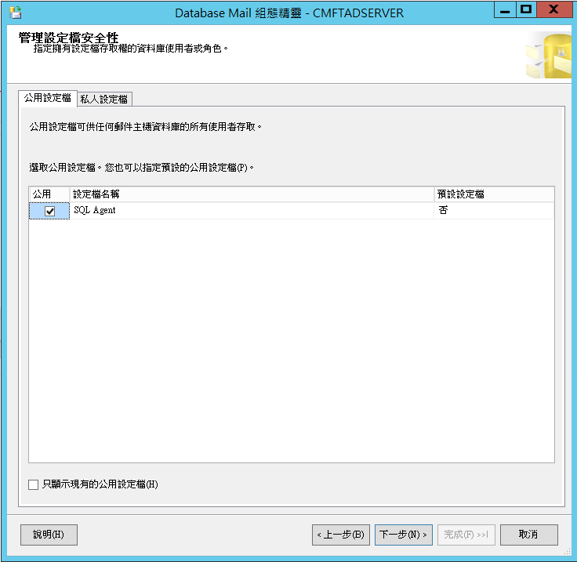

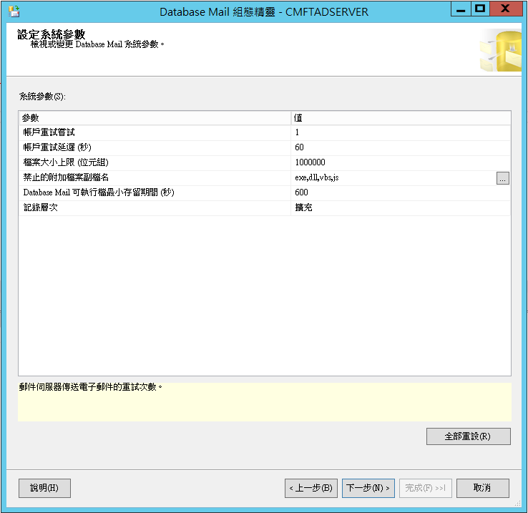

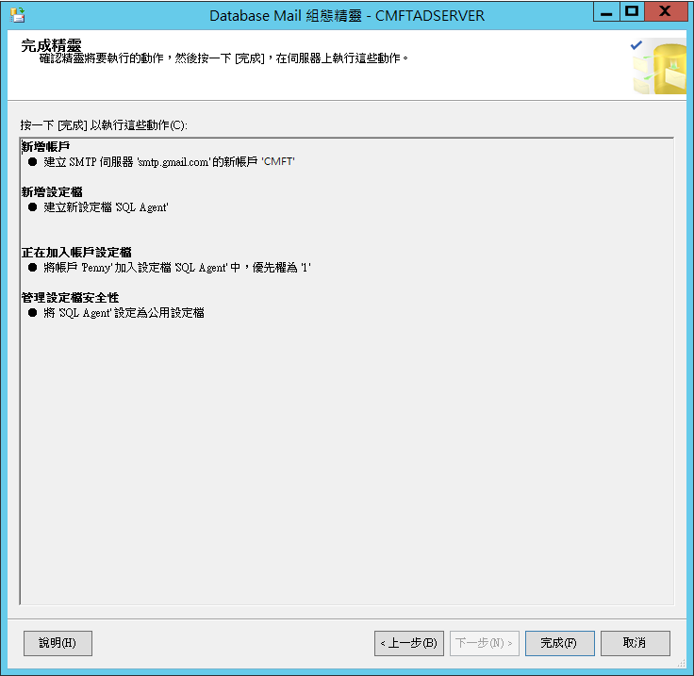

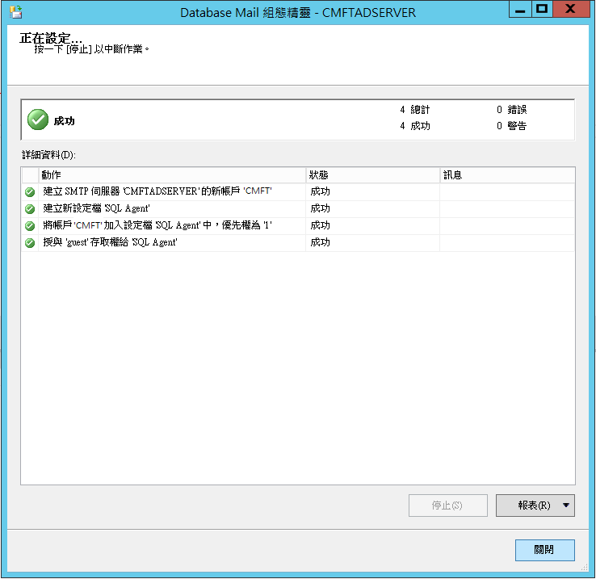

1. 郵件發送測試。

開啟SSMS=>管理=>Database Mail=>傳送測試電子郵件

Mail delivery test

Open SSMS => Administration => Database Mail => Send Test E-mail

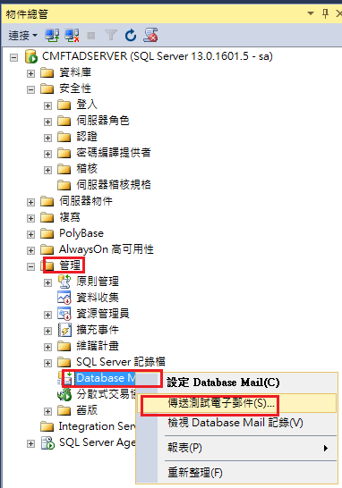

輸入先前註冊的電子郵件。

Enter the registered email.

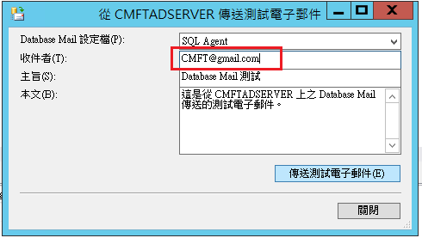

按下傳送測試電子郵件後，到信箱可以收取信件即設定成功。

Press to send the test e-mail, to the mailbox can receive letters that means that sets successfully.

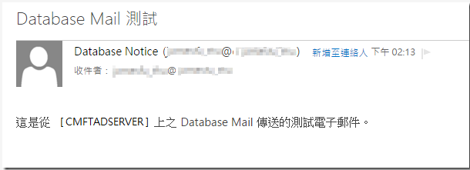

1. 設定當備份異常時發送信件。

開啟SSMS=>SQL Agent 點擊右鍵=>屬性

Set to send mail when the backup is abnormal

Open the SSMS => SQL Agent right click on the => attribute

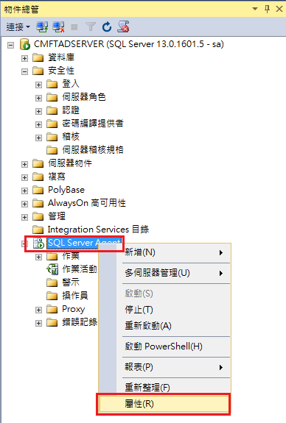

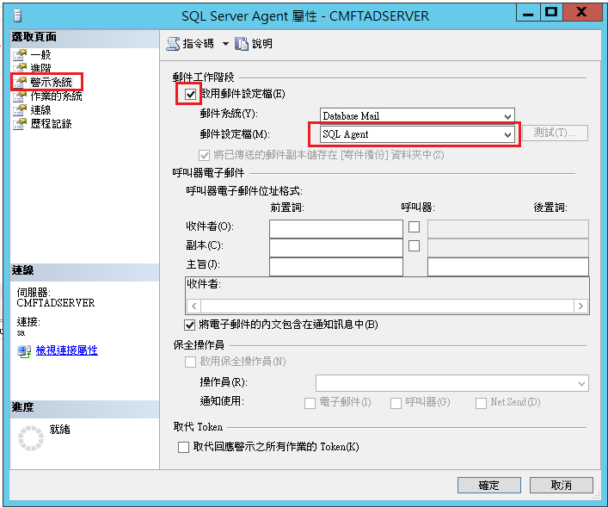

新增操作員。

Add operator.

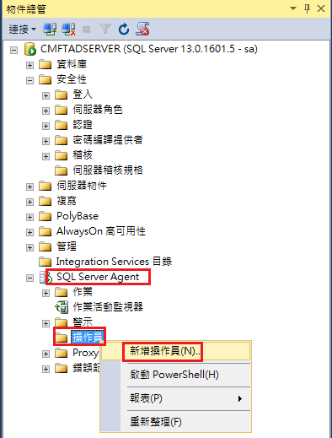

指定操作員的名稱和 E-Mail ( 如果需要通知到許多人的話，可以在每個 Email 帳號之間加入「 ；」做區隔,就可以一次通知多人了 )。

Specify the name of the operator and E-Mail (if you need to notify many people, you can add a " ；" between each email account, you can notify more people at once).

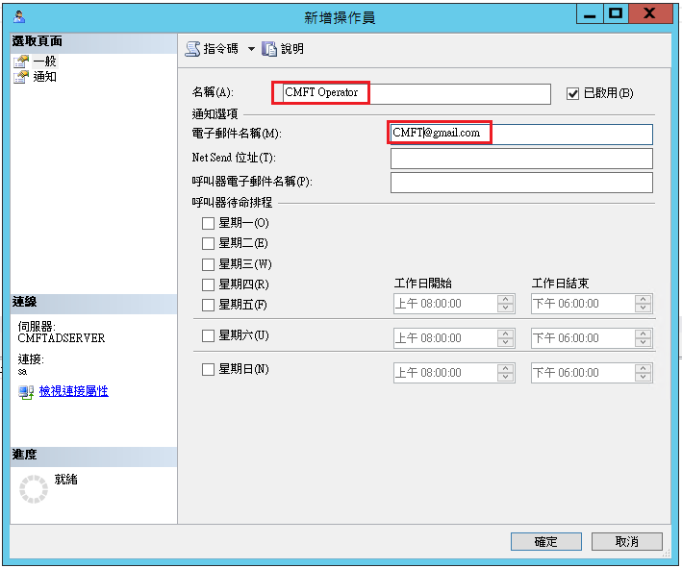

到已經建立的子計畫排程作業中設定事件通知。

Set up event notification in a subprogram schedule job.

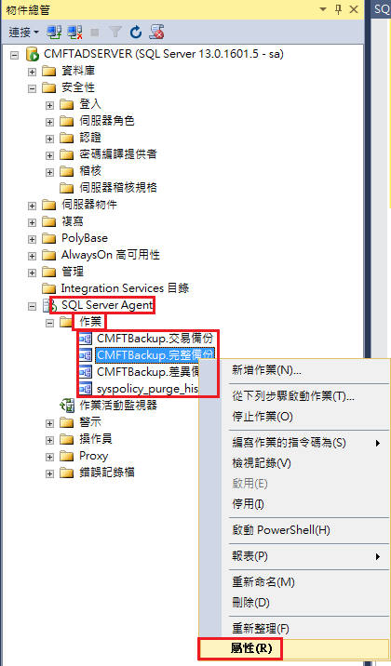

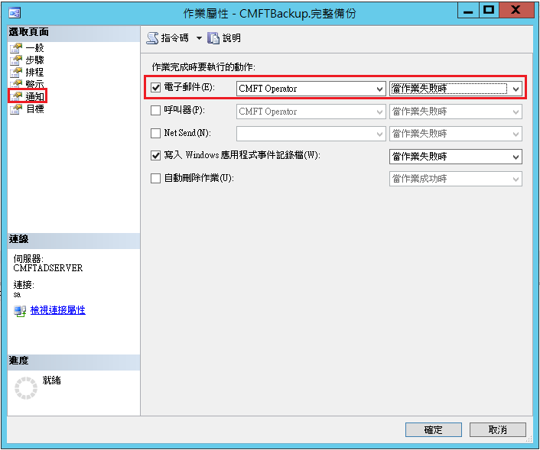

完成上述設定，後續如果有備份發生失敗時，則系統就會按照設定,通知相關人員了。

Complete the above settings, if there is a backup failure, the system will be set e-mail to relevant personnel.

## CMFT 軟體維護與更新處理 CMFT Software Maintainance and Upgrade.

### 人機介面軟體設定與更新流程 human machine interface on Console Setting and Uptading Flow

#### 主控台電腦的IP設定 The Setting of IP Address on Cosole

1. 根據下表網域,配置內網設定：

According to the following table, configure the network settings：

| 編號 No | 網址 IP | 設備 Equipment | 安裝位置 Location |
| --- | --- | --- | --- |
| 1 | 10.7.0.1 | (SDC- 4MSH - 001) L2 Switch 1 | OCC CER |
| 2 | 10.7.0.2 | (SDC- 4MSH - 002) L2 Switch 2 | OCC CER |
| 3 | 10.7.0.20 | CMFT OCC AD SERVER | OCC CER |
| 4 | 10.7.0.21 | (SDC- 4MSR - 001) CMFT SERVER A | OCC CER |
| 5 | 10.7.0.22 | (SDC- 4MSR - 002) CMFT SERVER B | OCC CER |
| 6 | 10.7.0.31 | (SDC- 4MNP - 001) Terminal Server | OCC CER |
| 7 | 10.7.0.35 | (SDC- 4MPR - 001) CMFT OCC Printer | OCC Room |
| 8 | 10.7.0.51 | (SDC- 4MWS - 001) CMFT Console 1 | OCC Room |
| 9 | 10.7.0.52 | (SDC- 4MWS - 002) CMFT Console 2 | OCC Room |
| 10 | 10.7.0.53 | (SDC- 4MWS - 003) CMFT Console 3 | OCC Room |
| 11 | 10.7.0.54 | (SDC- 4MWS - 004) CMFT Console 4 | OCC Room |
| 12 | 10.7.0.55 | (SDC- 4MWS - 005) CMFT Console 5 | OCC Room |
| 13 | 10.7.0.56 | (SDC- 4MWS - 006) CMFT Console 6 | OCC Room |
| 14 | 10.7.0.57 | (SDC- 4MWS - 007) CMFT Console 7 | OCC Room |
| 15 | 10.7.0.101 | (YSC- 4MWS - 001) L2 Switch | ROCC CER |
| 16 | 10.7.0.120 | CMFTROCC AD SERVER | ROCC CER |
| 17 | 10.7.0.121 | (YSC- 4MSR - 001) CMFT SERVER C | ROCC CER |
| 18 | 10.7.0.135 | (YSC- 4MPR - 001) CMFT ROCC Printer | ROCC Room |
| 19 | 10.7.0.151 | (YSC- 4MWS - 001) CMFT Console 8 | ROCC Room |
| 20 | 10.7.0.152 | (YSC- 4MWS - 002) CMFT Console 9 | ROCC Room |

表 4‑1: 硬體IP配置表

Table 4‑1: IP Configuration Of Hardware

1. 開啟網路連線->網路和共用中心->變更介面卡設定 (如下畫面) 。

to open the network connection -> Network and Sharing Center -> Change adapter settings (the following screen).

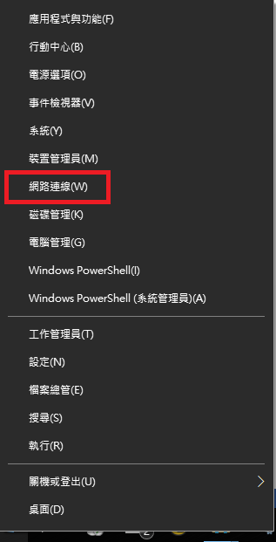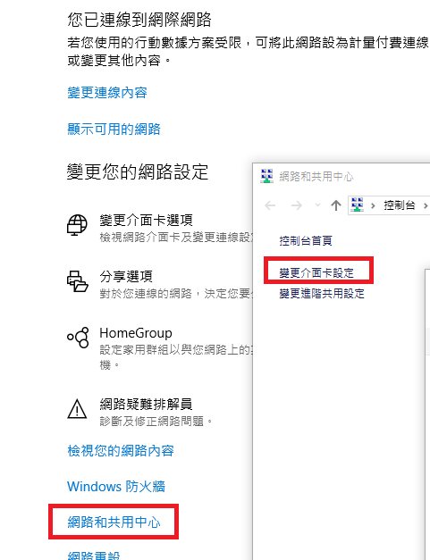

圖 4‑1: 電腦IP設定

Figure 4‑1: IP Address Configure

1. 『網際網路通訊定4版(TCP/IPv4)』後點選內容按鈕,設定IP位址 。

Select "Internet Protocol Version 4 (TCP/IPv4)" and press the Properties button to set the IP Address.

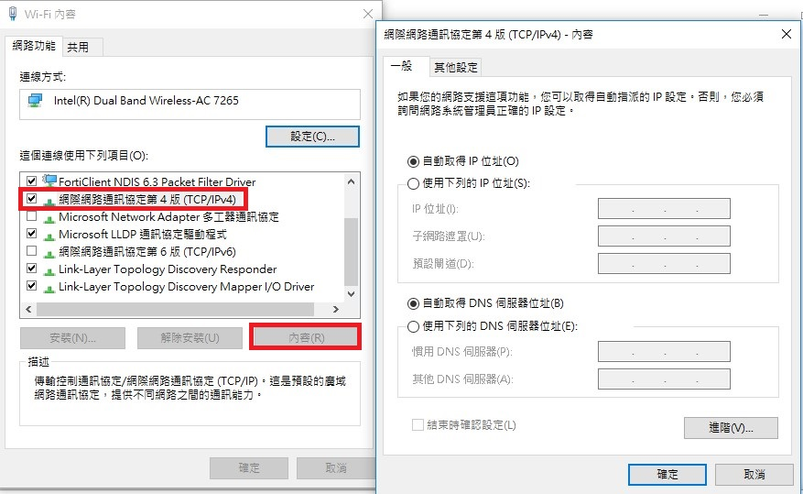

圖 4‑2: 電腦IP設定2

Figure 4‑2: IP Address Configure2

#### 用管理者權限執行進行驗證與更新CMFTConsole-SEtup.exe

1. 驗證IP與目前版本。

Verify the IP and Check the Version.

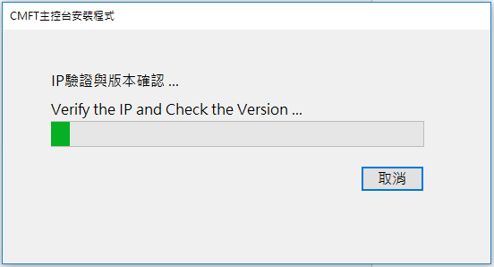

圖 4‑3: 安裝程式IP與版本驗證

Figure 4‑3: Verify the IP and Check the Version

1. 從伺服器端下載最新版本。

Download the new version.

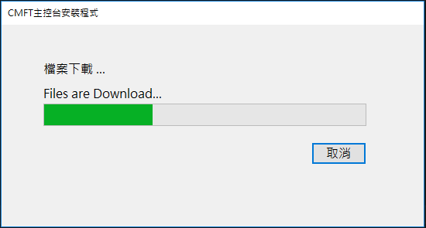

圖 4‑4: 下載更新版本流程圖

Figure 4‑4: Download the new version

1. 軟體更新。

Update and Set the Software.

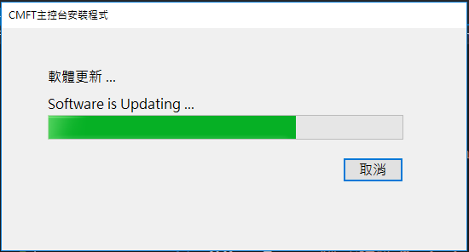

圖 4‑5: 安裝更新版本

Figure 4‑5: Update and Set the Software

1. 若更新失敗，可按下重試，重新執行更新流程。

If the update process is failed, you can press retry button to re-run the update process.

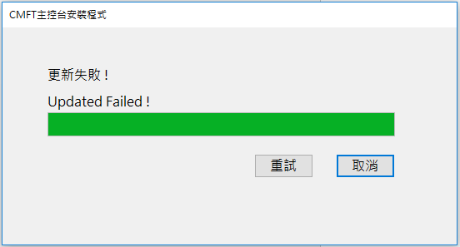

圖 4‑6: 更新失敗示意圖

Figure 4‑6: Update and Set the Software

#### 更新成功後,跳出登入畫面執行驗證登入程序After the update is successful, the login screen will be displayed to Perform the login process

1. 更新成功後將出現登入畫面 。

After the update is successful, the login screen will appear.

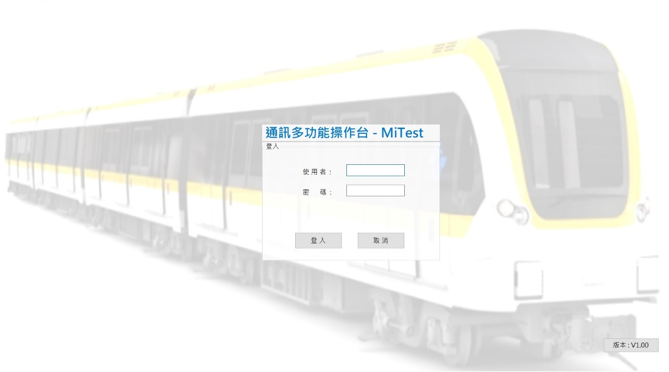

圖 4‑7: 登入畫面

Figure 4‑7: Login Screen

1. 當版本有更新時，版本將以紅色字體顯示。

When the version is updated, the version will be displayed in red font.

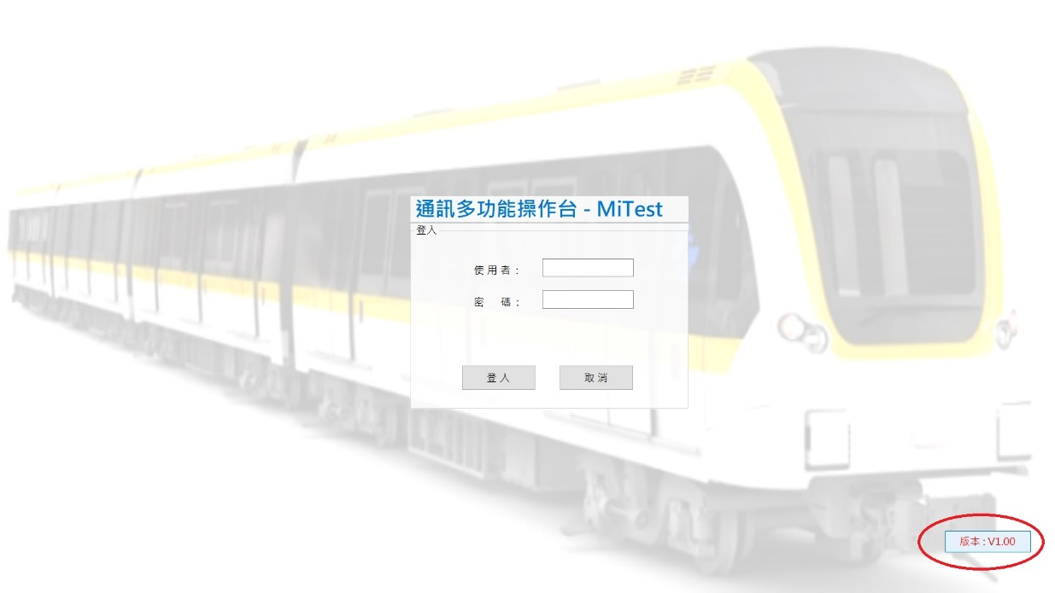

圖 4‑8: 有更新版告警圖

Figure 4‑8: New Version Exist Alarm Display

1. 按下版本按鈕進行版次驗證與更新確認。

Press the version button to verify version and confirm whether customer perform the update process.

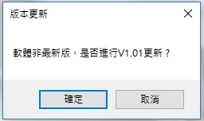

圖 4‑9: 更新確認

Figure 4‑9: Updated Conifrmation

### 伺服器服務軟體設定與更新流程The Services on Server Setting and Uptading Flow

#### 叢集設定與檢驗CLuster Configuration and ConfIrmation

##### 儲存儲區設定 Storage Setting

1. 在實體磁碟中新增磁碟區。

In physical fisk, add new disk area.

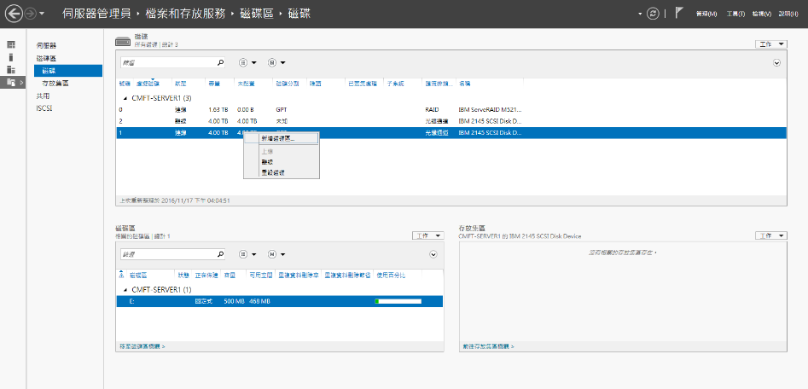

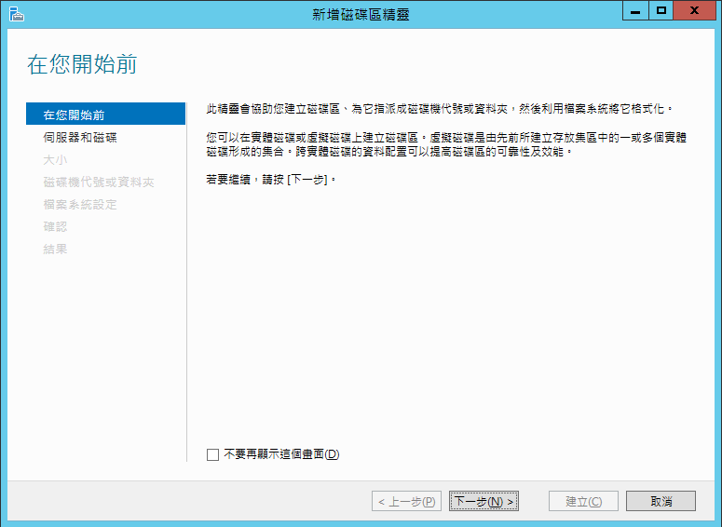

1. 下一步。

Next Step.

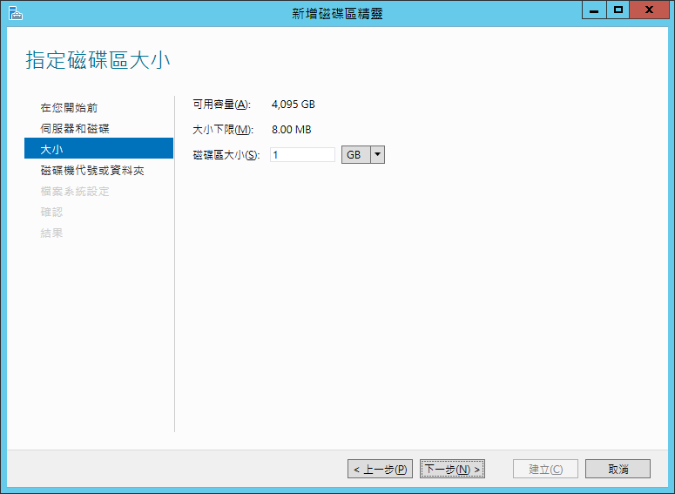

1. 指定磁碟代號。

Assigned the ID of disk.

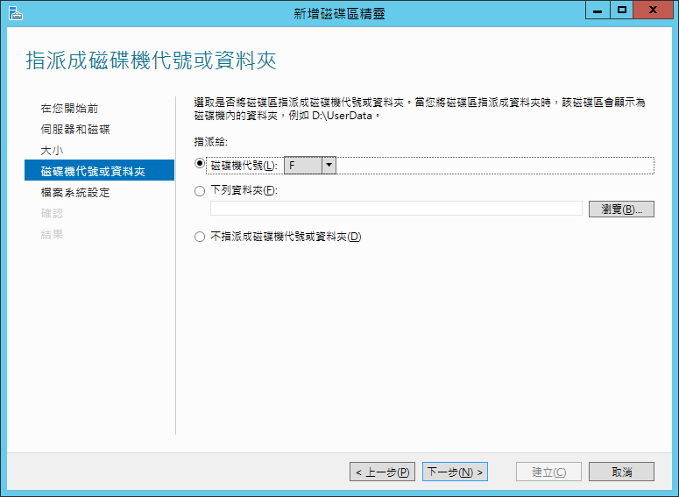

1. 設定格式並按下下一步。

Set the type And press Next Step.

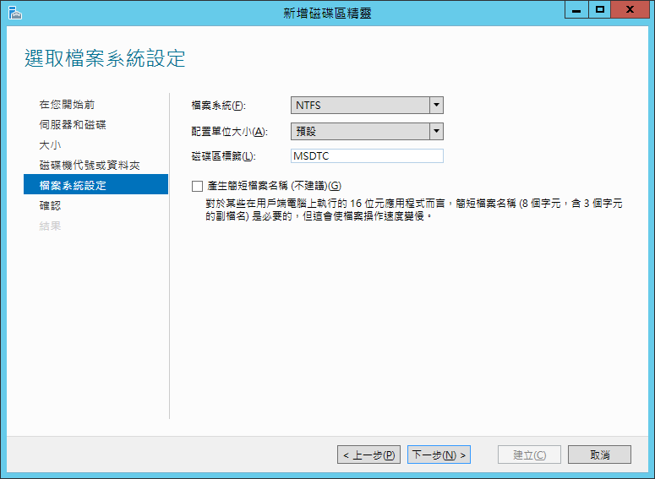

1. 確認後按下建立。

Confirm the information, then press Build

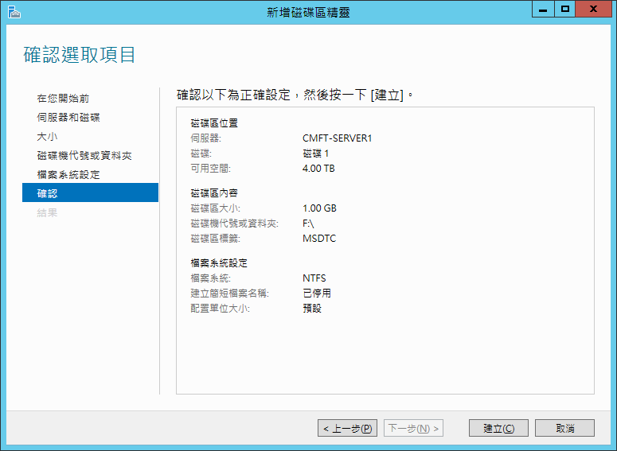

1. 顯示目前進行進度。

Display the progess.

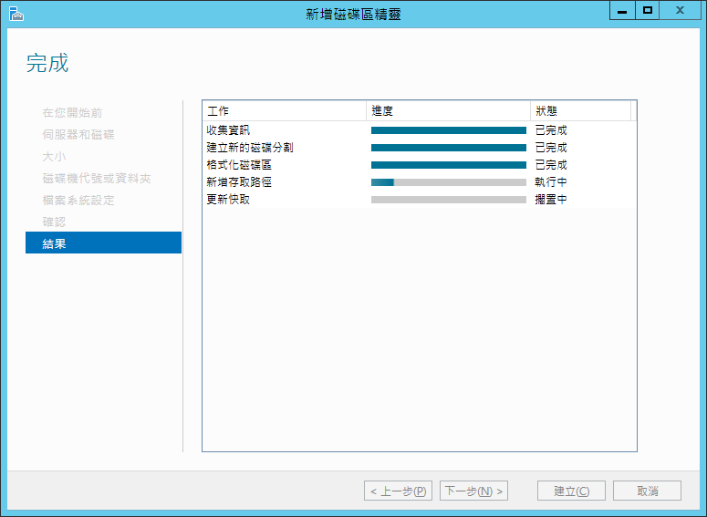

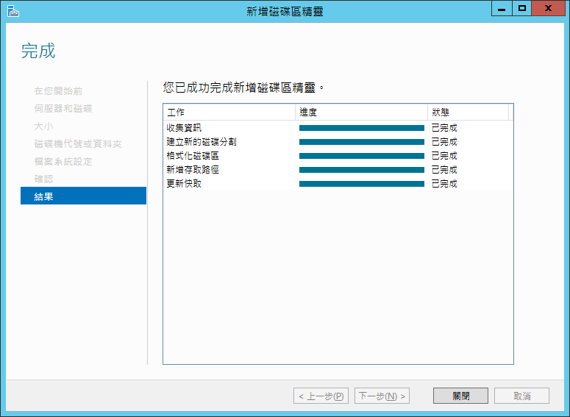

1. 完成。

Finished.

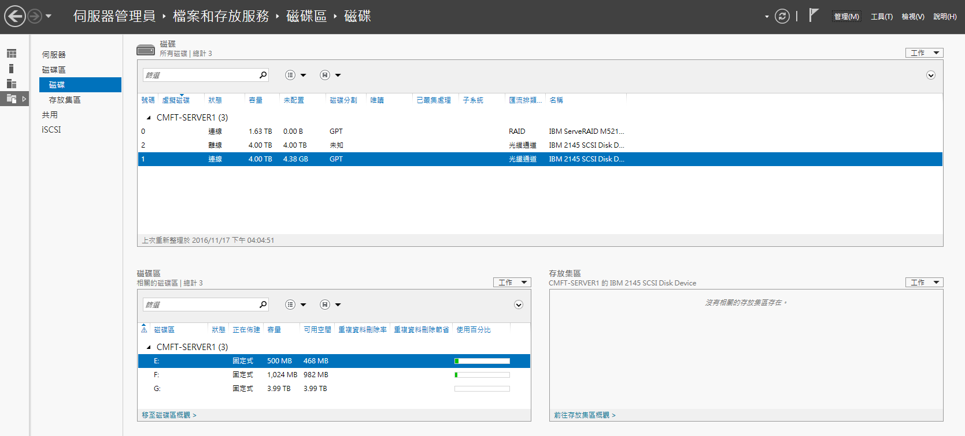

##### 安裝容錯移轉叢集管理工具

1. 新增角色與功能精靈後下一步。

Add role and function wizard and Next Step.

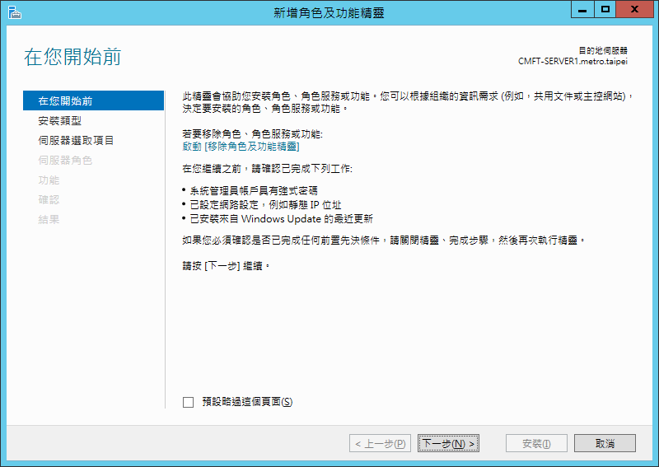

1. 選擇角色型或功能型安裝後下一步。

Select role type or functional installation, then Next Step.

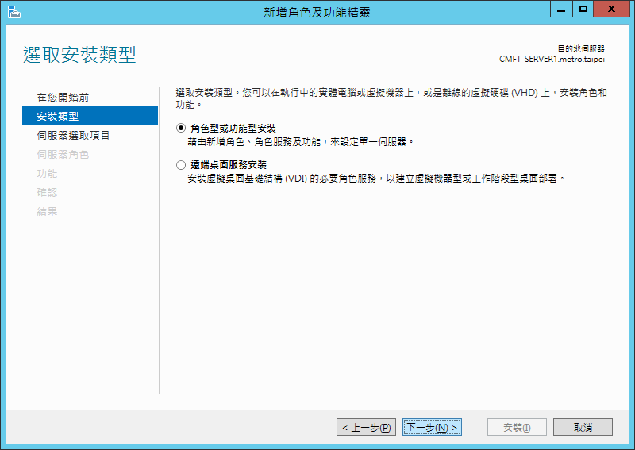

1. 選擇伺服器集區後下一步。

Select the server pool, then Next Step.

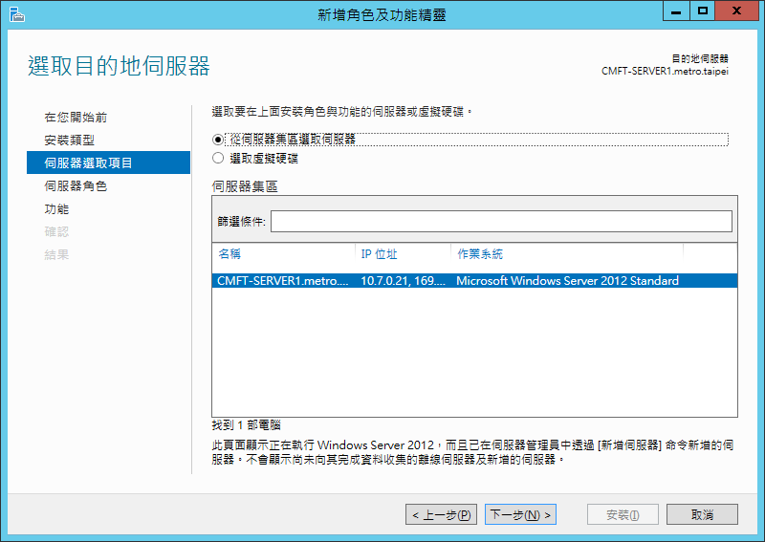

1. 選擇應用程式伺服器後下一步。

Select application server, then Next Step.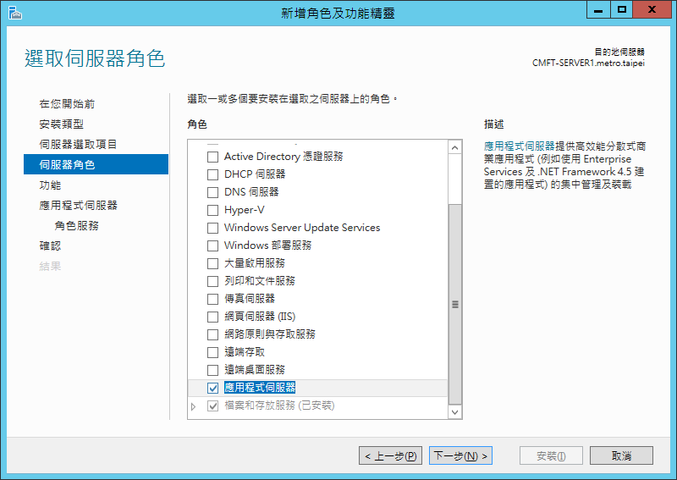

1. 勾選外寄網路交易與連入網路交易後下一步。

Check mark outbound online transactions and connected to the network transactions, then Next Step.

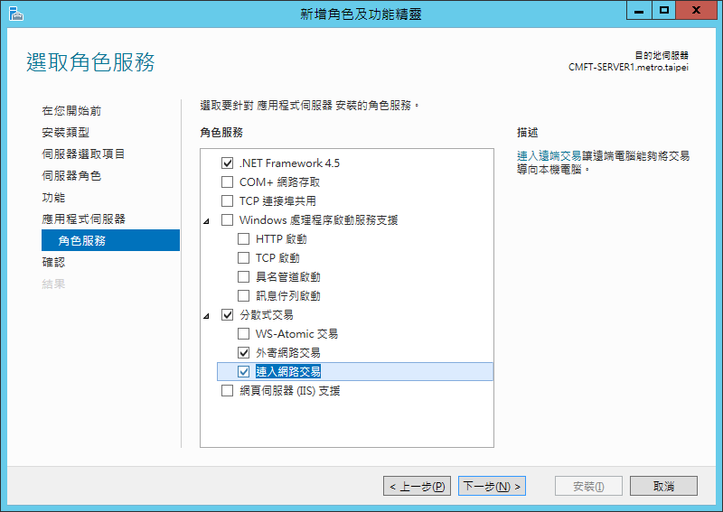

1. 選擇容錯移轉叢集後下一步。

Select failover transfer cluster, then Next Step.

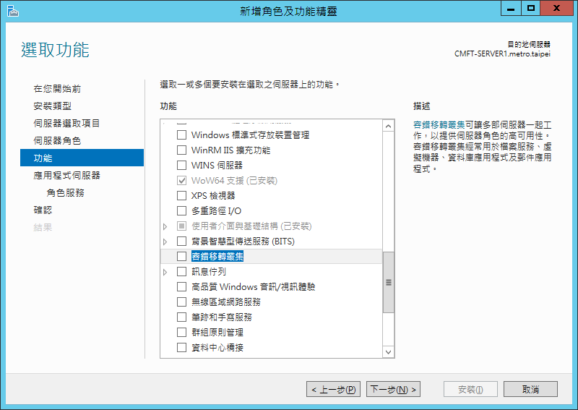

1. 新增功能後下一步。

Add Functuion, then Next Step.

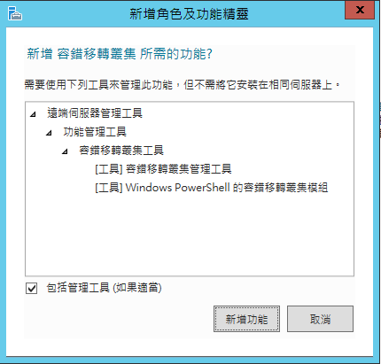

1. 確認選擇的功能後下一步。

Confrim the information, then Next Step..

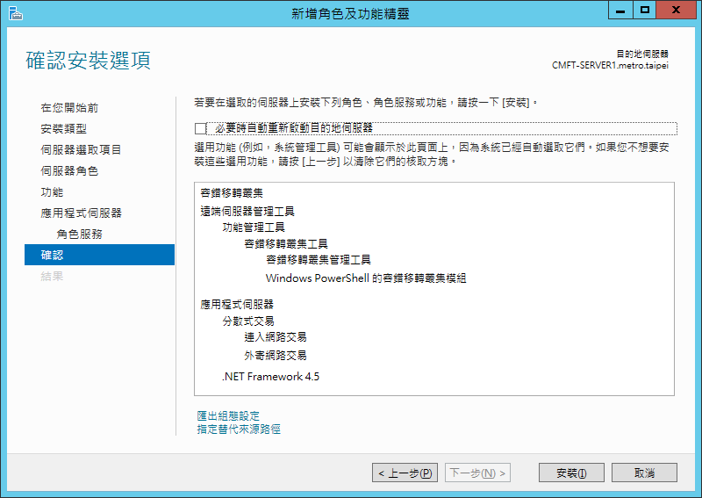

1. 確認相關要安裝的項目後按下安裝。

Press the Install button.

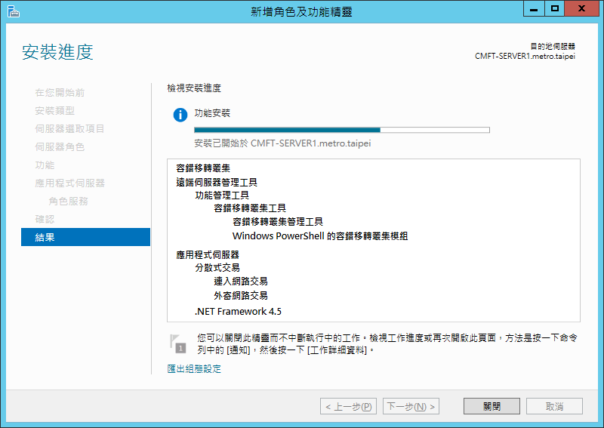

1. 完成後將之關閉。

After install finsihed, the screen will be closed.

##### 建立服務的叢集設定

1. 容錯轉移叢集管理員中設定角色。

In failover cluster manager, set the role.

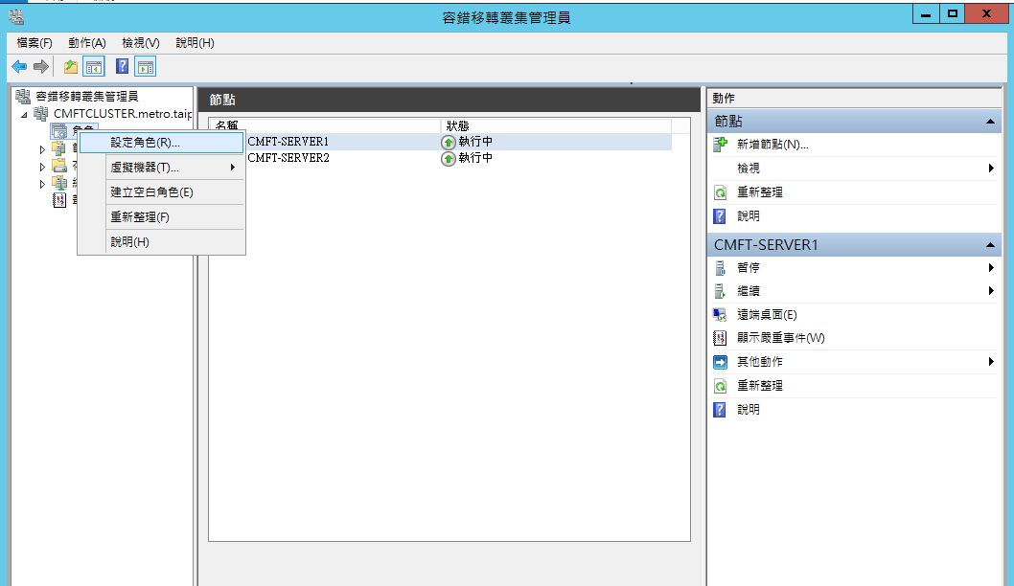

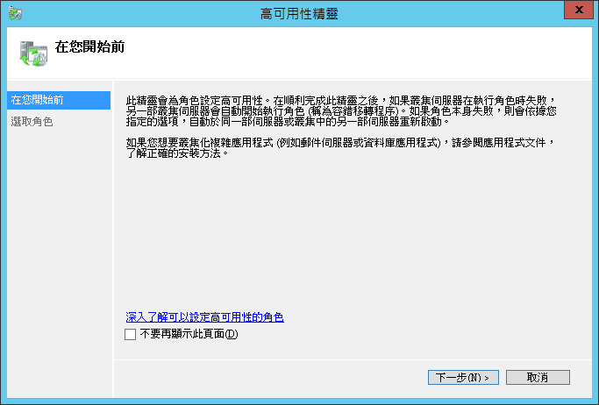

1. 選擇泛型服務。

Select the generic service.

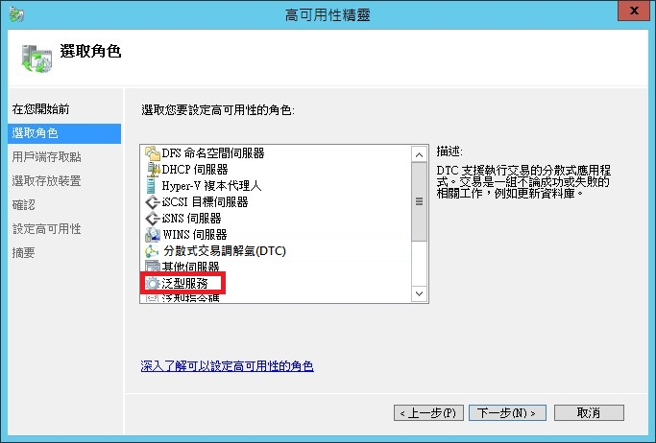

1. 叢集角色命名，並且設定叢集網路位址。

Named the role, and set the cluster network IP address for the role.

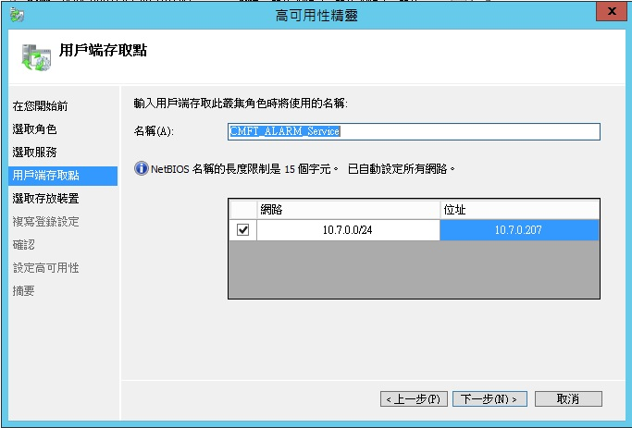

1. 此再驗證設定。

Verify the setting.

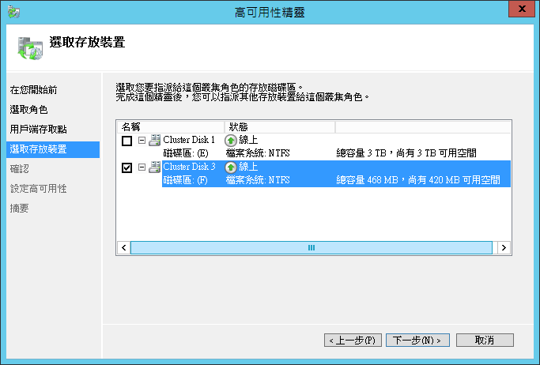

##### 伺服器服務IP分配表

1. 伺服器上IP分配表如下:

IP configurion table on CMFT Server

| 編號No | 網址IP | 描素Description |
| --- | --- | --- |
| 1 | 10.7.0.200 | CMFT CLUSTER Service |
| 2 | 10.7.0.201 | Cluster.TetraOtc Services |
| 3 | 10.7.0.202 | CLuster.ATS Services |
| 4 | 10.7.0.203 | CLuster. DLT Services |
| 5 | 10.7.0.204 | CLuster. CCTV Services |
| 6 | 10.7.0.205 | CLuster. PA Services |
| 7 | 10.7.0.206 | CLuster. DMD Services |
| 8 | 10.7.0.207 | CLuster. ALARM Services |
| 9 | 10.7.0.208 | CLuster. SCADA Services |
| 10 | 10.7.0.209 | CLuster. CMFT Services |
| 11 | 10.7.0.210 | CLuster. APP Services |
| 12 | 10.7.0.211 | CLuster. TimeSync Services |
| 13 | 10.7.0.212 | CLuster. MiFET Services |
| 14 | 10.7.0.213 | CLuster. ALARM Agent |
| 15 | 10.7.0.214 | CLuster. ATS Agent |
| 16 | 10.7.0.215 | CLuster. CCTV Agent |
| 17 | 10.7.0.216 | CLuster. DLT Agent |
| 18 | 10.7.0.217 | CLuster. DMD Agent |
| 19 | 10.7.0.218 | CLuster. PGIS Agent |
| 20 | 10.7.0.219 | CLuster. SCADA Agent |
| 21 | 10.7.0.220 | CLuster. SDS Agent |

表 4‑2: CMFT伺服器服務IP配置表

Table 4‑2: IP Configuration Of the Services on CMFT Server

1. 檢查每個服務的配置是否正確，下圖為資料庫叢集服務的範例。

Check the configuration of each service is correct, the picture shows the CMFT SQLCLUSTER Service example.

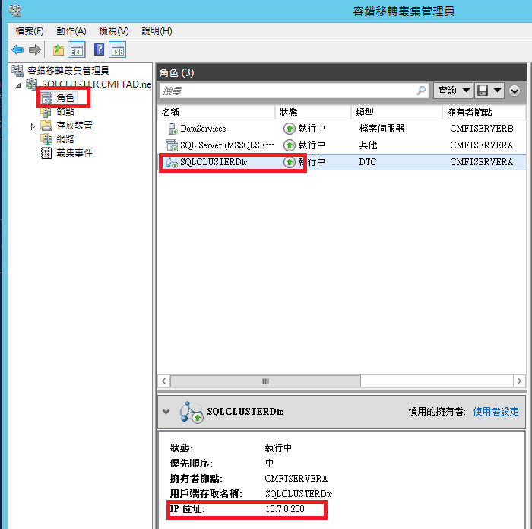

#### 服務安裝與更新流程Services Install And Updaeing Process

##### 版本確認Version Checking

1. 在C:\Program\MiCMFT Server\Version.Ini中確認目前版本。

To Check the cersion in the file: C:\Program\MiCMFT Server\Version.Ini.

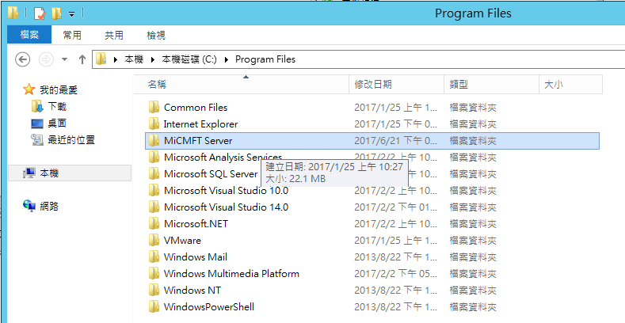

1. 資料內容如下:

The information is as follows:

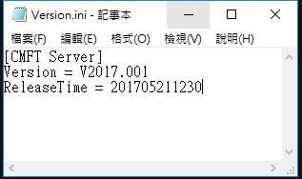

1. 檢查壓縮檔(EX: MiCMFT Server.V2017.002.7z)檔名中的版本日期是否和步驟(2)相同或更新版本。

Check filename of the archive (EX: MiCMFT Server.V2017.002.7z)whether the version is the same or later than the step (2).

1. 進行7z解壓縮。後開啟解壓縮後的Version.ini再次確認版本。Decompression the 7z file. After decompressed the file, Open Version.ini and Check the version Again.

##### 服務安裝 Services Install

1. 卸除舊版服務，點選C:\Program\MiCMFT Server\ UnInstall-All.bat，執行UnInstall-All.bat 檔案。

To remove the legacy service, click C: \ Program \ MineCRAFT Server \ UnInstall-All.bat to execute the UnInstall-All.bat file

1. 開始執行卸除任務顯示畫面如下：

Start the removal task display as follows:

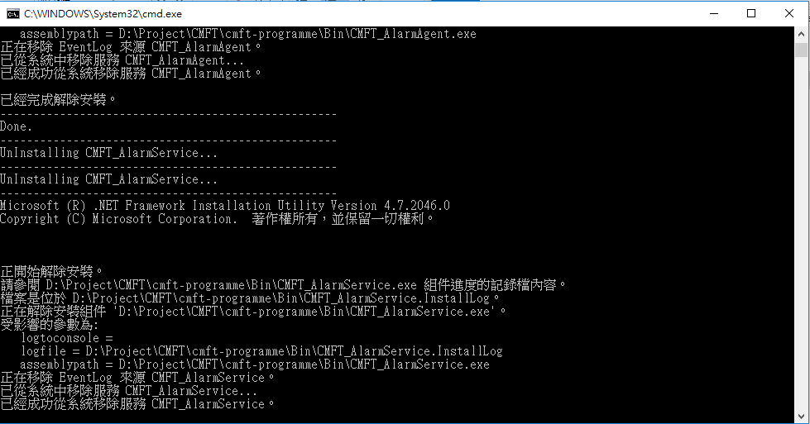

1. 安裝新版服務，點選C:\Program\MiCMFT Server\ Install-All.bat，執行Install-All.bat 檔案。

Install the new version’s services, click C: \ Program \ MineCRAFT Server \ Install-All.bat, execute the Install-All.bat file

1. 開始執行安裝顯示畫面如下：

Start the install task display as follows

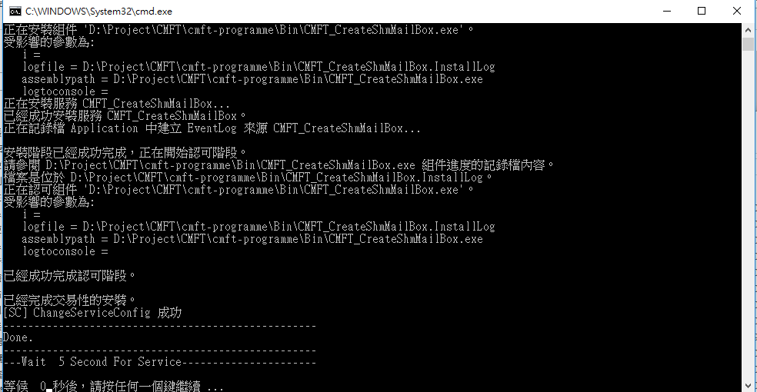

1. 安裝完成後在服務視窗中確認所有的服務都已經啟動。

After the installation is complete, to confirm that all the services have been started in the service window.

